Draft
Code of Practice

SCAFFOLDING WORK

TABLE OF CONTENTS

FOREWORD 4
SCOPE AND APPLICATION 4
1. INTRODUCTION 5
1.1 What is a scaffold and scaffolding work? 5
1.2 Who has health and safety duties relating to scaffolds and scaffolding work? 5
1.3 What is involved in managing risks associated with scaffolding work? 6
1.4 Training, information, instruction and supervision 6
2. MANAGING RISKS WITH SCAFFOLDS 8
2.1 Identifying the hazards 8
2.2 Assessing the risks 8
2.3 Controlling the risks 8
2.4 Reviewing the risk control measures 9
3. PLANNING SCAFFOLDING WORK 10
3.1 Scaffolding plan 10
3.2 Safe work method statements 11
3.3 Designers 11
3.4 Scaffold design 13
3.5 Adjacent buildings or structures 18
3.6 Unauthorised access 18
3.7 Emergency plan 18
4. CONTROLLING THE RISKS IN SCAFFOLDING WORK 19
4.1 Safe erection of scaffold 19
4.2 Safe dismantling of scaffold 20
4.3 Scaffold alteration 21
4.4 Falling objects and falls 21
4.5 Electricity 24
4.6 Powered mobile plant and traffic 24
4.7 Mixing components from different scaffold systems 25
5. TYPES OF SCAFFOLD AND RISK CONTROLS 27
5.1 Birdcage scaffold 27
5.2 Tower scaffold 27
5.3 Mobile scaffold 28
5.4 Tube and coupler scaffold 29
5.5 Frame scaffold 29
5.6 Hung scaffold 30
5.7 Single pole scaffold 31
5.8 Suspended (swing-stage) scaffold 31
5.9 Special scaffolds 34
5.10 Scaffold for demolition work 35
6. INSPECTION AND MAINTENANCE 36
6.1 Hand over inspections 36
6.2 Frequency of inspection 36
6.3 Scaffolds and scaffolding components 36
APPENDIX A – DEFINITIONS 38
APPENDIX B – SCAFFOLDING LICENCE CLASSES 41
APPENDIX C – TECHNICAL STANDARDS AND OTHER REFERENCES 42
APPENDIX D – SAFE USE OF SUSPENDED (SWING-STAGE) SCAFFOLD 43
APPENDIX E – SCAFFOLD INSPECTION CHECKLIST 54
APPENDIX F – SCAFFOLD HANDOVER CERTIFICATE: SCAFFOLD OVER 4M 56

FOREWORD
This Code of Practice for managing risks associated with scaffolding work is an approved code of practice under section 274 of the Work Health and Safety Act (the WHS Act).
An approved code of practice is a practical guide to achieving the standards of health, safety and welfare required under the WHS Act and the Work Health and Safety Regulations (the WHS Regulations).
A code of practice applies to anyone who has a duty of care in the circumstances described in the code. In most cases, following an approved code of practice would achieve compliance with the health and safety duties in the WHS Act, in relation to the subject matter of the code. Like regulations, codes of practice deal with particular issues and do not cover all hazards or risks which may arise. The health and safety duties require duty holders to consider all risks associated with work, not only those for which regulations and codes of practice exist.
Codes of practice are admissible in court proceedings under the WHS Act and Regulations. Courts may regard a code of practice as evidence of what is known about a hazard, risk or control and may rely on the code in determining what is reasonably practicable in the circumstances to which the code relates.
Compliance with the WHS Act and Regulations may be achieved by following another method, such as a technical or an industry standard, if it provides an equivalent or higher standard of work health and safety than the code.
An inspector may refer to an approved code of practice when issuing an improvement or prohibition notice.
This Code of Practice has been developed by Safe Work Australia as a model code of practice under the Council of Australian Governments’ Inter-Governmental Agreement for Regulatory and Operational Reform in Occupational Health and Safety for adoption by the Commonwealth, state and territory governments.
A draft of this Code of Practice was released for public consultation on 2 April 2012 and was endorsed by the Select Council on Workplace Relations on [to be completed].

SCOPE AND APPLICATION
This Code provides practical guidance for persons conducting a business or undertaking on the safe design, erection, use, alteration and dismantling of scaffolds in workplaces, including suspended, cantilevered, spur or hung scaffolds.

The Code of Practice: Construction Work provides further guidance for persons conducting a business or undertaking that involves construction work.

How to use this code of practice
In providing guidance, the word ‘should’ is used in this Code to indicate a recommended course of action, while ‘may’ is used to indicate an optional course of action.

This Code also includes various references to sections (s.) of the WHS Act and Regulations (r.) which set out the legal requirements. These references are not exhaustive. The words ‘must’, ‘requires’ or ‘mandatory’ indicate that a legal requirement exists and must be complied with.

INTRODUCTION

What is a scaffold and scaffolding work?
A scaffold is a temporary structure specifically erected to support access or working platforms. Scaffolds are commonly used in construction work so that workers have a safe, stable platform on which to work when work cannot be done at ground level or on a finished floor.
Scaffolds, once properly erected, are a control measure to prevent the risk of persons and objects falling when working at height.
Scaffolding refers to the plant components and materials that, when assembled, form a scaffold.
Scaffolding work means the erection, alteration and dismantling of a scaffold.
Scaffolding work that involves scaffold from which a person or object could fall more than four metres is classified as ‘high risk work’ under the WHS Regulations for which a licence is required.
Other key terms used in this Code are defined in Appendix A.

Who has health and safety duties relating to scaffolds and scaffolding work?
A person conducting a business or undertaking has the primary duty under the WHS Act to ensure, as far as reasonably practicable, that workers and other persons at the workplace are not exposed to health and safety risks arising from the business or undertaking.
The WHS Regulations for plant include specific obligations for a person with management or control of a scaffold at a workplace. There are also requirements under the WHS Regulations for construction work, high risk work and falls that may need to be complied with when using scaffolds.
For clarity, the person conducting a business or undertaking who has management and control of the scaffolding work is sometimes referred to in this Code as the ‘scaffolding contractor’.

Designers of plant and structures must ensure, so far as is reasonably practicable, that the plant or structure is without risks to health and safety when used for a purpose for which it was designed. Pre-fabricated scaffolding requires design registration under the plant regulations.

Manufacturers, importers and suppliers must ensure, so far as is reasonably practicable, that plant or structures they manufacture, import or supply are without risks to health and safety.

Installers must ensure, so far as is reasonably practicable, that the way the plant or structure is installed is without risks to the health and safety of persons who install, use, decommission or dismantle the plant or structure and others who are at or in the vicinity of the workplace.

Officers, such as company directors, have a duty to exercise due diligence to ensure that the business or undertaking complies with the WHS Act and Regulations. This includes taking reasonable steps to ensure that the business or undertaking has and uses appropriate resources and processes to eliminate or minimise risks that arise from the construction work.

Workers have a duty to take reasonable care for their own health and safety and that they do not adversely affect the health and safety of other persons. Workers must comply with any reasonable instruction and cooperate with any reasonable policy or procedure relating to health and safety at the workplace.

What is involved in managing risks associated with scaffolding work?
Effectively controlling health and safety risks involves following a systematic process known as risk management, consisting of the following steps set out in this Code:
- identify hazards
- if necessary, assess the risks associated with the hazards
- implement and maintain risk control measures, and
- review the effectiveness of control measures.
The WHS Regulations contain duties to manage risks relating to specific hazards, including hazardous manual tasks, noise, falls, confined spaces, construction work, plant, hazardous chemicals and asbestos.
Guidance on the general risk management process is available in the Code of Practice: How to Manage Work Health and Safety Risks.
Consulting your workers
S. 47: You must consult, so far as is reasonably practicable, with workers who carry out work for you who are (or are likely to be) directly affected by a work health and safety matter.

S. 48: If the workers are represented by a health and safety representative, the consultation must involve that representative.

Consultation with workers and their health and safety representatives is required at every step of the risk management process. In many cases, decisions about construction work and projects are made prior to engaging workers, therefore, it may not be possible to consult with workers in these early stages. However, it is important to consult with them as the scaffolding work progresses.

Consulting, cooperating and coordinating activities with other duty holders
S. 46: A person conducting a business or undertaking must consult, cooperate and coordinate activities with all other persons who have a work health or safety duty in relation to the same matter, so far as is reasonably practicable.

A construction workplace will often be shared by various persons conducting a business or undertaking, such as engineers, contractors and mobile plant operators. Persons with overlapping duties should exchange information about the risks associated with the scaffolding work including any traffic and plant movements near the scaffold area. They should work together in a cooperative and coordinated way so that all risks are eliminated or minimised so far as is reasonably practicable.

Further guidance on consultation is available in the Code of Practice: Work Health and Safety Consultation, Cooperation and Coordination.

Training, information, instruction and supervision
S. 19: A person conducting a business or undertaking must provide any information, instruction, training and supervision necessary to protect all persons from risks to their health and safety arising from the work carried out.

R. 39: A person conducting a business or undertaking must ensure that information, training and instruction provided to a worker is suitable and adequate having regard to:
- the nature of the work carried out by the worker
- the nature of the risks associated with the work at the time of the information, training and instruction, and
- the control measures implemented.
The training provided must be readily understandable by any person to whom it is provided.

R. 317: A person conducting a business or undertaking must not direct or allow a worker to carry out construction work unless the worker has successfully completed general construction induction training.

Training specific to the scaffold and/or scaffolding work and to the workplace should also be provided to workers. Workers in a supervisory role (for example, leading hand or foreman) should be experienced and trained in scaffolds and scaffolding work.

Further information on general construction induction training and other training is available in the Code of Practice: Construction Work.

High risk work licences
A person performing scaffolding work must hold the relevant scaffolding licence class if a person or thing may fall more than 4 metres from the scaffold. The licence is issued by the WHS regulator. Refer to Appendix B for further information on licensing classes.

Competent persons where licence is not required
A person is not required to hold a scaffolding licence if a person or thing may fall 4 metres or less from the scaffold. However, any person performing scaffolding work should be competent and must be provided with relevant information, instruction, training and supervision in the safe erection, dismantling, maintenance and alteration of the scaffold.

MANAGING RISKS WITH SCAFFOLDS

Identifying the hazards
Some examples of the hazards associated with work involving the erection, use, maintenance, alteration and dismantling of scaffolds include:
- scaffolding collapse (before, during and after placement of the scaffold)
- work near overhead electric lines
- mobile plant and other workplace traffic
- mixing components from different scaffold systems (for example, do not mix aluminium tubing with steel tubing)
- falls from heights
- falling objects
- manual tasks.

Assessing the risks
When assessing risks relating to scaffolds you should consider things such as:
- the type of scaffold to be used
- the height of the scaffold to be erected
- the scheduling of the scaffolding work
- the layout of the workplace, including proximity to public areas
- the surface on which the scaffold will be erected (ground conditions, the structural integrity of the surface to support the scaffold and its load)
- the number of people involved
- plant and equipment that will be used on or near the scaffold
- the skill and competencies required to erect, use, maintain, alter and dismantle the scaffold
- what exposures might occur, such as noise or ultraviolet (UV) radiation
- local weather conditions, particularly wind forces.

It should then be possible to:
- select the most suitable type of scaffold for the work
- minimise the working heights for persons erecting and dismantling scaffolds
- ensure that edge protection (including guardrails, mid-rails and toeboards), containment sheeting or other fall risk controls are able to be installed when working at height.

Controlling the risks
The ways of controlling risks are ranked from the highest level of protection and reliability to the lowest. This ranking is known as the hierarchy of control measures. The duty holder must always aim to eliminate a hazard first. If this is not reasonably practicable, the risk must be minimised by using one or more of the following:
- Substitution – for example:
  - use mechanical aids such as cranes, hoists, pallet jacks or trolleys to move equipment and materials wherever possible instead of manual lifting.
  - use scaffold systems which are made of lighter weight materials and use modern technologies, for example, modular systems which have shorter standard lengths or systems that are made of aluminium rather than steel or timber
- Isolation – for example, use concrete barriers to separate pedestrians and powered mobile plant to reduce the risk of collision
- Engineering controls – for example, provide a catch platform to prevent falling objects hitting workers or other persons below the work area.

If risk remains it must be minimised by implementing administrative controls, so far as is reasonably practicable. For example store scaffolding components as close as practical to the work area in order to minimise the distance over which loads are manually moved. Clear access ways should also be ensured so that materials and equipment can be easily accessed.

Any remaining risk must be minimised with suitable personal protective equipment (PPE), such as providing workers with hard hats, hearing protectors and high visibility vests.

Administrative control measures and PPE rely on human behaviour and supervision, and used on their own, tend to be least effective in minimising risks.

Combinations of control measures
In many cases, a combination of control measures will provide the best solution. For example, protect workers from falls using fall protection devices, such as guard rails (engineering), and safe systems of work (administrative), and other workers from falling objects by establishing an exclusion zone for the work area (isolation) and providing hard hats (PPE).

Reviewing the risk control measures
The control measures that are implemented to protect health and safety must be regularly reviewed to ensure they are effective and that no new hazards have been introduced by the control measures.
R. 38: A person conducting a business or undertaking must review and as necessary revise control measures:
- when the control measure is not effective in controlling the risk
- before a change at the workplace that is likely to give rise to a new or different health and safety risk that the control measure may not effectively control
- if a new hazard or risk is identified
- if the results of consultation indicate that a review is necessary
- if a health and safety representative requests a review.
Common review methods include workplace inspection, consultation, testing and analysing records and data.
When reviewing control measures, a SWMS must also be reviewed and revised where necessary.

PLANNING SCAFFOLDING WORK
Scaffolding work should be carefully planned before work starts so that it can be carried out safely. Planning involves identifying the hazards, assessing the risks and determining appropriate control measures in consultation with all relevant persons involved in the work, including the principal contractor, scaffolding contractor, designers and mobile plant operators.

Consultation should include discussions on the:
- nature and/or condition of the ground and/or working environment
- weather conditions
- nature of the work and other activities that may affect health and safety
- interaction with other trades
- access and egress from scaffold
- SWMS
- management of mobile plant and surrounding vehicular traffic
- public safety
- provision of adequate amenities.

Scaffolding plan
An effective plan will help identify ways to protect persons who are:
- erecting, using, maintaining, altering and dismantling the scaffold
- near the scaffolding work (for example, other workers and members of the public)

A scaffolding plan should be prepared by a competent person on behalf of the person conducting business or undertaking. In preparing the scaffold plan, the person should consult with:
- the scaffold designer, for example, to discuss the design loads and the capability of the structure to support any additional loadings
- the builder or principal contractor, for example, to assess the location of underground drains or pits. The work should be planned so as to avoid excavating service trenches under, through or adjacent to scaffolds
- workers, health and safety committees, and health and safety representatives regarding erecting, maintaining, altering and dismantling the scaffold
- other competent persons (for example, an engineer) familiar with such structures
- the electricity supply authority if the scaffold is being erected with in the vicinity of overhead electric lines.

The scaffolding plan should include a site layout plan and detail the elevations and sections of the scaffold. It is to be made available for inspection at the worksite. The scaffolding plan should address the following issues:
- basis of design
- foundations (including ground conditions)
- the weight bearing capacity of the surface where the scaffold is to be erected.
- size and weight of the scaffold (for example, dead, live and environmental loads)
- supporting structure
- access and egress
- tying and anchors (that is, where anchors will be placed on the supporting structure; and types of anchors to be used)
- bracing
- type of scaffold
- edge protection.

Safe work method statements
In some situations, scaffolding work may involve activities that are defined as ‘high risk construction work’ under the WHS Regulations. High risk construction work includes work that:
- involves a risk of a person falling more than 2 metres
- involves structural alterations or repairs that require temporary support to prevent collapse
- is carried out on or near energised electrical installations or services
- is carried out at a workplace in which there is any movement of powered mobile plant.

A safe work method statement (SWMS) must be prepared for any high risk construction work before the work starts. The SWMS must:
- identify the type of high risk construction work being done
- specify the health and safety hazards and risks arising from that work
- describe how the risks will be controlled
- describe how the control measures will be implemented, monitored and reviewed
- be developed in consultation with workers and their representatives who are carrying out the high risk construction work.
A SWMS is required, for example if the scaffold is erected near energised electrical lines or if there is a risk of a person falling more than 2 metres during the erection or dismantling process.
Further guidance on SWMS and an example SWMS template is available in the Code of Practice: Construction Work.

Designers
Scaffold designers may be involved in:
- the design of the structure (that is, the finished scaffold structure), or
- the design of the plant (that is, the scaffolding components that will be manufactured).

S. 22: Designers must ensure, so far is reasonably practicable, that the structure is designed to be without risks to the health and safety of persons in relation to the manufacture, assembly, construction or use of the structure or the proper demolition or disposal of the structure.
Plant must be designed to be without risks to the safety of persons who carry out any reasonably foreseeable activity at a workplace in relation to the assembly or use of the plant for a purpose for which it was designed, or the proper storage, decommissioning, dismantling or disposal of the plant.
Designers of plant or structures must:
- carry out, or arrange the carrying out of, any calculations, analysis, testing or examination that may be necessary to ensure, so far is reasonably practicable, that the plant is designed to be without risks to health and safety
- provide give adequate information to each person who is provided with the design of the plant or structure.

Anything that is constructed to support a load can be referred to as a structure, including a scaffold.
An experienced scaffold designer should be consulted during the design of any scaffold structure to provide input on ways to minimise the risk of injury.
The term designer includes anyone who modifies the design. For example, if the capacity of the scaffold is to be increased by adding additional components, a designer will need to complete additional calculations to ensure the modified structure is capable of supporting the additional load. The person designing the addition has designer duties and, if they are not the original designer, they should consult the original designer to ensure the new configuration does not compromise the existing design specifications or safety factors.
Safety report
R.295 The designer of a structure or any part of a structure that is to be constructed must give the person conducting a business or undertaking who commissioned the design a written report that specifies the hazards associated with the design of the structure that, so far as the designer is reasonably aware:
- create a risk to the health or safety of persons who are to carry out construction work on the structure or part; and
- are associated only with the particular design and not with other designs of the same type of structure.

The information requirements under the WHS Act may be incorporated into the safety report prepared under the WHS Regulations. The written safety report may include proprietary documentation that sets out the safe use of scaffolding components or component system, the type of scaffold and health and safety risk control measures to be used.

A person commissioning the construction work must consult, so far as is reasonably practicable, with the designer of the whole or any part of the structure about eliminating and controlling risks. If the person commissioning the construction work did not commission the design of the construction project, they must take all reasonable steps to obtain the designer’s safety report.

Where there is a principal contractor, the person conducting a business or undertaking who commissioned the scaffold work must give a copy of any safety report provided by the designer to the principal contractor.

The design process may be simple or complex depending on the size and complexity of the scaffold. However, a scaffold must be designed by a competent person, for example an engineer experienced in structural design, to ensure that it is capable of carrying the loads that will be applied to it.

Scaffold designers should consider the work practices necessary to carry out the erection and dismantling of the scaffold as designed and identify health and safety risks and controls at the design stage. Design matters to be considered include:
- the method and sequence of erecting and dismantling the scaffold and the related risks, particularly relating to manual handling
- the provision of safe access to and egress from the work areas on and around the scaffold
- minimising the working heights for persons erecting and dismantling scaffold
- that edge protection (including guardrails, mid-rails and toeboards), containment sheeting, fall arrest systems including horizontal life lines or other fall risk controls are able to be installed when working at height
- advice and information (such as drawings, scope of work instructions and bills of quantity) to be provided to the scaffolding contractor and the principal contractor regarding the use of the scaffold
- minimising any sloping surfaces on a scaffold that may cause slip hazards and ensure appropriate risk control measures are identified and included in the design.
Further guidance on the safe design of structures can be found in the Code of Practice: Safe Design of Structures.

Technical standards
A designer may use any technical standard or combination of standards and engineering principles that are relevant to the design requirements as long as the outcome is a design that meets all regulatory requirements, including for work health and safety. Engineering principles would include, for example, mathematical or scientific procedures outlined in an engineering reference manual or standard.
A list of relevant published technical standards is provided in Appendix C. The list is not exhaustive and scaffold designers may wish to consider other technical standards when developing a design and deciding on risk control measures.
Plant design registration
Prefabricated scaffolding components are subject to design registration requirements under Schedule 5 (Part 2) of the WHS Regulations. Prefabricated scaffolding is defined in AS1576.1:2010 – Scaffolding – General requirements as ‘an integrated system of prefabricated components manufactured in such a way that the geometry of assembled scaffolds is pre-determined’.
Persons must not use prefabricated scaffolding where its design has not been authorised by the WHS regulator unless it has been design registered by a corresponding WHS regulator.
If you are hiring prefabricated scaffolding, the supplier must provide the design registration number, usually on the supply docket or agreement. This will need to be kept at the workplace.
Duties are also placed on manufactures, importers and suppliers of design registrable plant. Further information can be found in Code of Practice: Safe Design, Manufacture, Import and Supply of Plant.

Scaffold design
The design of the scaffold should take into account:
- the strength, stability and rigidity of the supporting structure
- the intended use and application of the scaffold
- the safety of persons engaged in the erection, maintenance, alteration and dismantling of the scaffold
- the safety of persons using the scaffold
- the safety of persons in the vicinity of the scaffold.

Further information on the design of the structural members and components of a scaffold is available in AS 1576 Scaffolding (Parts 4 and 5) and AS/NZS 1576 Scaffolding (Parts 1, 2 and 3).
Foundations
Scaffold foundations should be designed and constructed to carry and distribute all the weight of the scaffold, including any dead and live loads, for example, perimeter containment screens, placed on the scaffold.
Ground conditions and loadings should be considered when designing the foundation of the scaffold.
Ground conditions
The principal contractor (for a construction project) and scaffolding contractor should ensure ground conditions are stable and inform scaffold erectors of any factors which may affect ground stability, before the scaffold is erected.
When a scaffold is erected on a surface other than soil it is important the surface is sufficiently stable to bear the most adverse combination of dead, live and environmental loads that can reasonably be expected during the period that the scaffold is in use.
Water and nearby excavations may lead to soil subsidence and the collapse of scaffold. Any likely watercourse, such as a recently filled trench, which has the potential to create a wash out under the scaffold base, should be diverted away from the scaffold.
Loadings
A scaffold should be designed for the most adverse combination of dead, live and environmental loads that can reasonably be expected during the period that the scaffold is in use.
The specifications of the designer, manufacturer or supplier should be followed for the maximum loads of the scaffold. The dead, live and environmental loads need to be calculated during the design stage to ensure the supporting structure and the lower standards are capable of supporting the loads.
Consider environmental loads, particularly the effects of wind and rain on the scaffold. For example, environmental loads imposed by wind and rain may be heightened if perimeter containment screens, shadecloth or signs are attached to the scaffold. Staggering the joints in standards may help control the risk of scaffold collapse from environmental loads (see Figure 1).
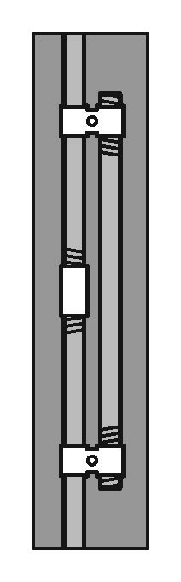
Figure 1: ‘Tension splices’ or ‘through bolts’ may be required to secure scaffolding components together to accommodate any environmental loads.

Dead loads relate to the self-weight of the scaffold structure and components including any working, catch or access platforms, stairways, ladders, screens, sheeting, platform brackets, suspension ropes, secondary ropes, traversing ropes, tie assemblies, scaffolding hoists or electrical cables.
Live loads include:
- the weight of persons
- the weight of materials and debris
- the weight of tools and equipment
- impact forces.

Scaffolds should not be used to support formwork and plant, such as hoist towers and concrete pumping equipment, unless the scaffold is specifically designed for this purpose.
Further information on loads is available in AS/NZS 1576.1 Scaffolding – General Requirements.

Supporting structures
Consider the capability of the supporting structure to bear the most adverse combination of loads possible during the use of the scaffold. Obtain advice from a competent person before erecting scaffolds on verandas, suspended flooring systems, compacted soil, parapets and awnings.

Propping may be required where the supporting structure is not capable of bearing the most adverse combination of loads.

Soleboards and baseplates
Soleboards and baseplates can be used to evenly distribute the load from the scaffold to the supporting surface (see Figure 2). Both soleboards and baseplates may be required for use on less stable surfaces, such as soil, gravel, fill or other product which creates a system of beams and flat slabs.
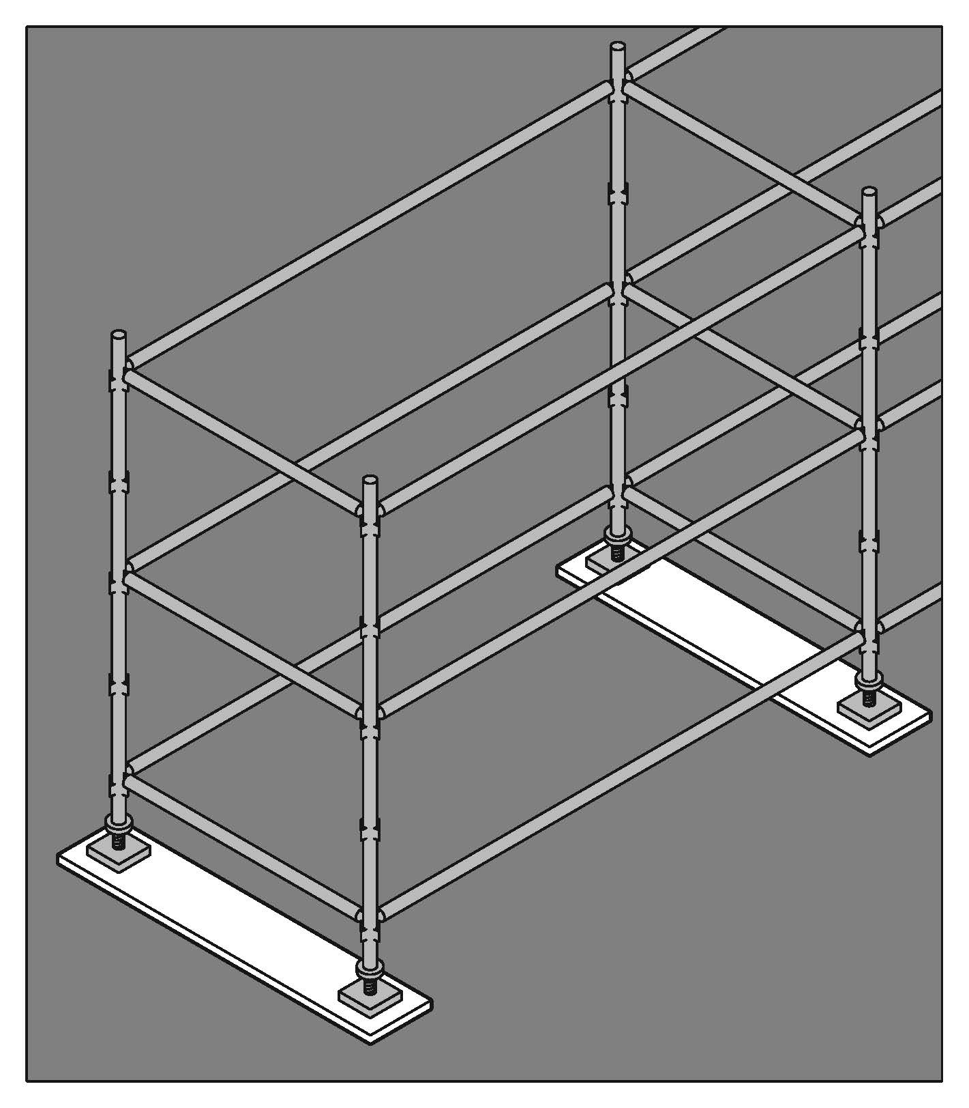
Figure 2: Soleboards and baseplates

The size of the soleboard will vary depending on the supporting surface. Where necessary a competent person should determine the bearing capacity of the ground or other supporting structure.
Soleboards should be level and some digging may be required to obtain a level surface.
Adjustable bases can be used on uneven surfaces for modular scaffold systems. No part of the baseplate or adjustable base should protrude over the side of the soleboard to ensure the loads are imposed evenly on the soleboard.
Needles and spurs should be considered where ground conditions are very unstable.

Stability
Scaffold stability may be achieved by:
- tying the scaffold to a supporting structure
- guying to a supporting structure
- increasing the dead load by securely attaching counterweights near the base
- adding bays to increase the base dimension.

Tying and anchoring
Tie methods and spacing need to be in accordance with the instructions of the manufacturer, designer or supplier.

Control measures for tying scaffold include the following:
- Consult with the scaffold designer, manufacturer, supplier or an engineer if it is not practical to position the ties in accordance with the instructions.
- more ties may be required if:
- the scaffold is sheeted or netted due to increased wind loadings
- it is used as a loading platform for materials or equipment
- attaching lifting appliances or rubbish chutes
- the person conducting business or undertaking should have a competent person regularly inspect the existence and effectiveness of scaffold ties to ensure they are not modified or altered by unauthorised persons (for example, finishing trades who may loosen, relocate or remove ties to obtain access to walls and openings)
- do not attach additional loads on the scaffold - for example, signs and perimeter containment screen – without first consulting with a competent person, who could possibly be the scaffold design engineer or the supplier
- cast-in anchors or ‘through bolts’ (that is, pass through a wall) are preferred to drill-in expansion or chemical anchors for securing scaffold ties because of possible failure due to faulty tensioning or epoxies
- drill-in expansion anchors should be limited to the load (torque) controlled type. The working load limit should be limited to 65% of the ‘first slip load’ stated in the information provided by the supplier
- deformation-controlled anchors, including self-drilling anchors and drop-in (setting) impact anchors, should not be used
- where chemical anchors are used, all anchors should be tested and proof loaded to the working load multiplied by a factor of 1.25
- all drill-in expansion anchors should be installed using a torque wrench set to the appropriate torque, unless the anchor has an in-built torque indicator. Documented verification is to be kept on site, stating the anchor setting torque, date of installation, location of installation and name of competent person installing the anchors
- drill-in expansion or chemical anchors should have a safety factor of 3 to 1 on their failure load. If any anchors fail, the remaining anchors on the same level should be tested
- ties should not obstruct access along the working and access platforms
- ties should interconnect with both the inner and outer scaffold standards (unless otherwise specified by an engineer) to increase the rigidity of the scaffold.

Working platforms
Working platforms, except suspended scaffolds should have duty classifications and dimensions complying with the manufacturers’ information on loadings.

Each scaffold should be designed to carry the required number of working platforms and to support its live loads. Scaffold planks on working platforms should:
- have a slip-resistant surface
- not be cracked or split
- be of uniform thickness
- be captive (that is, cannot be kicked off ) and not be capable of uplift or displacement during normal use
- be positioned so that no single gap between planks exceeds 10 mm
- not be lapped on straight runs of modular and tube and coupler scaffolding but may be lapped on hanging bracket scaffolds where butting of planks at a pair of brackets cannot be achieved.

Lapped scaffold planks may sometimes be used to cover gaps around corners of scaffold bays (see Figure 3). These planks generally may not need to be secured, provided the following are met:
- timber is lapped over metal planks
- planks are 1.2 metres long or greater
- plank overlap, past the edge of the plank underneath, is 300 mm or greater, and
- standards prevent planks from moving sideways on the scaffold.

If using plywood sheets to cover gaps between scaffold bays the plywood sheets should be:
- a minimum of 17 mm thick;
- only used to cover gaps less than 500 mm wide (unless approved by an engineer)
- secured.
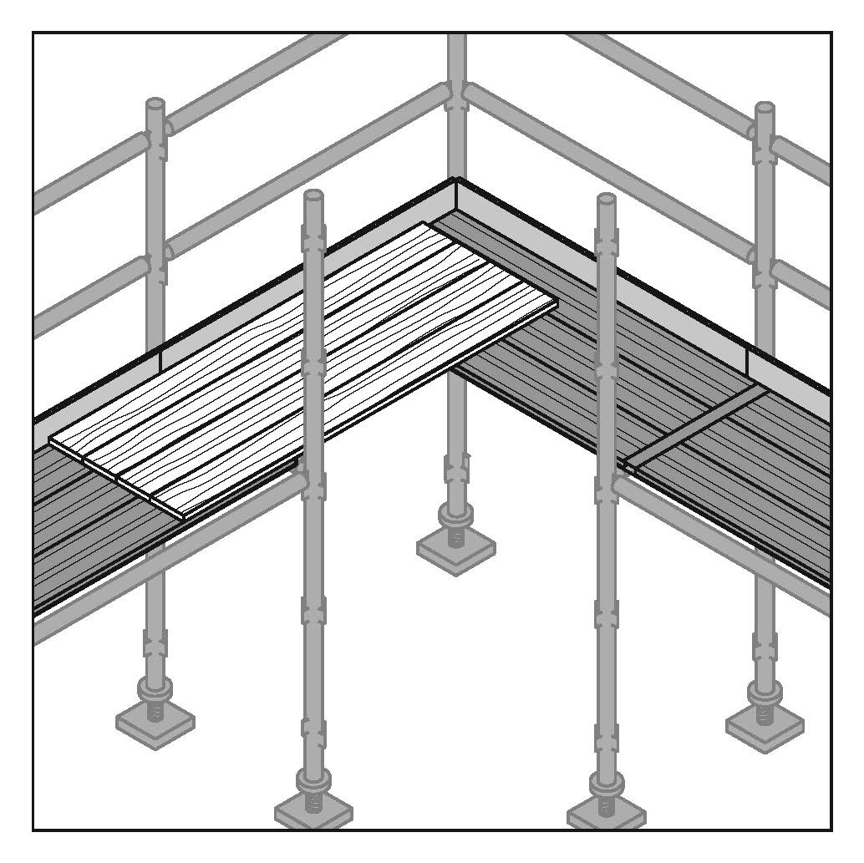
Figure 3: Overlapping planks.

Metal planks lapped on other metal planks should be secured using fixings such as a double tie wire or strapping. Tie wire or any other system that is not structurally rated should not be used to secure planks on hop-up brackets.

More generally:
- planks should be secured
- all hop-up brackets should be provided with tie bars to stop brackets from spreading apart, causing planks to dislodge, unless otherwise specified by the scaffold designer
- the overhang of planks which are supported by putlogs should be greater than 150 mm but less than 250 mm – otherwise uplift might occur
- avoid nailing or screwing laminated planks into position, unless otherwise specified by the manufacturer. Moisture penetrating the planks can cause damage and may not be easily detected.

Scaffold working platforms are generally rated as light, medium or heavy duty:
- Light Duty – up to 225 kg per bay. Examples include painting, electrical work, many carpentry tasks and other light tasks. Platforms should be at least two planks wide (approximately 450 mm)
- Medium Duty – up to 450 kg per bay. This is suitable for general trades work. Platforms should be at least four planks wide (approximately 900 mm)
- Heavy Duty – up to 675 kg per bay. This is what is needed for bricklaying, concreting, demolition work and most other work tasks involving heavy loads or heavy impact forces. Platforms should be at least five planks wide (approximately 1000 mm)
- Special Duty – has a designated allowable load as designed.

Adjacent buildings or structures
No part of the scaffolding activities should adversely affect the structural integrity of any other building. Ensure risks are controlled to prevent injury to persons or damage to adjacent buildings or structures from the:
- collapse of the scaffold onto the adjacent building or structure
- collapse of the adjacent building or structure, or a part of the building or structure.

Unauthorised access
R. 225: The person with management or control of a scaffold at a workplace must ensure that unauthorised access to the scaffold is prevented while the scaffold is incomplete or unattended.
This requirement applies to suspended, cantilevered, spur or hung scaffolds, as well as any scaffold from which a person or thing could fall more than 4 metres.

Access to the scaffold area should be restricted to those carrying out the scaffolding work while the scaffold is being erected, altered, repaired or dismantled. Control measures, such as barriers and warning signs, must be used to prevent unauthorised access when it is left unattended.

Emergency plan
R. 43: A person conducting a business or undertaking must ensure that an emergency plan is prepared for the workplace that provides procedures to respond effectively in an emergency.
To ensure a coordinated approach to responding in an emergency, the scaffold contractor should consult with the principal contractor to ensure any unexpected incidents, such as scaffold collapse or people falling from height, are included in the broader emergency plan for the construction site prepared by the principal contractor.

CONTROLLING THE RISKS IN SCAFFOLDING WORK
The following general requirements apply to scaffolds and section 6 of this code describes more specific inspection requirements.

R. 225: The person with management or control of a scaffold at a workplace must ensure that:
- the scaffold and its supporting structure are inspected by a competent person
- the scaffold is not used unless the person receives written confirmation from a competent person, who has inspected the scaffold, that construction of the scaffold has been completed
- if an inspection indicates that a scaffold or its supporting structure is unsafe that appropriate repairs, alterations and additions are made or carried out and the scaffold and its supporting structure are inspected again by a competent person before use of the scaffold is resumed, and
- unauthorised access to the scaffold is prevented while the scaffold is incomplete or unattended.
These requirements apply to suspended, cantilevered, spur or hung scaffolds, as well as any scaffold from which a person or thing could fall more than 4 metres.

Safe erection of scaffold
The following work method should be followed for erecting scaffold:
- after enough components of the scaffold have been erected to support it, immediately install:
- a platform at least 450 mm wide along the full length of the section of scaffold (see Figure 4)
- edge protection across the space between the uprights forming the outer frame of the scaffold at the level the scaffold has reached (see Figure 5)
- a means of access (for example, temporary stairs or a ladder) to the level the scaffold has reached.
- before the next level of the scaffold is erected, a platform should be installed below the level at a distance of not more than 2 metres (see Figure 6)
- a section of the platform may be left open to allow the passing of planks or other scaffolding components between levels
- a platform does not need to be installed on the bottom level of the scaffold
- a platform may be removed after work has started two levels above the level from which the platform is to be removed.

The following additional safe work practices should be followed when erecting scaffold.
- Scaffold ‘fittings’ and other connections should be securely tightened. Where ‘safety fittings’ are used, they should be fitted in accordance with the scaffolding plan.
- All scaffolding components should be installed as the scaffold is erected. For example, the installation of:
- all bracing and ties
- guy ropes or buttresses.
- Consider using specifically designed loading platforms and/or back propping to prevent overloading the building floor or the scaffold.
- Obtain certification from a competent person before erecting scaffold on awnings.
- Limit the number of workers on a scaffold at any one time.
- Develop a methodical work sequence if more than one worker will be on the scaffold at the one time for example, allocate specific tasks to each scaffolder.
- Work from a full deck of planks whenever possible.
- Do not climb on guardrails to gain extra height.
- Implement measures to control the risk of a fall if the internal gap (the gap between the inner edge of the length of the platform and the face of the building or structure immediately beside the platform) on scaffolds (includes hanging bracket scaffolds) is greater than 225 mm. For example, install:
- edge protection
- additional scaffold planks to minimise the size of the internal gap.

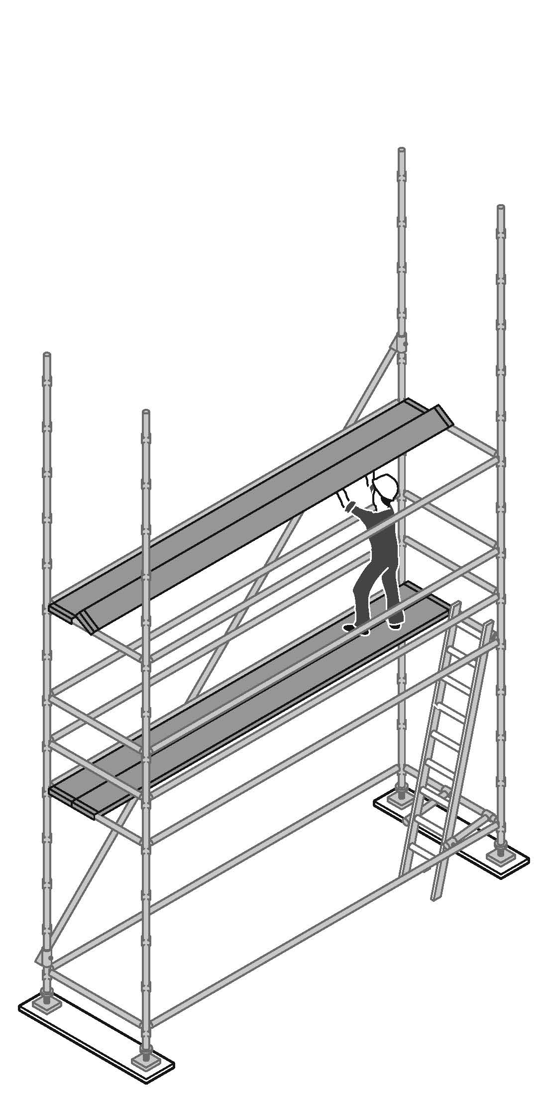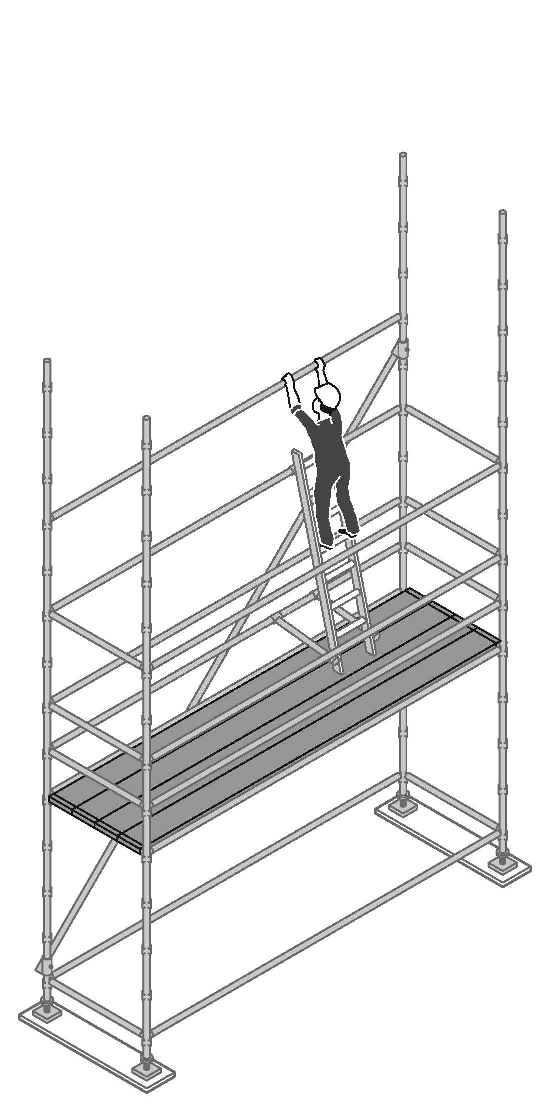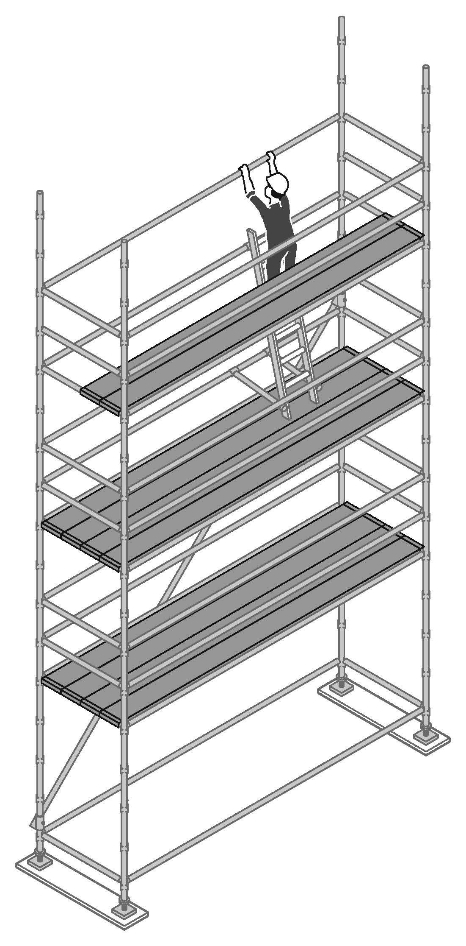
Figure 4. Work from a platform at least 450 mm wide to install planks overhead. Platform does not need to be installed on the bottom level of the scaffold. | Figure 5. Immediately install edge protection after enough scaffolding components have been erected. A section of the platform may be left open to allow scaffolding components to be passed between lifts. | Figure 6. Worker on two planks should have a fully decked platform positioned beneath them at a distance of no more than 2 metres.

Safe dismantling of scaffold
- Edge protection and any means of access can be removed as the scaffold is dismantled, provided it is removed at the last possible stage.
- A platform of at least 450 mm wide, at the level the dismantling has reached, is in place, where practicable.
- Ensure that when dismantling scaffold, the platform immediately below the level the worker is standing on, has a full set of planks across its width and is no lower than 2 meters.
- A section of the scaffold may be left open (for example no platform in place) to allow the lowering of planks or other scaffolding components between levels.

Scaffolding components should never be dropped in an uncontrolled manner when dismantling scaffold.

Scaffold alteration
Control measures to eliminate or minimise health and safety risks include:
- consulting the scaffold designer before making any alterations
- scaffold alterations are in accordance with the scaffolding plan
- alterations do not compromise the structural integrity of the scaffold
- systems are in place (for example, regular inspections) to identify unauthorised interference with the scaffold.

Falling objects and falls
R. 54: A person conducting a business or undertaking at a workplace must manage risks to health and safety associated with an object falling on a person if the falling object is reasonably likely to injure the person.

Control measures to eliminate or minimise the risk of a falling object can include catch platforms, perimeter screening and exclusions zones.

R. 78: A person conducting a business or undertaking must manage the risk of a fall from one level to another that is reasonably likely to cause injury to the person or another person.

Hazards which may increase the risk from a fall while erecting, altering or dismantling scaffold include:
- poor environmental conditions, for example:
  - strong winds that may cause workers to lose balance
  - rain causing a slippery work surfaces
  - glare emitted from work surfaces and/or poor lighting affecting visibility
- materials, equipment or protruding objects below, or in adjoining work area, for example:
  - pallets of construction materials
  - vertical reinforcing steel
  - a rubbish skip
  - exposed starter bars, and
  - picket fences
- void areas not identified or protected, for example, ladder access voids
- incomplete scaffolds or loose scaffolding components where work is being done, or is likely to be done, and
- inadequate training, instruction and supervision of scaffold workers.

Fall arrest platforms
A fall arresting platform can be used as a risk control measure to arrest a person’s fall during work at height.

If the slope of the surface where work is being done is:
- not over 26º – then install the platform no more than 1 metre lower than the surface (see Figure 7a), or
- over 26º – then install the platform no more than 300 mm lower than the surface (see Figure 7b).
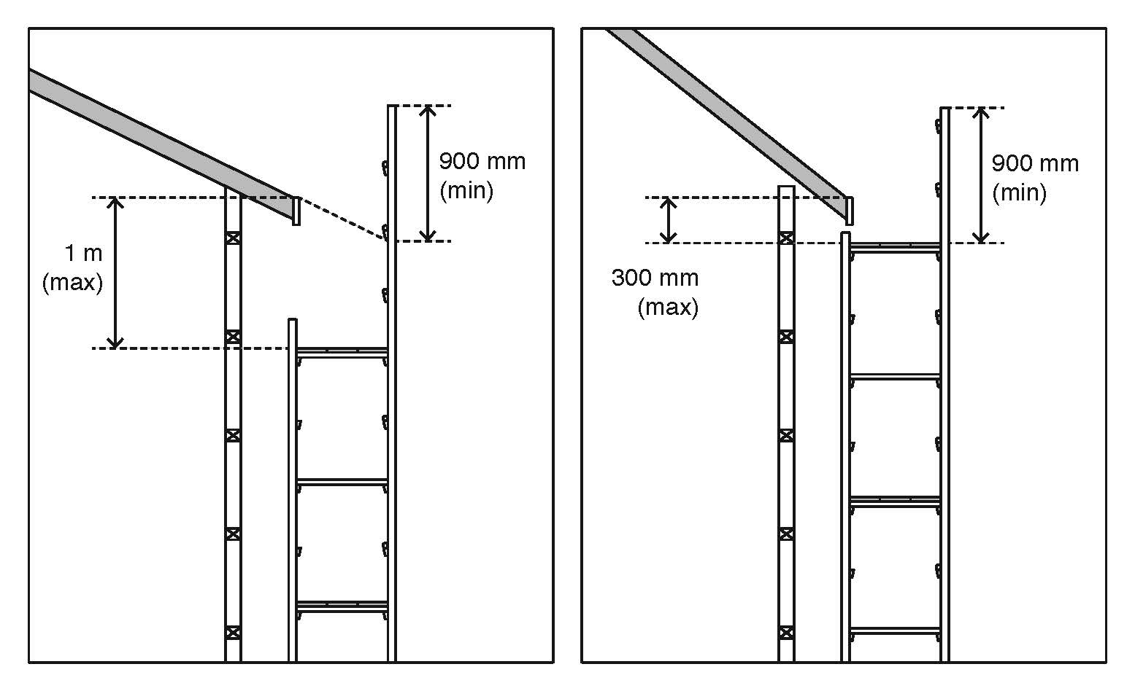
Figure 7a: Fall arrest platform ≤ 26° | Figure 7b: Fall arresting platform > 26°

The fall arresting platform should:
- be unobstructed and at least 675 mm wide for the length of the platform
- be able to withstand the impact of a fall onto it, and
- have edge protection erected:
  - along the outer edge of the length of the platform, and
  - along the edges of each end of the fall arresting platform.

If the internal gap (the gap between the inner edge of the length of the platform and the face of the building or structure immediately beside the platform) exceeds 225 mm, then implement a control measure to control the risk of a fall.

Edge protection
Edge protection may be used as a risk control measure to prevent the risk of death or injury from a fall during work at height.

Obtain written approval from a competent person before installing edge protection on a scaffold system which was not originally designed, supplied or manufactured with edge protection. Approval should include specifications on how to install and maintain edge protection.

A person conducting a business or undertaking must, so far as is reasonably practicable, identify all fall hazards associated with the installation and dismantling processes of edge protection and implement control measures. Controls for falling objects such as toeboards should also be considered when installing edge protection.

Access and egress
Workers must be provided with safe access to and egress from scaffold during the erection, use and dismantling of scaffold. Common means of access and egress include:
- temporary stairs or portable ladder access systems installed at the start of erection, progressed with the scaffold, and used by the scaffolder whenever possible
- permanently installed platforms or ramps
- personnel hoists (non-mechanical forms of egress, such as a ladder or stair tower should be provided in case of emergency), and
- using the existing floor level of a building, provided such access is safe.

Scaffolders should not climb standards externally.

Stairs should be secured to the scaffold bay. If not secured, the supplier should provide documentation illustrating the maximum amount of clearance allowed between the transom and the top and bottom of the stair module. Ensure the gap between the end of a stair module and a transom is as small as practicable. Large gaps can lead to stairs dislodging and falling when a load is placed onto it.

Ladders
Extension or single ladders should only be used as a means of access to or egress from a work area, not as a working platform. The following are additional safe work practices which should be followed when working on ladders:
- Ladders may be used where access to the working platform is needed by only a few persons, and where tools and equipment can be delivered separately to the working platform (for example, by materials hoist, crane or a rope and gin wheel).
- Ladders should be within a separate ladder access bay of the scaffold, wherever space permits.
- If the access bay is part of the working platform, a trap door is to be provided. Strict controls should be implemented to ensure the trap door remains closed while working from the platform.
- Ladders should be set up on a firm, level surface and not used on scaffold bays to gain extra height.

More detailed guidance on ladders is included in the Code of Practice: Managing the risk of falls at workplaces.

Perimeter containment screening
Perimeter containment screening may be used to protect persons from falling objects. Perimeter containment screens can be made of mesh, a good quality shade cloth, timber, plywood, metal sheeting or other material suitable for the purpose.

Perimeter containment screens should be located inside the standards on working platforms. Where used, the lining should be attached to the inside of the mesh. The lining can be attached using non-structural locating product which keeps the lining in place while minimising damage to the lining. However, the additional wind loading represented by the use of linings must be considered in the selection of an appropriate lining material.

The framework supporting a screen will need to be able to bear the load of the screen.

Fall-arrest systems
Fall-arrest systems can be used as a risk control measure to arrest a person’s fall when working on a scaffold. However, fall-arrest systems are not usually appropriate for erecting a scaffold because:
- workers are likely to hit a component of the scaffold before the fall is arrested;
- obtaining suitable anchorage points that can support a load of 15kN may be difficult;
- continuously hooking on and off the scaffold may be inconvenient; and
- fall arrest lines may become trip hazards.

Fall-arrest systems should only be used during the following scaffold activities.
- erecting or dismantling ‘drop’ or ‘hung’ scaffold where the scaffold is constructed from top to bottom, this allows for a clear fall zone, in the event of a fall;
- the fixing and removal of trolley tracks on suspension rigs;
- erecting or dismantling cantilevered needles and decking between the needles. Fall arrest systems could also be used during the erection of the first lift of scaffold where workers are standing on the deck between the needles;
- the erection and dismantling of cantilevered scaffolds prior to or when removing the initial platform; and
- the attachment and removal of spurs projecting from the supporting structure.

For further information on fall arrest systems refer to Chapter 6 of the Code of Practice: Managing the Risk of Falls at Workplaces.

Electricity
Any construction work that is carried out on or near energised electrical installations or services is high risk construction work and a SWMS must be prepared before this work commences. Contact with overhead electric lines has the potential to cause serious life threatening injuries or death.

Electrical power sources, whether overhead or underground can be a major hazard. In addition to direct electric shock and possible electrocution, contact with overhead electric lines can lead to a variety of hazards including arcing, explosion or fire causing burns, unpredictable cable whiplash and the electrifying of other objects (for example, signs, poles, trees or branches).
Specific control measures must be implemented when work is done in the vicinity of electric lines. The local electricity supply authority should be consulted and appropriate risk controls implemented.

More detailed guidance on managing risks associated with electricity is available in the:
- Code of Practice: Managing Electrical Risks at the Workplace
- Code of Practice: Working in the Vicinity of Overhead and Underground Electric Services.

Powered mobile plant and traffic
Mobile plant and vehicular traffic are hazards which can potentially affect worker safety and the safe use and structural integrity of a scaffold.
Control measures that can be used to prevent or minimise exposure to the risk of death or injury from moving plant and traffic include:
- Re-route motor vehicles and mobile plant away from the location of the scaffold, for example, by using traffic controllers to redirect traffic.
- Use barricades, signs, posts, buffer rails, guards, or concrete or timber kerbs to prevent mobile plant and traffic from coming into contact with a scaffold.
- Ensure the scaffold does not have any unnecessary protrusions, such as over-length transoms, putlogs, tie tubes or over-height standards.

Mixing components from different scaffold systems
Components from different manufacturers or suppliers, while looking compatible, are often of different dimensions and tolerances (see Figure 8).
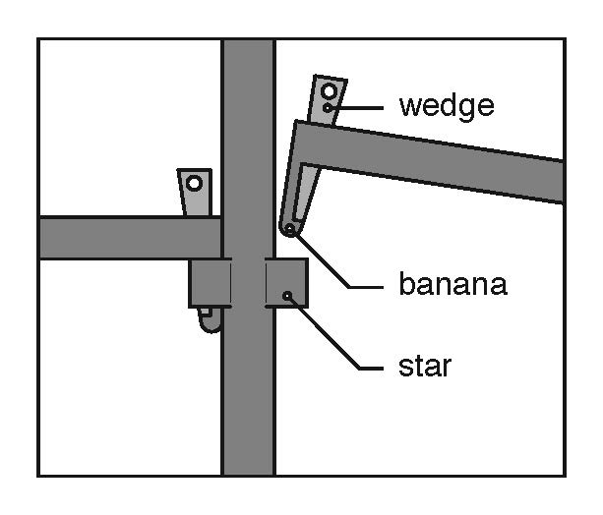
Figure 8: Mixing components. Do not mix different modular systems. Often connection points known as the ‘star’ and ‘banana’ used on these systems are of a different shape and tolerance and are not compatible.

Mixing incompatible scaffolding components can significantly affect the structural integrity of the scaffold and could lead to the possible collapse of the scaffold. Mixing incompatible components can also lead to increased wear on the components and difficulties in disassembly, which in turn may increase the risk of musculoskeletal injury to workers.

The following controls can be used to prevent or minimise the risk of injury and scaffold collapse due to the incorrect mixing of components:
- Do not mix scaffolding components from different manufacturers, unless a competent person approves that the:
- components are of compatible size and strength
- components have compatible deflection characteristics
- fixing devices are compatible
- mixing does not lessen the strength, stability, rigidity or suitability of the scaffold.
- Do not mix scaffolding couplers and tubing of different outer diameters and strengths unless designed specifically for the task by a competent person or the coupler manufacturer has designed the couplers for this purpose. For example, do not mix aluminium and steel components as steel clamps may cause aluminium tubing to be crushed reducing the strength of the tube.
- ‘Beam clamps’ or ‘flange clamps’ should be provided with information about safe use, including tightening torque required and when to use different types of couplers. If no information is provided contact the supplier, manufacturer or designer of the scaffold.

For further information refer to AS/NZS 4576 – Guidelines for Scaffolding and AS/NZS 1576.1:2010 – Scaffolding – General requirements which sets out the assurances that are needed before the components of different prefabricated scaffolding systems can be mixed in a scaffold.

TYPES OF SCAFFOLD AND RISK CONTROLS
The design, shape and location of the building or other structure should be considered when selecting the type of scaffold to be used. Choose a scaffold system that is most adaptable to the contour of the building or other structure, particularly if a modular scaffold is being considered. Also consider the purpose for which the scaffold is to be used, for example, bricklaying, plastering or demolition.

Scaffolds should be erected in accordance with the designer’s instructions and the scaffolding plan.

Birdcage scaffold
A birdcage scaffold is an independent scaffold that consists of more than two rows of standards in both directions and is connected by ledgers and transoms. It is mainly used for work that is to be carried out on a single level, such as ceilings.

Refer to the designer’s specifications when erecting and dismantling birdcage scaffolds made from modular scaffolding.

The following risk control measures should be implemented for birdcage scaffolds made from tube and coupler scaffolding:
- provide untied birdcage scaffolds with lengthwise bracing at each outer longitudinal row of standards.
- only use birdcage scaffold to support formwork that has been specifically designed for this purpose.
- provide longitudinal bracing or a tied face at every third longitudinal row of standards.
- brace the outside row of standards on each face and each third row internally with longitudinal bracing.
- provide transverse bracing at every fourth bay on the ends of the scaffold.
- consider using scissor lifts to assist with erecting or dismantling birdcage scaffolds.

A fall arrest system is generally not an appropriate risk control measure for the erection or dismantling of perimeter and birdcage scaffolds (see Section 4.4 for further information on fall arrest systems).

Tower scaffold
A tower scaffold is an independent scaffold consisting of four vertical members connected longitudinally and transversely.

The following control measures should be implemented for tower scaffolds:
- construct the tower with modular, frame, or tube and coupler scaffolding
- ensure the tower is resting on firm level ground with the wheels or feet properly supported. Do not use bricks or building blocks to take the weight of any part of the tower
- ensure the height of a tower scaffold, from the bottom of the scaffold to the working surface, is no greater than the multiple of the minimum base dimension as specified in the manufacturer, supplier or designer information.
- use alternative height to base ratios or extra support if the scaffold is:
- sheeted or likely to be exposed to strong winds
- loaded with heavy equipment or materials
- used to hoist heavy materials or support rubbish chutes;
- used for operations involving heavy or awkward equipment (for example, grit blasting or water-jetting)
- supporting a ladder.

Mobile scaffold
A mobile scaffold is a tower scaffold that is mounted on castors (see Figure 9).

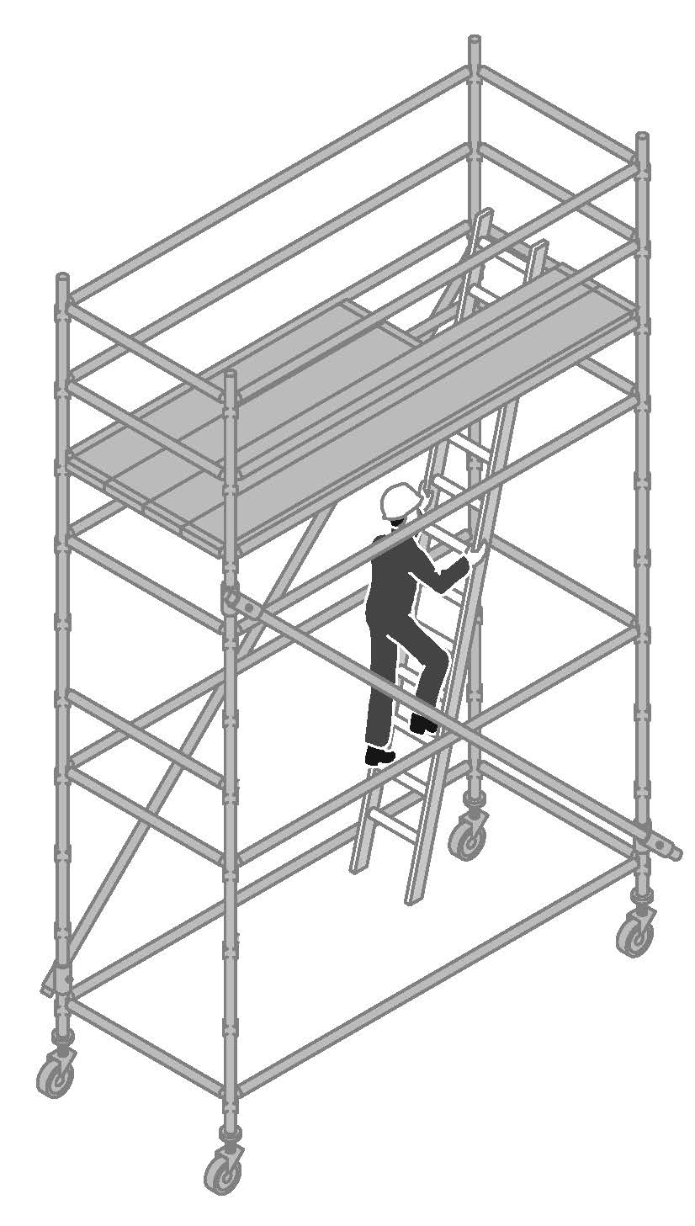
Figure 9: Mobile scaffold

Manufacturers and suppliers must provide information regarding the safe use and erection of mobile scaffolds. If a scaffold is to be altered, contact the manufacturer or supplier for additional guidance. All modular mobile scaffolds are to be erected in accordance with manufacturer’s specifications.

The following control measures should be implemented for mobile scaffolds:
- The height of a mobile scaffold, from the bottom of the scaffold to the working surface, should be no greater the multiple of the minimum base dimension as specified in the manufacturer, supplier or designer information.
- Where adjustable castors are used, the slope of the surface should not exceed 5 degrees.
- Use a secure internal ladder with a protected opening (for example, a hinged trap door) for access and egress to and from the scaffold.
- Select the appropriate size and capacity castors to support the total mass of the dead and live loads of the scaffold
- Use castors that have the working load limit clearly marked.
- Castors fitted to standards should be locked before erection continues.
- Castors with adjustable legs should be used and adjusted to keep the platform level when the supporting structure is at different heights.
- Incorporate plan bracing at the base of mobile scaffolds to provide greater stability.
- Before moving mobile scaffolds check that:
- there are no power lines or other overhead obstructions;
- the ground is firm and level;
- no person is on the scaffold;
- no equipment and material can be dislodged from the platform;
- the supporting surface is free of obstructions (a small obstruction may cause a mobile scaffold to overturn)
- electrical equipment and leads cannot be tangled.
- Brakes on castors are to be locked at all times unless moving the scaffold.
- Never move the scaffold in windy conditions.
- Push or pull the mobile scaffold from the base – never use powered vehicles to move the scaffold.
- If lifting a mobile scaffold by crane, sling the scaffold at its lowest point to prevent dislodgment of scaffolding components. However, a crane should not be used to lift aluminium mobile scaffolds because the scaffolding components may fail.
- Ensure guardrails, midrails and toeboards are installed on all working platforms.

Tube and coupler scaffold
Tube and coupler scaffolds are so-named because they are built from tubing connected by coupling devices. Due to their strength, they are frequently used where heavy loads need to be carried, or on structures with unusual design, shape and locations. The versatility of tube and coupler scaffolds enables them to be assembled in multiple directions in a variety of settings.
When using tube and coupler scaffolding consideration should be given to the diameters and strength of the tube and components being used to form the scaffold. Steel tubes and aluminium tubes should not be mixed in the one scaffold, except for guardrails, mid-rail or other members that are not structural members.
For a scaffold incorporating plain steel tube, the analysis and design should consider the most
adverse combination of tubes by wall thickness, strength of the tube material, or both.

Except where used as standards, tubes of different wall thicknesses must not be
interconnected by spigots or internal-type end-to-end couplers, unless additional measures are
taken to positively secure the joint, such as by fixing a short tube with swivel couplers over
and parallel to the joint (scarfing), or by fixing a bridle with right-angle couplers to the
adjacent members.

Metal tube and coupler components should be regularly inspected for damage and particular attention given to crushing, deformation, cracks, corrosion and splitting.
Further information on technical standards for tube and coupler scaffolding can be found in Appendix C.

Frame scaffold
Frame scaffold is a scaffold assembled from prefabricated frames, braces and accessories. Frame scaffolds such as ‘A’ and ‘H’ frame trestle scaffolds are commonly used by bricklayers, plasterers and painters, and for general fit-out and finishing work.

Frame scaffold should be erected and dismantled by a competent person in a progressive manner to ensure both the installers safety and the stability of the overall structure and braces should be attached to the frames in accordance with the manufacturer’s or supplier’s instructions. As the height of frames increase, there is a greater need to provide lateral stability to the frames.

Frame scaffold should be stable and erected on a suitable foundation to ensure it can adequately carry and distribute the loads such as materials and workers evenly to each frame. Measures to control instability and prevent possible toppling can include the use of ties to a permanent structure or using outriggers.

Frame scaffold should:
- install barriers (or edge protection) where the potential fall exceeds 2 m or the fall area contains hazards such as sharp objects – e.g. steel reinforcing bars
- support the relevant live load or duty rating – not exceeding load limit. Note: the full width of a frame trestle must be fully planked, irrespective of the duty rating
- have scaffold planks that are uniform and in good condition (no splits, cracks, knots, bends, etc), overhang their end supports between 150–250 mm and are secured against uplift
- establish a horizontal work platform. On sloping or uneven ground use a frame trestle that incorporates height adjustment. Do not use bricks or blocks as soleplates
- have a safe means of access and egress – e.g. by secured ladders or from the building if approximately level with the platform.
- have a safe means to load material onto the working platform – e.g. use mechanical means or, if this is not practicable, pass (do not throw) material up to the working platform
- control the movements of multiple persons – e.g. do not walk around others on 2-plank platforms.

Most bracing systems for tubular frame scaffolds are manufactured from light materials and are easily damaged by misuse or abuse so care should be taken during installation and dismantling. Under no circumstances should anyone climb the braces or frames.

The erection of this type of scaffold should be informed by relevant technical standards and further information can be found at Appendix C.

Hung scaffold
A hung scaffold is an independent scaffold that hangs from another structure, but is not capable of being raised or lowered when in use.

The following control measures should be implemented for a hung scaffold:
- the hung scaffold should be designed by a competent person and verification obtained that the structure that is to support the hung scaffold is capable of bearing the load
- the scaffolding plan should include information about the position of the check couplers
- if a cantilevered suspension rig is to be used, information should be included on how the rig is to be constructed and secured
- standards on a hung scaffold should be tension spliced
- all vertical hanging tubes are to be provided with check couplers at the suspension points and underneath the platform.

Single pole scaffold
A single pole scaffold consists of a single row of standards connected by ledgers. Putlogs are fixed to the ledgers and built into the wall of the building or structure.
A single pole scaffold is dependent upon the structure against which it is placed for support. It is important that no components of this type of scaffold are removed until the scaffold is being dismantled.

Suspended (swing-stage) scaffold
A suspended scaffold incorporates a suspended platform that is capable of being raised or lowered when in use. An example of a suspended scaffold is a swing-stage scaffold.
The following risk control measures should be implemented for a suspended scaffold:
- ensure safe access to and egress from the cradle
- consult and instruct workers on the correct procedures for using and working on suspended scaffolds. Include instructions on all safety features including emergency stop, load limiting device, and rope lock device, as well as raising and lowering operations, particularly in the event of an emergency (for example, power failure)
- ensure a rescue and retrieval procedure is developed before starting work
- suspended scaffolding components should be inspected for damage, wear and cracks before use and at pre-determined intervals. Non-destructive testing for cracks in high stress areas (for example, dye penetrant testing) may be needed to identify cracks not easily visible.
Further information regarding the safe use of swing-stage scaffolds is in Appendix D. In addition, any relevant component manufacturers’ requirements and engineer requirements for each installation should also be followed.

Design issues
Component control measures for each component of a suspended scaffold include the following:
- suspended scaffolds should be designed by a competent person, and
- the suspension system and the cradle should be designed to withstand 1.25 times the stalling load applied by all scaffold hoists in use. This feature prevents failure in the event of the cradle snagging on an obstruction. A twin rope hoist motor should be used.

Method of fixing needles
The method of fixing the suspension needles is to be clearly shown on a detailed drawing that has been certified by a competent person. The following options apply for fixing the inboard length of the needles to the structure:
- where the needle is fixed to the floor the fixing is to be positively restrained – chemical and friction type anchors are not to be used (for example, a u-bolt fitted over the needle and through the concrete floor slab could be used)
- scaffold couplers should not be used to secure the counterweight or other anchorage to the rear of the needle (see Figure 10). A positive connection, which does not rely on friction, is to be used. One example is a bolted or pinned connection where the bolt or pin passes through the structural members and is prevented from accidental removal with a nut or other locking system (for example, split pin or ‘R’ clip)
- if the needle is attached to an anchorage point or existing structure on the building, the anchorage system and method of attaching the needle are to be competent person certified. Restrain the back of the needle to an competent person certified anchorage point
- where props are used these are to be installed to the top of the needle and to the underside of the floor above. Ensure the props are fixed to prevent dislodgement. The floors should be certified by a competent person to be able to safely withstand the point loading applied by the props
- where counterweights are used, these are to be adequately secured by keyed lock, and preferably on top of the needle.

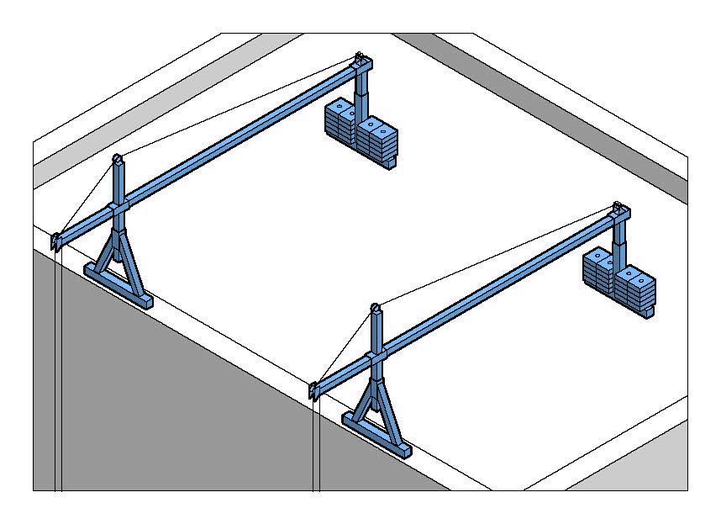 | Figure 10: Suspended (swing-stage) scaffold –Suspension mounting.
Suspension systems
- Ensure the suspension system is designed and constructed in accordance with the designer’s specifications.
- Inspect the suspension system before use and after relocation to ensure all components are secure and in working order.
- Ensure persons who use suspended scaffolds are competent and receive training and instruction on the safe use of the system, including information on hoist operation and emergency procedures.
- Obtain competent person certification that the suspension needles, parapets, roof structure or other parts of the structure can support the ‘parapet clamps’ or outriggers. An example of an unsuitable support system would be timber or single skin brick parapets.
- Access to the suspension system should be restricted to persons involved in the work. Access can be restricted by:
- erecting signs and barricading (for example, warning tape, barrier mesh/parawebbing, or temporary fencing) around the suspension rig,
- the use of permit-to-work systems in the restricted area, or
- locking off access doors and hatches to the roof, balcony or other area where the suspension system is located.
The person with management or control of the suspension system area should check the restriction is in place.
- Ensure counterweights are secured to prevent unauthorised removal.
- Suspension ropes should be inspected for damage such as kinks, wear, corroded or broken wires, and replaced if necessary.

Further information on suspension ropes is available in AS 2759 – Steel wire rope–Use, operation and maintenance.

Scaffold hoists
- Ensure scaffold hoists comply with the manufacturer’s specifications. Only suspension ropes noted in the specifications (compliance plate attached to the hoist) should be used.
- After each use, ensure a trained person inspects and checks scaffold hoists, in accordance with the manufacturer’s instructions.
- Electric scaffold hoists should have a device to limit the lifting capacity of the hoist to a maximum of 1.25 times the rating of the hoist. The scaffold hoist limiting devices should be tested to the manufacturer’s instructions prior to use.

Further information on scaffold hoists is available in AS 1418.2 – Scaffolding hoists and AS 1576.4 Suspended scaffolding.

Cradles
- Cradles are to be constructed in accordance with the manufacturer’s specifications.
- Inspect all connection fixings before use to check they are secure (see Figure 11).
- Evenly distribute materials in the cradle.
- Cradles should be clearly marked with the working load limit (WLL). The length and type of material used to construct the cradle will influence the WLL of the cradle. Verify the WLL with the manufacturer or supplier where there are no clear markings on the cradle.
- If the cradle varies from the original manufacturer’s specifications, a suitably qualified and experienced engineer should verify the modification before use.
- Restrict the lateral movement of the cradle such as with the use of suction caps or tying off the cradle with rope.
- Work should cease and the cradle lowered to the ground during windy conditions.

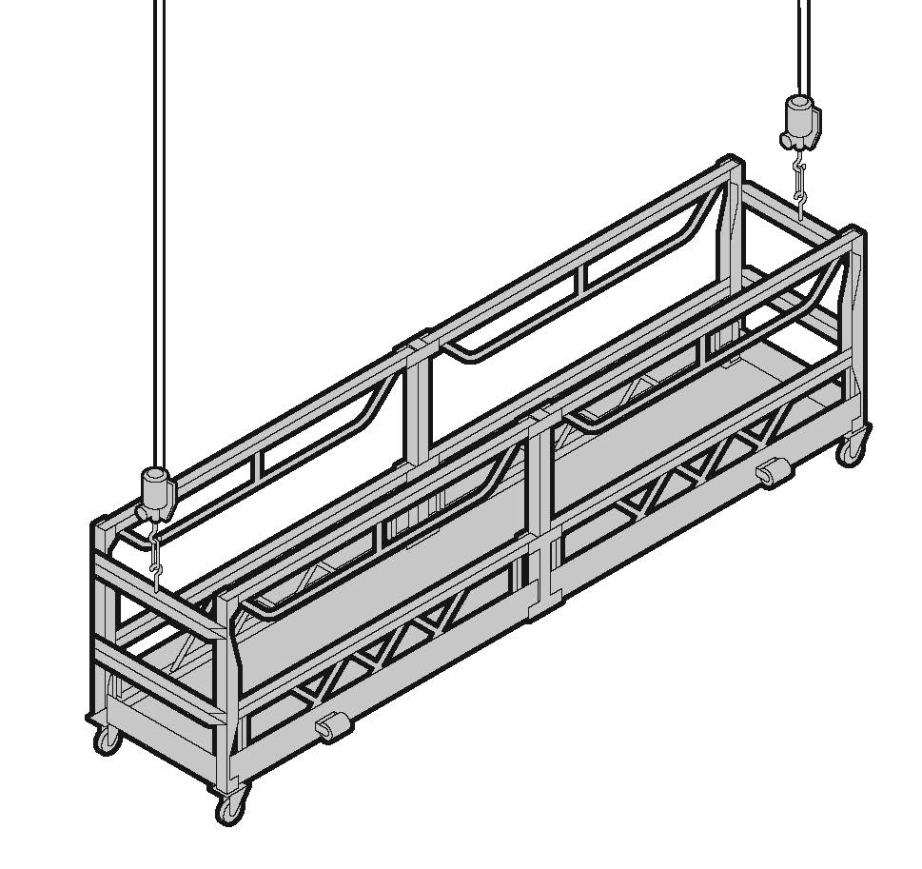 | Figure 11: Suspended (swing-stage) scaffold – Cradle (suspended) end
Trolleys
To prevent a trolley from falling off the beam, use lower keeper plates or a strap that wraps around the top of the beam. Trolleys that are not fitted with such a system should be removed from service. Obtain guidance from manufacturers and designers on effective systems to use.

Fall arrest and travel restraint harness systems:
- Persons located in swing-stage cradles should wear fall arrest harnesses attached to a properly designed anchorage system. However, the harnesses may be used in a travel restraint application, attached to a static line in the cradle, where a fall out of the cradle is not possible. A thorough assessment should be undertaken to ensure appropriate control measures are in place to address any secondary risks that might arise.
- Where the guardrail or other edge protection is not provided for scaffolders erecting the suspension system, fall arrest systems are to be used. This includes, erecting or dismantling swing-stage scaffolding components, or when doing preparatory or quoting activities where other positive fall prevention (such as staying on the safe side of a 900mm parapet) is not used.
- If independently anchored safety lines are used, then a high level of training and rescue procedures should be in place.
- Wherever fall arrest systems are used, a rescue procedure must be developed and documented. The rescue procedure should not place others at risk of injury.

Further information on fall arrest systems is available in the Code of Practice: Managing the risk of falls at workplaces.

Special scaffolds
Cantilever scaffold
A cantilever scaffold is a scaffold that is supported by cantilevered load-bearing members.

The following risk control measures should be implemented for a cantilevered scaffold:
- design and position cantilever beams in accordance with the engineer’s requirements and the scaffolding plan
- ensure a competent person certifies that the supporting structure can support the cantilevered scaffold
- use the following preferred methods for fixing the inboard length of the cantilevered beam to the structure:
- fix the beam to the floor below using a positive fixing (for example, a u-bolt fitted over the beam and through the concrete floor slab)
- use counterweights on the beam, or
- install props to the top of the beam and to the underside of the floor above. Ensure the props are fixed to prevent dislodgement.
Hanging bracket scaffold
Hanging bracket scaffolds are systems supported by frames on buildings or other structures. Hanging brackets are sometimes in the shape of an upside down ‘L’, one arm of which is fixed to a vertical surface, the other projecting horizontally to support scaffold planks.

Other hanging bracket scaffold systems may include horizontal members that are supported by floors of buildings or other structures.

The following risk control measures should be implemented for hanging bracket scaffolds:
- provide a safe means of access for persons installing hanging brackets
- use connectors where differential deflection becomes a tripping hazard
- use an engineer to design hanging bracket scaffolds and their means of support. Engineering verification may be provided by calculation and/or load testing.
- supporting structure should be able to support dead and live loads applied by the hanging brackets
- where hanging bracket scaffold is to be used as a fall arresting platform (refer to previous information in this chapter and relevant technical standards listed in
Appendix C) ensure that spacing of brackets does not exceed the maximum plank spans specified by the manufacturer
- planks may overlap planks on straight runs on hanging bracket scaffolds (where butting of planks at a pair of brackets cannot be achieved), provided the overlap is at least 300 mm.
Note: This does not refer to overlap of planks on putlogs. For further information on minimum and maximum overlapping for planks on putlogs, refer AS 1576 Scaffolding – General requirements.
Spur scaffold
A spur scaffold is a scaffold that is supported by inclined load-bearing members.
The following control measures should be implemented for a spur scaffold:
- fix propping systems between the floor and ceiling at intervals to suit the spacing of the standards within the scaffold
- provide suitable headstocks at the top of each propping system to distribute the loads imposed
- ensure all propping systems are securely tied together and braced
- brace spurs exceeding 1.8 metres in length in both directions at the centre, unless designed otherwise.

Scaffold for demolition work
At a minimum, heavy or special duty scaffold should be used during demolition work to contain dislodged materials or to provide a safe working platform and edge protection for workers.

Factors which affect the stability of scaffold for demolition work include:
- the load imposed by demolished material dislodged onto the scaffold
- wind forces acting on containment sheeting on the scaffold face
- water retention in containment sheeting by capillary attraction
- progressive removal of building elements affecting the lateral stability of the upper portion of the scaffold
- progressive removal of ties and dismantling of scaffold.

The following risk control measures should be implemented for scaffold for demolition work:
- the vertical spacing of scaffold ties may have to be reduced to facilitate the demolition cycle
- containment sheeting on the internal face of the scaffold should be installed to deflect any material into the building. This reduces the potential for overloading the scaffold
- ensure the scaffold is dismantled progressively and in line with the demolition work
- scaffold planks should be secured to prevent dislodgement from falling debris.

For further information on demolition work, refer to the Code of Practice: Demolition Work.

INSPECTION AND MAINTENANCE

Hand over inspections
The following requirements apply to suspended, cantilevered, spur or hung scaffolds, as well as any scaffold from which a person or thing could fall more than 4 metres:
R. 225: The person with management or control of a scaffold at a workplace must ensure that the scaffold is not used unless the person receives written confirmation from a competent person, who has inspected the scaffold, that construction of the scaffold has been completed.

Procedures must be developed for the inspection and maintenance of the scaffold and scaffolding components to ensure that the scaffold is safe to use and remains in a safe condition. The inspection of scaffolds and scaffolding components at a workplace is particularly important when the scaffold is in place for a prolonged period of time. An example scaffold inspection checklist is included at Appendix E.
The person responsible for the erection of the scaffold from which a person or object could fall more than four metres must provide the principal contractor or the person conducting a business or undertaking with a handover certificate which should be kept at the workplace until the scaffold has been dismantled (see Appendix F).

Frequency of inspection
R. 225: The person with management or control of a scaffold at a workplace must ensure that the scaffold and its supporting structure are inspected by a competent person:
- before use of the scaffold is resumed after an incident occurs that may reasonably be expected to affect the stability of the scaffold (for example, strong winds or storms)
- before use of the scaffold is resumed after repairs; and
- at least every 30 days.

The frequency of inspections may vary depending on weather and workplace conditions, the type and size of the scaffold and the risks associated with scaffold collapse.
The supplier of the scaffold should also be consulted on the appropriate intervals for inspection when the scaffold is first installed.
Inspection records should be kept on site and include the location, comments, date and time of inspections, relevant design or specification reference and the person who conducted the inspection. Further information on scaffold inspection requirements refer to AS/NZS 4576 Guidelines for scaffolding.

Scaffolds and scaffolding components
R. 225: If an inspection indicates that a scaffold at a workplace or its supporting structure creates a risk to health or safety, the person with management or control of the scaffold must ensure that:
- any necessary repairs, alterations and additions are made or carried out; and
- the scaffold and its supporting structure are inspected again by a competent person before use of the scaffold is resumed.
Suppliers and owners of plant must ensure that the plant is without risk to health and safety when properly used. Procedures for the regular inspection of new and re-used scaffolding components should be developed and implemented to ensure scaffold defects are detected and any affected components are identified, repaired or disposed of and replaced as appropriate.
The scaffold must also be structurally sound and safe to use. Where issues are identified and repairs, alterations and/or additions are made, the scaffold must be reinspected and confirmed as safe to use.

APPENDIX A – DEFINITIONS
Access platform | A platform that is only used or intended to be used to provide access for persons, or for persons and materials to or from places of work
Anchors in relation to scaffolds | Need to consult technical experts for definition
Baseplate | a plate to distribute the load from a load-bearing member to the supporting structure.
Bay | The space enclosed by four adjacent standards, or the equivalent space in a single pole scaffold
Brace | A member, usually a diagonal, which resists lateral loads and/or movements of a structure.
Castor | A swivelling wheel attached to the lower end of a standard for the purpose of supporting and moving a scaffold
Catch platform | A temporary platform attached to a scaffold to contain debris falling from a work platform.
Chute | An inclined or vertical trough or tube through which articles are passed from a higher to a lower level.
Competent person | A person who has acquired through training, qualification or experience the knowledge and skills to carry out the task.
Counterweight | A weight or series of weights that counterbalance a scaffold from overturning.
Cradle | The portion of a suspended scaffold that incorporates a suspended platform.
Dead Load | A permanent inert load on a building or other structure due to the weight of its structural members and the fixed loads they carry, which impose definite stresses and strains upon the structure.
Edge protection | A barrier to prevent a person or thing falling from the edge of:  • a building or other structure; or  • an opening in a surface of a building or other structure; or  • a fall arresting platform; or  • the surface from which work is to be done e.g a scaffold.
Fall arresting platform | A platform installed to arrest the fall of a person who falls from a building or other structure.
Frame scaffold | A scaffold assembled from prefabricated frames, braces and accessories.
Guardrail | A fixed structural member to prevent persons from falling from a height, such as roof, work platform, walkway, stairway or landing.
Guy rope | A rope used to help stabilise a vertical member
Hazard | A situation or thing that has the potential to harm a person.
Landing | A level area used to provide access to a stairway or ladder, or located at an intermediate level in a system of stairways or ladders.
Ledger | A horizontal structural member longitudinally spanning a scaffold.
Lift | The vertical distance from the supporting surface to the lowest ledger or level at which a platform can be constructed, or the vertical distance between adjacent ledgers or levels at which platforms can be constructed.
Loading bay | A platform on a scaffold for the storage of materials and equipment.
Member | Anything that forms part of the scaffold assembly
Needle | A cantilevered structural member that forms part of the scaffold assembly.
Outrigger | A framed component that increases the effectiveness of base dimensions of a tower and is attached to the vertical load-bearing members.
Parapets | A vertical element usually located at the edge of a balcony, roof, bridge or similar structure.
Perimeter containment screening | A screen—  - designed to stop objects falling on persons from a level of a building  - to redirect a falling object onto a catch platform
Platform | An elevated surface
Platform bracket | A bracket attached to the scaffold to enable a platform to be placed between the scaffold and the building or structure.
Putlog | A horizontal structural member spanning between ledgers or a ledger and an adjacent wall, and intended to support a platform
Scaffold plank | A decking component, other than a prefabricated platform, that is used or intended to be used in construction of any platform supported by a scaffold.
Soleboard | A board that is able to distribute the load from a load-bearing member to a supporting surface and is intended for use underneath baseplates.
Spur | An inclined load-bearing member that transmits a load to the supporting structure.
Standard | A vertical structural member that transmits a load to the supporting structure.
Strut | A scaffold member subject to a compressive force.
Supporting  structure | Any structure, structural member or foundation that supports a scaffold
Suspension rig | A supporting structure (including the trolley rack) from which a cradle is suspended.
Suspension rope | A rope carrying the weight of a cradle and supporting an imposed load.
Tie | A member or assembly of members used to tie a scaffold to a supporting structure .
Transom | A horizontal structural member transversely spanning an independent scaffold at the standards.
Travel restraint system | A system that—  - consists of a harness or belt, attached to 1 or more lanyards, each of which is attached to a static line or anchorage point; and  - is designed to restrict the travelling range of a person wearing the harness or belt so that the person cannot get into a position where the person could fall off an edge of a surface or through a surface.
Tube and coupler | Scaffolding that consists of steel tubing (tube) and joining or fixing components (couplers) that are fixed together to form a required scaffold design.
Working load limit (WLL) | The maximum working load that may be applied to any component or system.
Working platform | A platform from which persons perform work and may also be used to support materials and equipment.

APPENDIX B – SCAFFOLDING LICENCE CLASSES
Scaffolding  Licence Class | Description of work activity for licence class
Basic scaffolding | Scaffolding work involving:  - modular or pre-fabricated scaffolds; or  - cantilevered materials hoists with a maximum working load of 500 kilograms; or  - ropes; or  - gin wheels; or  - fall arrest systems, including safety nets and horizontal lifelines; or  - bracket scaffolds (tank and formwork)
Intermediate scaffolding | Scaffolding work included in the class of Basic scaffolding.  Scaffolding work involving:  - cantilevered crane loading platforms; or  - cantilevered scaffolds; or  - spur scaffolds; or  - barrow ramps and sloping platforms; or  - scaffolding associated with perimeter safety screens and shutters; or  - mast climbing work platforms; or  - tube and coupler scaffolds (including tube and coupler covered ways and gantries)
Advanced scaffolding | Scaffolding work included in the class of Intermediate scaffolding  Scaffolding work involving:  - cantilevered hoists; or  - hung scaffolds, including scaffolds hung from tubes, wire ropes or chains; or  - suspended scaffolds

Further information relating to scaffolding licence classes can be found in Schedule 3 of the WHS Regulations.

APPENDIX C – TECHNICAL STANDARDS AND OTHER REFERENCES
Technical Standards
The following table is a list of published technical standards that provide guidance on the design, manufacture and use of certain types of plant. These technical standards provide guidance only and compliance with them does not guarantee compliance with the WHS Act and Regulations in all instances. This list is not exhaustive.

Australian Standards and Australian/New Zealand Standards
Reference | Title
AS/NZS 1170.2.2011 | Structural design actions – Wind actions
AS 1418.2.1997 | Cranes (including hoists and winches) - Serial hoists and winches
AS/NZS 1576.1.2010 | Scaffolding – General requirements
AS/NZS 1576.1.1995 | Scaffolding – General requirements
AS 1576.2.2009 | Scaffolding – Couplers and accessories
AS 1576.2.1991 | Scaffolding – Couplers and accessories
AS 1576.2.1991/  Amendment 1-1992 | Scaffolding – Couplers and accessories
AS/NZS 1576.3.1995 | Scaffolding – Prefabricated and tube-and-coupler scaffolding
AS 1576.4.1991 | Scaffolding – Suspended scaffolding
AS 1576.4.1991/ Amendment 1-1992 | Scaffolding – Suspended scaffolding
AS/NZS 1576.5.1995 | Scaffolding – Prefabricated splitheads and trestles
AS/NZS 1576.6.2000 | Metal tube-and-coupler scaffolding (deemed to comply with AS/NZS 1576.3.1995)
AS/NZS 1891.1.2007 | Industrial fall-arrest systems and devices - Harnesses and ancillary equipment
AS/NZS 1891.4.2009 | Industrial fall-arrest systems and devices - Selection, use and maintenance
AS/NZS 4576.1995 | Guidelines for scaffolding
Available from: SAI Global Limited
GPO Box 5420, Sydney, NSW, 2001
Tel.: 131 242 or (02) 8206 6000
Fax: 1300 65 49 49 or (02) 8206 6001
Email: Email mail@saiglobal.com
Internet address: www.saiglobal.com.au

APPENDIX D – SAFE USE OF SUSPENDED (SWING-STAGE) SCAFFOLD
There have been a number of fatalities involving swing stage scaffolds where poor design and lack of verification have been a major contributor. In order to prevent a reoccurrence of such incidents, it is important that designers, installers and users of swing stage scaffolds pay particular attention to the following.

1. Design and engineering
All components of the suspension rig should be designed and documented by a competent person, such as a person who holds a tertiary qualification in a relevant engineering discipline.

All areas of design for a suspended scaffold system need to receive a formal sign-off from a competent person. The formal sign-off for the swing-stage system is to include the needle suspension system, cradle, and hoist. Certification of the different components can be provided by different parties.

Prior to being set up, competent person verification of the structural adequacy of the suspension system and the cradle is to be obtained. The manufacturers of the cradle and hoist are to provide the structural verification and information on the maximum working load limit (WLL). The suspension and supporting structures are to be designed and verified by a competent person.

2. Loading
The working load limit (WLL) is to be clearly marked on the cradle of the suspended scaffold. The WLL of a cradle will depend on factors such as its length, type of construction and material type. Materials loaded into the cradle should be evenly distributed and not be concentrated in one area.

To prevent overloading, swing-stage operators must verify the mass of the load to be included in the cradle.

3. Load-limiting devices
Australian Standard 1576 Part 4 - Suspended scaffolding specifies electric scaffold hoists shall have a device to limit the lifting capacity of the hoist to a maximum of 1.25 times the rating of the hoist. Whatever the hoist stall capacity is, the suspension system and the cradle are to be designed to withstand the stalling load applied by all scaffold hoists in use. This feature prevents failure in the event of the cradle snagging on an obstruction.

4. Installation
At the first installation of a swing-stage scaffold system, a competent person must provide verification that the swing-stage scaffold system has been installed safely. Persons holding an advanced rigger or advanced scaffolder licence must be engaged to install suspended scaffolds.

On subsequent moves and reinstallation of the swing-stage scaffold system on that project, the reinstallation must be reinspected and verified by a competent person. If the reinstallation is different to that which was originally verified by the engineer, other than a smaller outboard, smaller cradle or larger inboard, a competent person must approve the new installation.

5. Inspection
Inspections to provide verification are to be carried out as outlined in previous sections. In addition, swing-stage components are to be inspected for damage, wear and cracks before use and at pre-determined intervals. Some cracks may not normally be visible to the eye. Non-destructive testing is to be performed to check for cracks in high stress areas.

6. Fall arrest systems
Persons located in swing-stage cradles should wear fall arrest harnesses attached to a properly designed anchorage system. A travel restraint system, where a fall is not possible, attached to a static line in the cradle may be used. A thorough assessment should be undertaken to ensure appropriate control measures are in place to address any secondary risks that might arise.

Information on the design of fall arrest systems is also provided in AS 1891 - Industrial fall arrest systems and devices and the Code of Practice: Managing the Risk of Falls at Workplaces and Part 4.4 of the WHS Regulations.

7. Public protection
Where work is carried out above or in the vicinity of pedestrian or vehicular access, adequate protection (such as hoarding and other falling object restriction devices) must be provided to eliminate or minimise the risk to the public.

8. Training and competence
A person should be competent and provided with specific training in the safe operation of the swing-stage scaffold before that person begins using the swing-stage.

SWING STAGE ADVICE

Equipment supply advice
Suppliers should obtain and keep written confirmation that:
- The suspended scaffold system has been designed in accordance with AS/NZS 1576.1 and AS 1576.4.
- Couplers supplied for use with suspended scaffold have been designed, tested and marked in accordance with AS 1576.2.
- Scaffold hoists have been designed, manufactured and tested in accordance with AS 1418.2.

In particular, suppliers should ensure that:
  - The design of the powered scaffolding hoists being supplied must be a twin rope type.
  - All scaffold hoists and secondary protective devices should have legible data plates bearing the following information:
    - Type model identification
    - Serial number
    - Details of steel wire rope used with the hoist – nominal size, grade (quality), construction, and maximum length (where applicable)
    - Rated capacity hoisting
    - Name or identification mark of the manufacturer of the hoist
    - Reeving requirements, where applicable
    - Power supply requirements, where applicable.
  - The Residual Current Device (RCD) for the cradle, should have a legible data label bearing the following information:
    - Rating load in Amps
    - Residual tripping current (not exceeding 30 mA)
    - Power supply in Volts.
  - All hoisting controls must be labelled and, unless the function is obvious, the operational functions displayed. All switches should be of the spring loaded/deadman type that returns to safe operation. Further information can be found in AS/NZS 4576. Labels should include:
    - operation instructions
    - emergency stop switch
    - up and down control.
  - The control box should be compatible with the operation of the specific type and model of hoist and, if multiple hoists are used, each hoist should have the same operating specifications.
  - The control box should be removable, unless an alternative method is used to isolate power to the cradle, for safety and security when the suspended scaffold is not in service.
  - Before each site delivery, each scaffold hoist, each secondary protective device and each load-limiting device should have been inspected and subjected to an operational test in accordance with the recommendations given in AS/NZS 4576.
- Undergo inspection and testing
- If an electrically powered scaffold hoist, be fitted with a load-limiting device that will prevent the hoist from lifting more than 125% of its rated load
- If a secondary protective device, be capable of preventing the cradle from falling due to a failure within the hoist.
  - Between hiring’s of scaffold equipment the supplier must ensure that all scaffolding components are inspected and maintained.
  - The supplier of the suspended scaffold must provide, for the users of the equipment, written operating and safe use instructions and the daily safety checklists.

Scaffold environment advice
Scaffold erectors and operators should take into consideration the areas around the suspended scaffold during design, erection and operation. The following particular areas of concern should be considered and addressed prior to work commencing on the erection or operation of the scaffold:
- Where the scaffold is erected adjacent or over public space or adjoining property, there may be the need to provide specific controls (for example, hoardings, catch platforms, barricades, etc.)
- Where the possibility exists for other workers to enter the area below the suspended scaffold, specific controls may need to be provided (for example, catch platforms, barricades, signs, etc).
- Overhead electric lines are a major hazard and no part of the suspended scaffold including suspension and secondary ropes, which should be anchored, shall be closer than 4m to any overhead electric line. For further information erecting scaffold near overhead electric lines refer to the Code of Practice: Work in the Vicinity of Overhead Electric Lines and Underground Electrical Services.
- All electric lines should be considered live unless there is written confirmation from the local distribution company that the electric lines are not live at the specific time that work is being undertaken.
- Uncontrolled vehicle movement in close proximity to a suspended scaffold (collision), the trailing power cable or hoisting cables (entanglement) may lead to structural collapse, uncontrolled movement of the platform or mechanical damage. Protective measures may need to be provided to control the movement of vehicles. For further information, refer to the Code of Practice: Traffic Management in the Workplace.
- Where cranes operate in close proximity of a suspended scaffold, there is a risk of the load snagging the scaffold or endangering persons on the platform. Specific site procedures may need to be developed to minimise the risk.
- Where corrosive substances are to be used on the scaffold or in its vicinity, it may be necessary to develop specific procedures to minimise the risk of damage to critical scaffolding components.
- The use of certain types of equipment in some areas may place persons at high risk. The dangers presented by hazardous areas should be assessed before selecting equipment (for example, electric hoists should not be used where dust can form an explosive atmosphere).

Installation design advice
The scaffold configuration should be suitable for the location and the intended use of the equipment. The scaffold designer should consider the following to manage any risks:
- The building or structure to which the suspended scaffold is to be mounted must be capable of supporting the scaffold and all intended loads (dead, live and environmental loads). The supporting structure should be assessed by an engineer and a statement of assessment provided.
- A detailed design plan should be prepared for the erection of each suspended scaffold that takes into account the design specifications of the scaffold, the limitations of the support structure, maximum operational wind speed or lateral forces it may be exposed to during erection or operation.
- Where structural alterations to the suspended scaffold are made, the changes should be recorded on an amended design plan. The designer or another competent person should review and approve the changes before the scaffold is used for the first time.
- Damage can be caused to the cradle or hoisting systems if certain activities are undertaken without adequate protective measures being in place (for example, welding, water or pressure blasting, demolition activities).
- To operate correctly an adequate power supply must be available for electrically powered hoists, ensure that the voltage drop does not exceed 5% of the nominal supply voltage.
- The flexible cord for the suspended scaffold is only part of this 5%.
- Additional information on the electrical requirements is provided in A6.5.
- Lateral restraints should be used to prevent instability of the platform which may result from the work procedures or wind, and may include:
- Lanyards
- Tensioned wire ropes
- Removable ties
- Fan units
- Suction Units
- Ensure all restraints are removed when no longer required.

Scaffold erection advice
The scaffold erector should ensure that nothing in the way which the suspended scaffold is erected is unsafe or a risk to the health of the scaffolder(s) or others and when installed and properly used is not unsafe or a risk to health of the operators or others:
- The person carrying out or directly supervising the erection, dismantling or modification work on any suspended scaffold must have either Advanced Certificate in Scaffolding or Rigging.
- The person supervising the work must have a copy of the design plan, which specifies the rigging requirements including the number, size and positioning of the counterweights, prior to the erection or modification of the suspended scaffold.
- Ensure that fall protection is in position at the building edge or the scaffolders are using safety harnesses with adequate anchorage points if working near an exposed edge.
- To prevent injury to workers the area around the support rig should be restricted to only those workers engaged in assembling the scaffold.
- To prevent injury to persons, from dropped cables, rigging components or tools, a sufficiently large area below the scaffold should be barricaded off to prevent access.
- During erection, where there is no physical barrier at edge to prevent objects falling off the supporting structure or when work is occurring over the edge, a safety observer should be positioned, if necessary, to prevent people accessing the barricaded area below the scaffold.
- Any counterweight should be manufactured for that purpose, labelled with its mass in Kg, be placed directly on the needle or innermost support in the designed location, and secured by a keyed lock.
- When used, traversing tracks should be fitted with through-bolted stops at the ends, to prevent any trolley from running off and each trolley must have a rated working load of a least 1000 Kg.
- The outboard end of a needle should never be lower than the inboard end.
- The suspension rig must form a structure that is rigid and stable under working conditions.
- Only the wire rope recommended by the manufacturer for the hoist shall be used, details of the wire rope construction can be located on the hoist data plate. The use of the wrong construction of wire rope in a scaffold hoist has result in sudden failure, with the rope severing in the hoist.
- A secondary protective device shall be provided for each scaffold hoist, to operate on a secondary wire rope. This device provides an emergency brake to hold the cradle if the hoist or wire rope within the hoist fails, some types may also prevent an over-speed decent.
- It is essential that the secondary protective device’s internal mechanism is adjusted for the size of wire rope fitted, as some devices are capable of using different sizes of wire rope.
- The secondary wire rope for any scaffold hoist should be attached to the suspension rigging, at a point that is independent of the main suspension rope attachment.
- All cradle components should be inspected, on site, prior to assembly and checked to ensure all locating pins and clips are fitted and in position.
- A sign, clearly displaying the safe working load limit, in kilograms, should be fixed to the inside of each cradle.
- The cradle should have guardrails, midrails and toe boards fitted, the working deck needs to be fixed, of a non-slip type and with adequate drainage holes. None of these components should have visible signs of mechanical damage (cracked or split welds, missing or broken decking, cut or bent guardrails, etc).
- The finished suspended scaffold must conform to the design plan. Alterations due to installation conditions must be included on an amended plan. The designer or another competent person must review these variations and approve the modified plan before the scaffold is first used.
- A competent person or the certificate holder responsible for erecting or altering the scaffold should supply a written statement that the scaffold is complete and safe for use before the scaffold is used for the first time and after every alteration.

Electrical installation advice
An adequate power supply is essential for the safe operation of the suspended scaffold hoists. The principal, electrical and scaffolding contractors should co-ordinate the planning of the electrical installation to ensure appropriate voltage levels are provided. This may include locating the power-board close to the scaffold, dedicated power circuits, larger sub-mains and alternative methods of positioning the power-board:
- To limit voltage drop the suspended flexible cord should:
- Not be of excessive length, or
- If extra length is required, have larger size conductors to compensate.
- The power supply for the suspended scaffold may need to be close to the scaffold, to limit the length of the flexible cord needed to descend to the platform; this will assist in limiting voltage drop.
- The construction power-board should be designed so the removal of the suspension flexible cord from the socket-outlet requires a person to complete a deliberate act.
- The suspended flexible cord should be supported in a manner that protects the cable from mechanical damage and prevents the cable from bending at a radius less than the manufacturer’s minimum. If manufacturer’s information is not available, AS/NZS3000 gives the minimum internal radius as 6 times the cable diameter.
- Any suspended flexible cord should be the heavy-duty double insulated type and be able to support its own weight over the length of the drop. Electrical cable should be fitted with thimble and eye for suspension to stop damage to cable.
- The flexible cord should be supported in such a manner as to prevent the cradle from fouling or causing mechanical damage to the cable. The cable should be installed so that it is not pulled across the structure of the cradle.
- The flexible cord should be long enough to allow the cradle to descend to the ground or a lower structure, for egress, in an emergency.
- When in use the control box should preferably be attached to the guardrail of the cradle on the side away from the working face.
- The electrical cables installed in the cradle should not be excessive in length, to prevent mechanical damage occurring to the cables and to limit voltage drop.
- Electrical cables from the control box to the hoists should be enclosed for protection from mechanical damage and securely attached to cradle. Additional mechanical protection may be required and is dependent on the work undertaken (for example, demolition, grinding, abrasive blasting).
- There should be a system that allows the suspended scaffold to be effectively isolated from the power supply when not in use, to prevent unauthorised operation; this may be located within a locked power-board or by the use of a readily removable control panel on the cradle.

Scaffold operation advice
The person conducting business or undertaking engaging workers operating in suspended scaffolds, prior to operating the equipment, must have procedures and safe systems of work in place to ensure that the equipment is safe to use and persons are not exposed to risks to their health and safety:
- A written statement that the scaffold is complete and safe for use must be supplied by a competent person responsible for erecting or altering the scaffold, prior to operating the scaffold.
- The supplier of the suspended scaffold must provide written operating and safe use instructions and the daily safety checklists.
- The workers suspended on the platform must have a method of safe egress and procedures must be in place for the rapid retrieval of the suspended people in the event of an emergency. This could be an onsite crane work box or other method. It is not sufficient to rely on the local fire and rescue service.
- The risk of debris from higher work falling onto workers in the cradle must be eliminated or minimised.
- Workers must be provided with training in the safe work practices for suspended scaffolds, including carrying out daily inspections and any emergency procedures. Workers should be able to demonstrate these safe work practices before working in the suspended scaffold.
- Effective communications must be in place between the cradle or chair and other workers to alert others on site in case of an emergency. It may include people in the workplace being in sight of the cradle/chair at all times to observe hand signals, hear whistles, bells or in radio or telephone communication.
- Where access and egress is not from the ground or a protected landing, safety harnesses and lanyards shall be provided and used when entering or leaving the cradle. During this procedure, safety harnesses shall be attached to suitable anchorage points such as a static line or horizontal rail within the swing stage. The cradle should also be effectively secured to prevent movement.
- If the scaffold is subjected to movement due to wind forces or the work procedures being undertaken, lateral restraints are required.
- The cradle platform should be in a tidy condition with unobstructed access along the entire length.
- The total load of all persons, materials, and equipment must not exceed the safe working load limit of the suspended scaffold.
- During work breaks, the platform should be secured to the structure to prevent damage due to wind. The power should be disconnected from the scaffold hoists, supply point or control board.
- Overnight or longer periods require the platform to be parked in its storage position and secured to the structure to prevent movement or damage due to wind:
- Where not on a secured site, it should be parked in an inaccessible position.
- All trailing ropes and cables to be securely stored, protective devices locked onto ropes, power cables disconnected from supply and if air operated air-lines disconnected and pressure released.
- Each day, prior to commencing work from the scaffold, the operator must carry out a safety inspection and complete the daily log-in sheet, in line with the requirements of the supplier.
- A competent person must inspect the cradle and suspension system at not greater than 30 day intervals, if the scaffold has been onsite and not altered during that time.
- All portable electrical equipment including scaffold hoists and cabling should be inspected and tested every 3 months, while the RCD protection devices are to be time/current tested monthly.

Boatswain’s chair operation advice
When boatswain’s chairs are used, the following issues also need to be addressed:
- Unless a large enough exclusion zone is setup under the chair to protect other persons, measures should be in place to prevent tools or equipment falling from the chair (eg. lanyards for hand tools, heavy equipment suspended from another rope).
- The operator must be able to activate all controls including the emergency descent system from the seated position.
- If the chair is subjected to movement due to wind forces or the work procedures being undertaken, lateral restraints are required.

CHECKLISTS

Swing stage scaffold supplier checklist
Scaffold Suppliers - Pre-delivery of equipment | yes / n/a / no
Are the powered scaffold hoists twin rope type?
Do scaffold hoists and the secondary protective devices have legible data plates bearing the necessary information?
Does the RCD in the cradle have a legible data label bearing the necessary information?
Do the controls have all necessary labels and operational functions displayed?
Are the hoist(s) and the central control box compatible?
Is the control box designed to be removed from the platform when not in use?
Has the correct type, size and length of flexible power cord been provided?
Is the correct size and type of wire rope provided?
If required, has the secondary protective device been adjusted for the size of wire rope to be used?
Has each hoist and secondary protective device undergone inspection and load testing before being installed onsite?
Have all scaffold components been inspected before being sent to site?
Are the counterweights specifically manufactured for the purpose and correctly labelled?
Are the supplied components compatible with the design plan?
Have all relevant safe use instructions and checklists been provided to the user?
Unless yes or n/a is recorded the scaffold should not be used, until rectification occurs.

Swing stage scaffold contractor/principal contractor checklist
Scaffold design engineer | yes / n/a / no
Has the supporting structure been assessed by an engineer?
Has a statement of assessment for the supporting structure been provided to the site?
Has a detailed design plan been prepared for the erection of the scaffold?
Have alterations or changes to the scaffold been amended to the design plan?
Has the tasks which are to be carried out from the scaffold been taken into consideration when selecting and designing the scaffold?
Has the protection of the public been addressed?
Has the protection of other workers been addressed?
Has the protection of workers, who have to erect the scaffold been addressed?
Has the issue of the proximity to overhead power-lines been addressed?
Has the issue of vehicle traffic around the scaffold been addressed?
Has the voltage drop (electrical power) limitations of the installation been taken into consideration?
Have measures to restrict lateral movement of the scaffold, during operation, been addressed?
Have issues relating to safe access and egress of the workers, who are to use the platform, been addressed?
Has the storage and security of the scaffold, when not in use, been addresses?
Unless yes or n/a is recorded the scaffold should not be used, until rectification occurs.

Swing stage scaffold erection and installation checklist
Scaffold Erection and Installation | yes / n/a / no
Is the erection, alteration or dismantling of the scaffold carried out or directly supervised by the appropriate certificate holder?
Has the supporting structure been assessed by a competent person?
Has a statement of assessment for the supporting structure been provided to the site?
Does the scaffold erector have a copy of the scaffold design plan, prior to erection?
Do the scaffolders erecting the scaffold have adequate fall protection?
Has the protection of the public been addressed?
Has the protection of other workers been addressed?
Has the issue of the proximity to overhead power-lines been addressed?
During the erection, if needed, are the areas around the support rigging, underneath and adjacent to the cradle barricaded off?
During erection, if needed, is a safety observer positioned to prevent access to the area below the scaffold?
Are the supplied counterweights labelled with their weight in Kg and have they been manufactured for the purpose?
Are the counterweights correctly and securely attached to the suspended scaffold support rigging?
If used, are traversing tracks fitted with stops at each end of the rails?
If used, are traversing trolleys rated at least to the WLL of the system?
Are the outboard ends of the needles higher than the inboard ends?
Is the suspension rig stable?
Is the wire rope used of the correct size and type for the hoist?
Is each hoist fitted with a secondary protective device?
Has the secondary protective device been adjusted for the size of wire rope fitted?
Are all wire ropes independently attached to the rigging?
Has the suspended cradle been assembled correctly?
Is the safe working load limit displayed in the cradle?
Is the cradle in good mechanical condition?
Has the scaffold been erected as per the design plan?
Has safe access been provided for workers to enter and leave the cradle?
Has the scaffold been erected as per the design plan, with any modifications or changes approved and recorded on an amended plan?
Unless yes or n/a is recorded the scaffold should not be used, until rectification occurs.

Swing stage scaffold electrical installation checklist
Electrical Installation | yes / n/a / no
Has an adequate power supply been provided for the suspended scaffold?
Has the voltage drop requirements for suspended flexible cable been taken into consideration?
Is the construction power-board situated near the support rigging of the suspended scaffold?
Can the suspended flexible cable be accidentally removed from power-board?
Has the suspended flexible cable been correctly secured to the support rigging and the cradle?
Is the suspended flexible cord the correct type?
Has the suspended cable adequate running clearance?
Is the suspended cable of sufficient length?
Is the control box attached to the outside guardrail?
Are the electrical cables from the control box to each hoist, correctly installed?
Are the cables from the control box to each hoist adequately protected from mechanical damage?
Unless yes or n/a is recorded the scaffold should not be used, until rectification occurs.

Swing stage scaffold handover checklist
Handover of Scaffold | yes / n/a / no
Has the completed or altered scaffold been inspected before being used for the first time?
Has a written statement of completion been supplied?
Has the user of the scaffold been supplied with all safe use information?
Has the PCBU/Principal contractor or building owner swing-stage statement been completed?
Has the Competent person benchmarks for swing-stage set-up verification been completed?
Has the Swing-stage suspension system verification statement been completed?
Unless yes or n/a is recorded the scaffold should not be used, until rectification occurs.

Swing stage scaffold and boatswain’s chair operation checklist
Operation | yes / n/a / no
Has the supporting structure been assessed by a competent person and a statement of assessment for the supporting structure been provided to the site?
Has the completed or altered scaffold been inspected before being used for the first time and a written statement of completion been supplied?
Has the scaffold been erected as per the design plan?
Are emergency rescue procedures in place to remove trapped worker(s)?
Has sufficient protection been provided for the public?
Has sufficient protection been provided for other workers?
Are measures in place to protect the worker(s) on the suspended scaffold from falling debris?
Has the supplier provided a copy of the operator’s manual and copies of the daily checklist?
Are the operator(s) authorised by their employer to operate the scaffold hoist?
Have the operator(s) received instruction on the operation of the equipment?
Have all persons working in the suspended scaffold received instruction in the safe systems of work and the emergency procedures for the equipment?
Have the dangers of overhead electric powerlines been addressed?
Are the supplied counterweights adequate for the purpose, of the correct number and are securely attached to the suspension support rigging?
Is the suspension rigging stable?
Is the wire rope used of the correct construction and size for the hoist?
Is each hoist fitted with a secondary protective device?
Has the secondary protective device been adjusted for the size of wire rope fitted?
Are all wire ropes independently attached to the support rigging?
Has the cradle or chair been assembled correctly?
Does the cradle or chair appear to be in good mechanical condition?
Is a sign with the safe working load in Kg fixed inside the cradle or to the chair?
Is the load on the platform within its safe working load?
Is safe access provided for workers to enter and leave the cradle?
If required, are lateral restraints being used?
Is there safe access along the entire work platform of the cradle?
Is there sufficient control over the movement of vehicles in the area of the scaffold?
Is there sufficient control of cranes working in the vicinity?
Are there sufficient controls over the storage, handling, and use of hazardous substances on the cradle?
Is the selection of the type of scaffold hoist appropriate for the location?
Is there an effective method of communication between the occupants of the work platform and the ground?
Has the correct type and size of suspended flexible electrical power cord been provided?
Is the suspended flexible electrical cable of sufficient length?
Is the suspended flexible cable installed so that it cannot be accidentally removed from power-board?
Has the suspended flexible cable been correctly secured to the support rigging and the cradle?
Has the suspended flexible cable adequate running clearance?
Is the control box attached to the outside guardrail?
Are the electrical cables from the control box to each hoist, correctly installed and are the cables protected from mechanical damage?
Unless yes or n/a is recorded the scaffold should not be used, until rectification occurs.

Unattended swing stage scaffold checklist
Unattended Scaffolds | yes / n/a / no
When the scaffold is unattended for short periods, are appropriate safety measures observed?
When left unattended for longer periods, are appropriate safety measures observed?
Unless yes or n/a is recorded the scaffold should not be used, until rectification occurs.

Inspection, servicing & maintenance checklist
Inspection, Servicing & Maintenance | yes / n/a / no
Have the operator(s) prior to using the scaffold, been completing the daily checklist?
Has the scaffold undergone the monthly inspection?
Have all the electrical leads, components, and electrical protection devices been inspected and tested (as per Industry Standard for Electrical Installations on Construction Sites)?
Unless yes or n/a is recorded the scaffold should not be used, until rectification occurs.

APPENDIX E – SCAFFOLD INSPECTION CHECKLIST
- Scaffold vicinity
- Has public protection been provided?
- Have sufficient safeguards against overhead electric lines been provided?
- Is there sufficient control over vehicle movement?
- Is there sufficient control over crane operation?
- Are there sufficient controls for the storage, handling and use of hazardous substances?
- Are scaffolds erected a safe distance away from trenches or excavations?

- Supporting structure
- Is the supporting structure in good condition?
- Does the supporting structure have adequate strength?
- Are there sufficient controls to prevent deterioration of the supporting structure?
- Are all measures to strengthen the supporting structure adequate?
- Is the risk of the supporting structure being overloaded from other sources adequately controlled?
- Is the scaffold built on solid ground? If built on soft ground, are soleboards used to properly distribute the load?

- Soleboards and baseplates
- Are there sufficient soleboards?
- Are the soleboards of suitable material and in a serviceable condition?
- Are the soleboards secure?
- Are there sufficient baseplates?
- Are the baseplates of the appropriate type?
- Are the baseplates serviceable and of suitable dimensions?
- Are the baseplates secure?

- Scaffold structure
- Are the standards bearing firmly?
- Are the standards plumb (or as designed)?
- Are the longitudinal standard spacings correct?
- Are the transverse standard spacings correct?
- Are the joints in standards correctly positioned?
- Are the joints in standards correctly secured (special duty or hung scaffold)?
- Are the ledgers level (or as designed)?
- Are the ledgers continuous (or as designed)?
- Are the lift heights correct?
- Are the horizontal ledger spacings correct?
- Are the ledgers correctly secured?
- Are ledger joints correctly positioned (tube and coupler scaffold)?
- Are the joints in ledgers correctly secured (tube and coupler scaffold)?
- Are there sufficient transoms/putlogs?
- Are the transoms/putlogs correctly positioned and secured?
- Is the bracing adequate?
- Is the scaffold sufficiently stable?
- Are the ties correctly positioned and correctly fixed?

- Platforms
- Does the scaffold have the required number of working platforms?
- Are the working platforms at the required locations?
- Are catch platforms correctly positioned?
- Are the platforms and supporting scaffold constructed for the appropriate duty live loads?
- Are the platform dimensions suitable for the intended work?
- Is there adequate edge protection?
- Are the platforms correctly constructed?
- Are planks secured against wind?

- Access and egress
- Is there safe access and egress to every scaffold platform?
- Are temporary stairways correctly installed?
- Are portable ladders of an industrial grade, serviceable and correctly installed?
- Are access ways and access platforms correctly installed?

- Containment sheeting
- Has the scaffold been designed for wind loading on any containment sheeting?
- Are the fixing ties secure?
- Are there any rips or tears?
- Are the overlap joints satisfactory?

- General fitness for purpose
- Is there adequate provision for material handling?
- Are the clearances between the scaffold and adjacent structures correct?
- Is there adequate protection from falling debris?
- Has the scaffold been adequately designed to support all attachments?
- Are all approaches and platforms effectively lit?

- Mobile scaffolds
- Is the supporting surface hard and flat?
- Is the area of operation free of floor penetrations, powerlines and other hazards?
- Are the castor wheel locks in working order? They should be locked at all times, except during movement of the scaffold.

APPENDIX F – SCAFFOLD HANDOVER CERTIFICATE: SCAFFOLD OVER 4M
Scaffold supplier/erector |  | Client
Certificate No: |  | Client Name:
Company Name:

Address: |  | Address:
 |  | Site Address:
Contact Phone: |  | Contact Phone:
Fax: |  | Fax:
Project Details
Project/Reference Number:
Description of area handed over:
Drawings attached:

Intended use of scaffold:

Duty Classification:
Number of working decks:
Top working platform height:
3 m Bays: | 2.4 m Bays: |  | 1.8 m Bays:
1.3 m Bays: | 0.8 m Bays: |  | Access Bays:
Plant Design Registration Number: | Additional Details:
Handover of scaffold
The scaffold detailed above has been erected in accordance with the attached drawings and the model WHS Regulations and model Code of Practice: Managing Risk For Scaffolds; be informed by relevant technical standards; and is suitable for its intended purpose.
Name: |  | Signature:
High risk work licence No:
Time: |  | Date:
Acceptance – on behalf of the client
Name: |  | Signature:
 |  | Date:
Arrange for scaffold to be inspected at intervals not exceeding 30 days or immediately following any incident which may affect the adequacy of the scaffold.
Design registration number to be displayed at access points.

Note: Some mobile scaffolds (for example, aluminium) may not be stable at a 3 to 1 height ratio. AS 1576 Scaffolding specifies a side load test for verifying the stability of scaffolding. Documentation verifying that the mobile scaffold complies with this test is required.
Differential deflection occurs when two scaffold planks sag unevenly.

