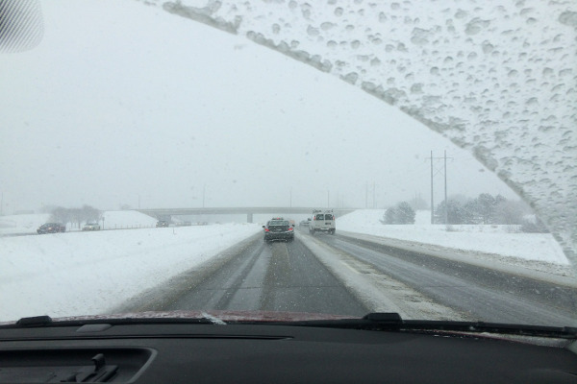
12 Tips for Winter Driving P1 –Tool box talk
Driving requires all the care and caution possible any time of year. But winter driving has even greater challenges because of wet and icy road surfaces, longer hours of darkness and poor visibility because of snow, rain and fog.
Today well look at the first 6 of 12 tips to help you drive more safely this winter.
1. Allow enough time to get to your destination. Rushing in difficult driving conditions can lead to an accident. Turn your radio on to listen to the road report and weather forecast. Leave a few minutes earlier in the morning, and allow plenty of time to get to work. Buckle up your seat belt or safety restraint before you start driving.
2. Stay alert. Don't drive when you are under the influence of alcohol, drugs or certain medications. Read the labels of prescription drugs and over-the-counter medicines to determine if they can cause drowsiness. Driving demands your full attention.
3. Stay calm. Sometimes other drivers will become frustrated with slow-moving traffic. Keep your temper and don't let other drivers aggravate you. Maintain a safe speed and drive defensively.
4. Keep a safe distance between you and other vehicles. The "two second rule" works well on dry roads and in ideal conditions, but in winter you should extend it to four seconds. Watch the vehicle directly ahead of you. As it passes a stationary object start counting - "one thousand and one", "one thousand and two", and so on. Your vehicle should not pass the same object until you say the word "four."
5. Keep your car well-maintained and in good working order. This includes having good tread on your tires, the engine tuned-up for winter, and all lights functioning properly. In colder climates, you may need to add anti-freeze to the radiator. In some areas, gasoline antifreeze may be required.
6. Clean your windows and headlights frequently. Keep your windshield washer fluid topped up. Good visibility is essential to safe driving. Clean your windows and headlights of ice or snow before starting out, and repeat frequently throughout your trip.
Tomorrow we'll finish up the tips.
This toolbox topic was reviewed by ______________________________________ on ___________________________ with the following employees:

