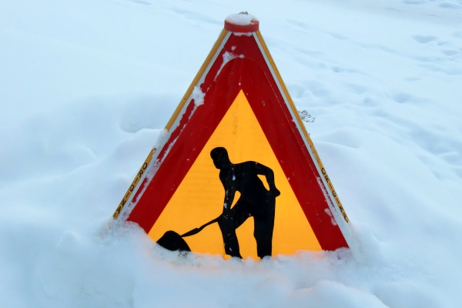
Tool Box Talk - Snow Removal
Winter weather brings new hazards especially in snow and ice removal.
Consider these winter weather safety tips:
Staying warm and dry are important for preventing hypothermia, a dangerous lowering of the bodys core temperature. Dress in layers of clothing, so you can remove outerwear if you get too warm. Keep dry by using waterproof footwear and clothing, and keep a change of socks and gloves handy in case yours get wet. In severely cold weather, protect your hands, toes and cheeks from freezing which will cause the tissue damage known as frostbite.
 Take it easy when you shovel show by hand because of the possibilities of back injury and heart attack. Push, rather than lift, snow when possible. If the snow is wet and heavy, take smaller loads. Take frequent breaks, keep from getting too warm and drink water often to replace fluid and minerals lost by sweating.
Snow Removal Equipment:
 Check over equipment such as a snowblower before use to make sure it is functioning properly and safety guards are in place. Dont run gasoline-powered equipment indoors because of the danger of carbon monoxide exposure. Do a circle check of plows and other mobile equipment to look for problems and obstructions.
 Keep people away from the area where you start or operate the machine. Shift into neutral and make sure all clutches are disengaged before starting the motor.
 Walk slowly and carefully so you dont slip, and keep a firm hold on the machine. If you try to remove snow too quickly youll overload the machine. Stay away from the discharge opening to prevent entanglement or being struck by objects propelled by the blades. Do not use a snow thrower on steep slopes. Make sure you dont hit obstructions such as curbs or tree roots.
 Never put your hand in any part of the equipment while the machine is running. First turn off the engine, wait for all moving parts to stop and disconnect the spark plug wire so the machine cant accidentally start up. Use a tool, never your fingers, to remove any snow or ice buildup.
This toolbox topic was reviewed by ______________________________________ on ___________________________ with the following employees:

