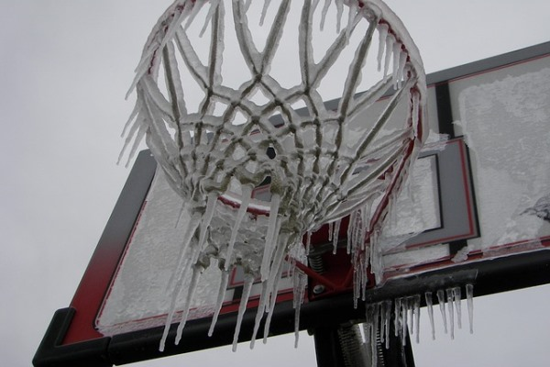
Tool Box Talk - Ice Storm Preparedness
Have you ever experienced an ice storm? This is a type of severe weather in which ice coats streets, sidewalks and power lines. It makes transportation extremely hazardous, and it can shut down the electrical power in an entire city, occasionally for days and weeks. Trees and power lines break and fall, sometimes crushing or electrocuting people in the way.
Montreal in Canada, Spokane, WA and New York are cities that have suffered through ice storm disasters in recent years. The experiences of those three communities can help you prepare to survive extreme winter weather in your area.
Preparedness is the key to getting through a winter storm with minimum danger and discomfort. So plan what you would do in a weather emergency.
How would you heat your home if the electricity went out? If you are thinking you would just wheel the barbecue indoors from the patio, stop right there. People die during winter storms when they try to use outdoor fuel-burning equipment indoors. The carbon monoxide created by burning fuel builds up in a poorly-ventilated area and can kill the occupants without warning. You should only use a heating device designed for indoor use.
You can keep your home warmer by closing off the rooms you don’t need to use and huddling in the warmest room with all the blankets you can round up. During previous ice storms, many families and their neighbors spent days like this.
What about light? If you’re thinking of candles, that’s another bad idea. Houses go up in flames during winter storms because of candles. Instead, make sure you have battery-operated lights, such as flashlights, and a good supply of batteries.
How about communication? Without electricity, your television, radio and computer won’t do much for you. You need to keep a battery-operated radio in your home for emergencies such as this. You also need a telephone that can be plugged directly into a telephone jack and which can operate without electricity. So if all you have are phones linked to cordless stations and answering machines, make sure you pick up a no-frills telephone to use in an emergency.
A supply of clean drinking water and foods that can be eaten without cooking are important survival supplies in any season.
If you have special needs such as medicine, keep enough on hand to get you through a few days of being stuck at home or in a shelter.
Keep an eye on your neighbors, particularly those who are elderly, caring for young children or living alone. Weather extremes are hardest on the old, the young and those in poor health, so help them to stay warm, dry, fed and cared for.
Winter storms claim lives when people are trying to work in extraordinary circumstances. Shoveling snow or doing other heavy work in the cold weather can cause heart attacks for those in poor health or unaccustomed to such work. And operating chainsaws during disaster cleanup has proved fatal for persons without experience with these dangerous tools.
This toolbox topic was reviewed by ______________________________________ on ___________________________ with the following employees:

