Toolbox Talks

PLANNING AHEAD TO DRIVE SAFELY

If a company’s safety program could make a new year’s resolution, it would be to not have any equipment or vehicle accidents this year. This is due to the high number of motor vehicle / equipment accidents in last year.
One of the best ways that we can have an impact on this record instead of another car is to always make sure that we are prepared before we begin to drive away in a vehicle.
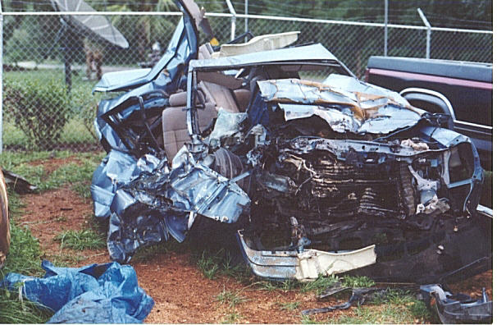
- Plan your route prior to starting your car. Don’t be trying to drive and read a map at the same time.
- Inspect your vehicle.
    - Inspect underneath your vehicle for leaks.
    - Ensure that your fluids are full.
    - Check the headlights, turning signals, horn and the brakes.
    - Clean all ice off of your windows. Wait for your window to totally defrost before moving.
    - Check air levels in tires.
- Adjust your mirrors and wear your seatbelt.
- Keep both hands on the steering wheel.

Furthermore, having a defensive attitude when you drive can also help you to meet your goal of not having any accidents this year. To drive defensively, you should:

- Control your emotions, research has shown that losing control of your emotions account for nearly 80 % of vehicle collisions. If another driver cuts you off, tailgates, or drives too slowly remain calm.
- Use the 2 second rule of thumb. (keep a distance of 2 seconds traveling speed distance between you and the next car)
- Follow the posted speed limits.

Drivers License Suspensions

Loss of driving privileges could result in loss of work or a change in your job description. A valid driver’s license is required to operate any company vehicles and equipment on all jobsites.

CREWMEMBER SAFETY TOPIC

