TOOLBOX TALK – Not Reporting the Near Miss
There are a number of common reasons why people don’t report near misses. One is that we don't want to get into trouble with a supervisor or fellow worker. Another reason might be embarrassment. Nobody likes to admit to being part of an accident or close call. Or we might find it is too much trouble to report it - forms to fill out, questions to answer.
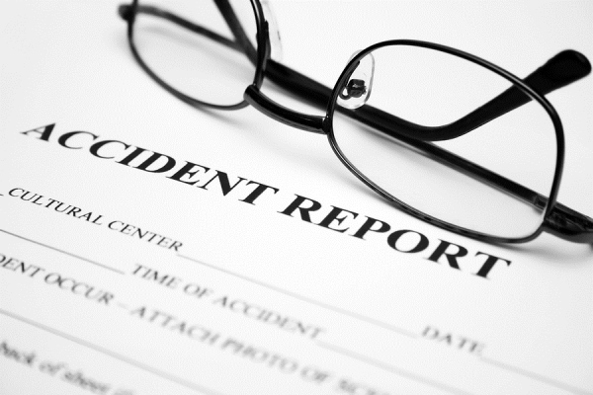
Of course, none of these reasons amount to much when you consider that reporting a close call might save a co-worker from serious injury or death. Imagine what it would be like to watch a buddy die because of a hazard which you knew about but did not report. Think about it - what if you were the only one who knew materials were being stacked unsafely, because just last week you had to jump out of the way of a falling object? How would you feel if another worker was crushed and killed when the stack collapsed again?
When an accident occurs and someone is injured or killed, chances are someone else knew that the hazards existed. Think about that. Someone else probably had a hunch that the brakes were worn out, or the emergency exit was blocked, or the chemical container was in a position to be knocked over or whatever . . .
How do you think that person will feel after an accident occurs? Chances are, he'll wish he had reported the hazard.

