TOOLBOX TALK - Vehicle Inspections

Vehicle Inspections Safety Talk
The roads can be an extremely dangerous place. According to the National Highway Traffic Safety Administration, there were an estimated 6.3 million police-reported car accidents in the United States in 2015. While many accidents are caused by distracted driving and driving under the influence, mechanical issues also lead to accidents. Vehicle inspections and preventative maintenance are effective ways to prevent mechanical issue-related crashes.

Mechanical Issue-Related Crashes
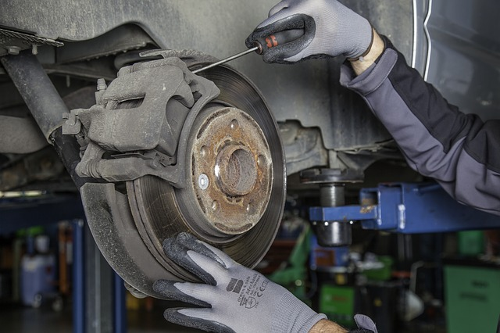
Only a few types of mechanical issues represented the majority of accidents that were caused by some type of failure in a vehicle. The National Highway Transportation Safety Administration stated in a 2008 report that tire/ wheel degradation or failure represented 43% of all mechanical issues resulting in crashes. Brake degradation or failure was second at 21% and steering/suspension/ transmission failure represented 10.5% of mechanical issues that lead to accidents. It is important to inspect your vehicle for these common issues.

Vehicle Inspections
Most states require an annual in-depth inspection of any vehicle registered in that state to help avoid these types of problems creating a hazard on the road. It is important to also complete more frequent inspections of your vehicle prior to use. A simple walk around of your car or truck prior to operation can avoid an accident. A few things to look for during a quick inspection:
- Look for low tire pressure. This could signal that you need air in the tire or a patch depending on the problem.
- Look for any bubbles in your tire. If there is a bubble in your tire this means you have a break in a belt in the tire and it is now compromised. It is recommended that you use your spare or get it replaced immediately before driving the vehicle again because the tire could give way at any time.
- Start the car and listen for any odd noises.
- Make sure there are no objects that you could strike pulling out from where you are parked.
- Pull forward and test the brakes before starting your trip.

Preventative Maintenance
There is a lot of maintenance vehicles require to ensure safe and efficient operation. Changing tires before they get too worn is very important to be able to operate a vehicle safely. Other common issues to address include changing the oil, replacing belts, replacing fluids, and replacing windshield just to name a few. Read your vehicle’s owner manual to get familiar with what preventative maintenance needs taken care of and when.
Summary
While the majority of the time you will never any of the issues mentioned above, the one time you do it could result in a serious accident. Take mechanical issues seriously and when you find one during an inspection get it fixed by a professional to ensure the vehicle is safe to operate.

