TOOLBOX TALK - Fixed Objects (Motor Vehicle Safety)

Fixed Objects Safety Talk
Striking fixed objects with moving equipment or vehicles is common in manufacturing settings, on construction sites, and for occupations such as delivery drivers. Striking fixed objects is 100% avoidable if the proper steps are taken to prevent these kinds of incidents. It is important to take the time and energy to properly eliminate or mitigate the chance that fixed objects are struck.

Ways to Prevent Striking Fixed Objects
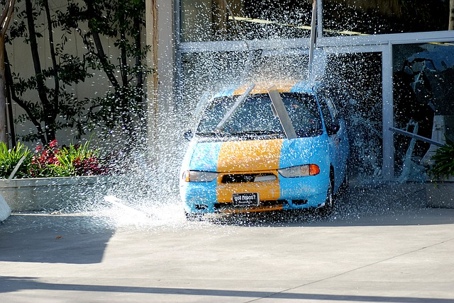
The single best way to prevent these types of incidents is through elimination of the exposure to the hazard. Fixed objects are just that, they are fixed; the only way they will be struck is from the movement of the vehicle you are controlling. Elimination can be achieved by not being near the fixed object at all or by not installing the object in an area where it can be struck in the first place. Often times poor planning or foresight is involved in these types of incidents. Obviously not all fixed objects that are encountered at work were installed by our company and many of them cannot be eliminated or reinstalled in another spot.
While elimination of all work tasks involving moving equipment or vehicles near fixed objects is not possible, there are many other additional safeguards and best practices that can be used to reduce the chance that objects are struck. A few of these other safeguards:
- Avoid backing. Often times objects are struck when individuals are backing up.
- Never park within a few feet of a fixed object. Doing so leaves more of a chance that you or the next person using the equipment or vehicle will strike the object.
- Always perform a full walk around of the vehicle or equipment prior to operation.
- Pay attention while operating or driving- even at low speeds. Distractions or complacency are often a factor in low speed collisions.
- Use a spotter anytime you are working near fixed objects.
- Make the object more visible by using orange flags or other bright markers to bring attention to it.
- For objects at a worksite that are critical to operations or are costly to repair such as an AC unit, place concrete barriers or another protective barrier around it so the barrier is struck first instead of the critical object.

Summary
There are many ways to prevent striking a fixed object. Elimination of work tasks near these objects or avoiding installing fixed objects near paths of travel in the first place is the best choice. A combination of safeguards is another effective method to reduce the chance of striking fixed objects. These types of incidents are truly 100% preventable if the proper steps are taken to avoid them.

