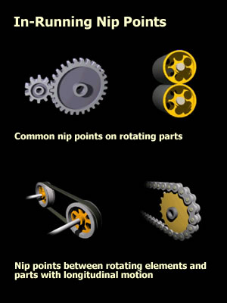
In-running nip points are frequent sites of injuries from machinery. Nip points exist where material enters a gradually narrowing opening, for example, pulling rolls, and the material is strong enough to pull body parts, such as fingers, hands, arms, and hair, into the pinch point.
Dangerous nip points also occur in machinery parts not in direct contact with the material, such as near pulleys, gears, and spindles—where linear or rotary motion of the moving equipment occurs through narrowing openings between components. Frequently the machine is running too fast, or is too powerful to allow stopping before significant injury occurs.

Dangerous Practices
When performing safety inspections, I see far too many cases in which personnel are exposed to dangerous in-running nip points. These situations particularly are prevalent when the material is hand-fed or personnel are working near the machinery.
It is important for everyone involved in the production process to be aware that there are many, many nip points in most production operations, and that these nip points present a high injury risk. It is equally important to be aware that the nip points become even more hazardous when the material or machine is not moving smoothly, such as when feeding problems, erratic speeds, misalignments, breakdowns, and other abnormal conditions are present. Under these circumstances, manual intervention to remedy the problem occurs frequently, and during the urgency and stress of resuming production, dangerous work methods may arise inadvertently.
Manhandling the material; using pry bars or other inappropriate tools; making adjustments on the move that should be done when the machine is stopped; reaching for dropped items; and slipping on cluttered or slippery floors all can cause body parts to enter nip points.

The Unexpected
In-running nip points sometimes exist in unexpected places. One instance I investigated involved an operator who bent over to pick up a part that fell on the floor. Her hair was pulled in by the machine's belt drive pulley, located only a few inches above the floor. A guard covered the upper portion of the pulleys and belt. Very unfortunately for the woman, the in-running nip point was below the guard.

