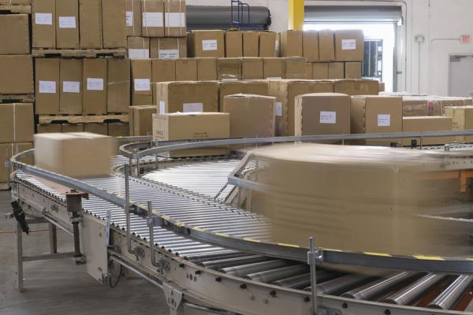
Find a way to cut down on the amount of materials you handle manually, and you've got a good thing going. You lessen the chances of hurting your back and hands, which are two of the more common types of on-the-job injuries. In addition, your capacity for work will increase and so will production.
That's why conveyors are widely used. They move materials efficiently and safely. Conveyors are one of the earliest forms of automation. In fact, they've been around so long that we don't really look at them as a form of automation but as basic machinery for getting the job done.

Like other things we work with, conveyors are safe when used correctly. They're not a means of human transportation or a plaything. They come in many shapes and sizes, and each is designed to do a specific job, so it's not easy to sum up conveyor safety in a few sentences. But needless to say, you have to use the right conveyor for the job.

Certain safety precautions must be taken even though you don't work directly with conveyors. For instance, don't crawl over or under them. This is pretty elementary safety advice, but there are still many people who have tried it and get injured in the process.

Never ride a conveyor. We all find it's difficult enough going through life and avoiding injury without trying some foolhardy stunt. So unless your job requires it, stay away from conveyors. Don't attempt to operate a conveyor unless you've been checked out on the procedures and are authorized to run it. Persons working on or about a conveyor should know the location and operation of stopping devices. If they don't, they should consult their supervisor.

Don't attempt to clean any belts or parts while the conveyor is running. If it's necessary to clean belts or drums while the equipment is in motion, proper barrier guards should be provided at pinch points.

Most companies that manufacture conveyors try to make them safe. If the equipment isn't safe, modifications have to be made. Pinch points and moving parts must be guarded. If a conveyor runs overhead, precautions must be taken to prevent injuries from materials which might fall from above. If a conveyor runs at head height or is the type that carries material hung from hooks, measures should be taken to prevent persons from being struck, and employees in the area should remain alert to possible danger.

Conveyors should be stopped and controls locked out when repairs are being made, and the equipment shouldn't be started again until it is certain that all is clear.

When you place materials on a conveyor or take them off, pinch points are created because of the movement of the machinery. So watch your hands and stay alert. When putting materials on a conveyor, place them so that they will ride safely.

The fact that conveyors run steadily and smoothly may lull you into a false sense of security when you're around them. Don't fall into this trap. Conveyors can be dangerous. Loose clothing and jewelry, particularly rings, are dangerous to wear on the job. Combine them with the presence of a conveyor and the hazard potential increases quickly.

Regardless of whether you're working with conveyors or any other type of machinery, you're expected to observe basic safety rules. In addition, your help is needed in reporting unsafe conditions or malfunctions to your supervisor. These steps will go a long way toward eliminating hazards and protecting your ability to earn a living.

