Two-Person Lifting Tips

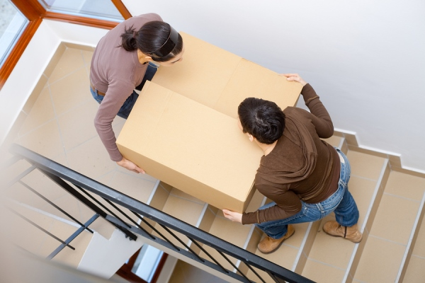

Occasionally we can’t or shouldn’t lift something by ourselves. Items that are heavy, large, awkward in shape or awkward in weight need two or more people to lift. However, if you don’t do that in an organized fashion, a helping hand could become a hurting hand.
Have you ever helped move a something up or down the stairs and after it’s done it seems like it would have been easier to do it yourself. With two or more people lifting, communication is the key to doing it safely. All those involved have to be on the same page or else someone may do something to cause an injury to another. Here are some tips.
For a safe, correct, two-person lift:
- Work with a person about your height.
- Decide in advance which person will direct the move.
- Keeping knees bent and back straight, lift and raise the load together.
- Move smoothly together as you carry, keeping the load at the same level.
- Unload at the same time, keeping knees bent.
- If moving something up or down stairs, the taller person should be at the lower level.
This toolbox topic was reviewed by ______________________________________ on ___________________________ with the following employees:

