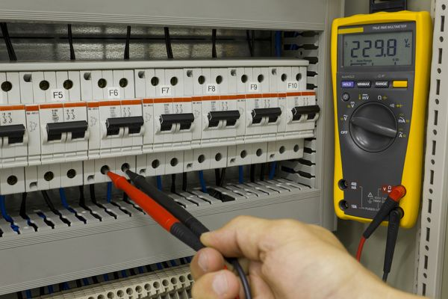
TBT-Verify Lockout/Tag out

Verify is defined in the dictionary as "to ascertain the truth or correctness of, as by examination, research, or comparison"

Verification is the last step and one of the most important steps in the Lockout Ta gout process. It is also the most skipped step in the process. You must verify that the energy is no longer a hazard.

- If you're locking out a machine to enter it, push the start button to ensure the machine won't start.
- If you're locking out an electrical box, utilize a meter to ensure the energy isn't present.
- If you're locking out an air valve, trip the mechanism to ensure the pressure is truly gone and the stored energy is bled off.

Many times people take for granted that because they have thrown the disconnect, that the energy is no longer a hazard . . . however the verification step is there for a reason. Never take chances. Never make an assumption. Verify you have eliminated the hazard of the energy.

Your life may depend on it.

SAFETY TRAINING CERTIFICATION FORM
Toolbox Topic Covered: Lockout/Tag out Standard – Importance of LOTO

Company Name: ____________________________ __________ Date: ____________

Training led by: _______________________________________

PRINT NAME SIGNATURE
_____________________________________ ____________________________________
_____________________________________ ____________________________________
_____________________________________ ____________________________________
_____________________________________ ____________________________________
_____________________________________ ____________________________________
_____________________________________ ____________________________________
_____________________________________ ____________________________________
_____________________________________ ____________________________________
_____________________________________ ____________________________________
_____________________________________ ____________________________________
_____________________________________ ____________________________________
_____________________________________ ____________________________________
_____________________________________ ____________________________________
_____________________________________ ____________________________________

