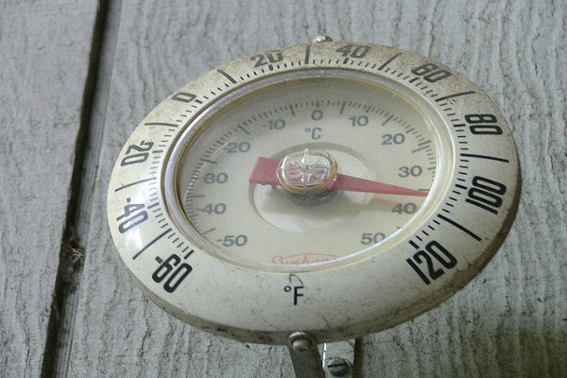
TBT-Heat Disorders - Risk Factors

This week we’ve been looking at various heat stress disorders that may affect us as the summer heat increases the temperature and humidity of our facility. During the summer, we must all take precautions to ensure our bodies don’t get over heated.
Today we’ll look at ways some factors that increase your likelihood of having a heat stress episode:
- Young or old age. Infants and children younger than 4 and adults older than 65 are at higher risk of heat exhaustion. The body's ability to regulate its temperature isn't fully developed in the young and may be inhibited by illness, medications or other factors in older adults. Both age groups tend to have difficulty remaining hydrated, which also increases risk.

- Certain medications. Drugs that affect your body's ability to stay hydrated and respond appropriately to heat including
- Those that narrow your blood vessels (vasoconstrictors, such as ergotamine)
- Those that regulate your blood pressure by blocking adrenaline (beta blockers, such as atenolol)
- Those that rid your body of sodium and water (diuretics, such as hydrochlorothiazide),
- Those that alleviate allergy symptoms (antihistamines),
- Those that calm you (tranquilizers, such as phenothiazines, butyrophenones and thioxanthenes
- Check with your doctor
- Obesity. Carrying excess weight can affect your body's ability to regulate its temperature and cause your body to retain more heat.

