OSHA Training Toolbox Talk: OSHA’s Revised Haz-Com Standard – “Non-Mandatory” Information

[Reference 1910.1200(f) / 1926.59(f)]

Today we will wrap up our series of toolbox talks related to OSHA’s revised Hazard Communication standard. To recap, we have discussed the new GHS format for container labels, including the eight mandatory pictograms, and we have also covered the information that is required to appear on the new safety data sheets (or SDS’s). However, there is some information included on labels and SDS’s that is not required by OSHA, but appears because it addresses our duties to protect our environment and also to comply with other agency rules.

For example, there is one last pictogram we have not yet covered. This one is titled “Environment”, and displays an icon of a fish and a tree in water (see pictogram attached to this toolbox talk, we recommend you make copies to use as handouts for each trainee). While the footnote on this pictogram says “non-mandatory”, that simply means that aquatic toxicity is not regulated by OSHA, whose jurisdiction is worker health and safety. However, there are federal or state environmental protection agencies that do regulate the storage, use, and disposal of products that could be harmful to fish and aquatic plants. So pay particular attention to the Precautionary Statements appearing on the label for products bearing this pictogram, as they list specific recommended measures that should be followed during use, storage, or disposal of that product and contaminated packaging to minimize harm to the aquatic environment.

You may also recall that four of the sixteen sections of the Safety Data Sheets we previously discussed were also marked as “non-mandatory” per the OSHA hazard communication standard. But even though these sections may not directly affect the health and safety of workers, we must still pay attention to these sections because they outline other types of hazards, as well as regulations that may be mandatory per other agencies. For example, section 12, titled Ecological Information, lists information about ecological toxicity, bioaccumulation, and degradability of the product in soil or water. Section 13 of the SDS is titled Disposal Considerations, and provides a description of waste residues and information on proper methods of disposal - including contaminated packaging. Section 14 of the SDS is titled Transport Information, and lists information like the UN number and shipping name for the product that may be needed to comply with requirements of the Department of Transportation (or DOT) when these products are shipped. And Section 15 is titled Regulatory Information, and may list other safety, health and environmental regulations applicable to the associated product.

So even though some of the information on container labels and safety data sheets is non-mandatory per the OSHA standards, this is still important information we need to be aware of to help insure we address other type hazards and regulations.

Does anyone have a question or comment about the non-mandatory information appearing on labels and safety data sheets? Please be sure to sign-in on the training certification form.

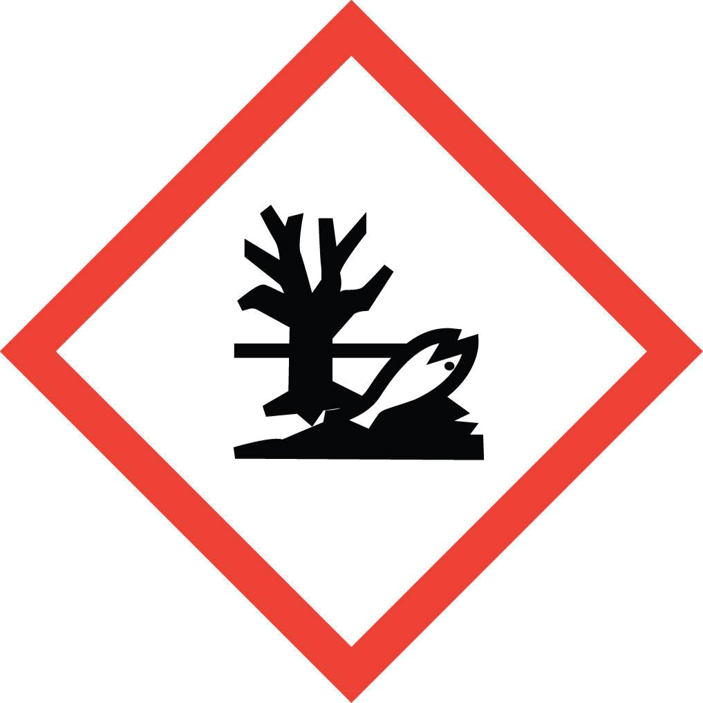

ENVIRONMENT

(Non-Mandatory)

• Aquatic Toxicity

SAFETY TRAINING CERTIFICATION FORM

Toolbox Topic Covered: OSHA’s Revised Haz-Com Standard – “Non-Mandatory” Information

Company Name: ____________________________ __________ Date: ____________

Training led by: _______________________________________

PRINT NAME SIGNATURE

_____________________________________ ____________________________________

_____________________________________ ____________________________________

_____________________________________ ____________________________________

_____________________________________ ____________________________________

_____________________________________ ____________________________________

_____________________________________ ____________________________________

_____________________________________ ____________________________________

_____________________________________ ____________________________________

_____________________________________ ____________________________________

_____________________________________ ____________________________________

_____________________________________ ____________________________________

_____________________________________ ____________________________________

_____________________________________ ____________________________________

_____________________________________ ____________________________________

