TBT-Chemical Labels - Part 1
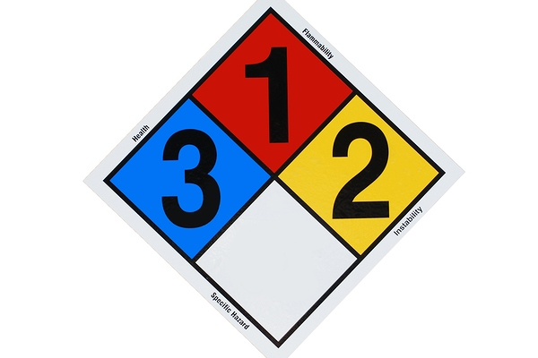

Labels on chemicals are your first line of defense to know what you are using and what, if any, special precautions or PPE should be used.

Many chemicals and other substances are hazardous if not used properly. You can be safe if you know which are hazardous, what the hazards are, and how to work with them safely. You can detect many of these hazards by reading the labels.

Every container of hazardous material has a label—a good place to start. Label information usually includes:
- What’s in the container
- What type of hazard might be present
- Special instructions
- How to protect yourself
- Basic first aid.
The label doesn’t tell everything, but it’s a good starting point—read it first!

