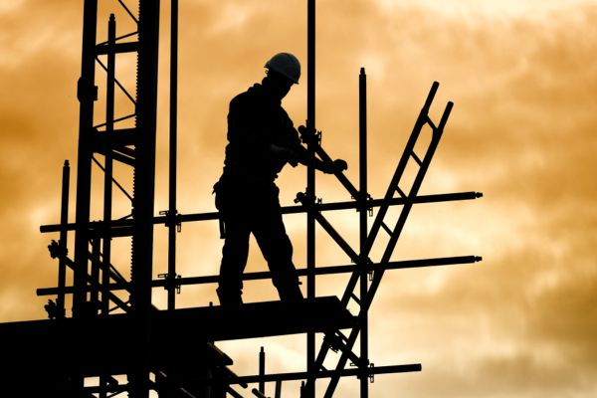
Tool Box Talk - Falls From Any Height

Who needs fall protection equipment? If you said workers building bridges or cleaning office tower windows you would be right. But what about all the workers who work at lesser heights, just a few feet off the ground? They should also be protected from falls - which can be every bit as fatal.
Consider your work area. Are there locations from which someone could fall? What sort of protection is in place to prevent a fall? And is there equipment to stop a fall?
The situations to be considered are both:
- Permanent - such as a fixed ladder on a process tank or mezzanine floor where materials are stored.
- Temporary - such as a scaffold or the top of a loaded truck.
Fall protection equipment is broadly divided into two categories:
- One is fall prevention equipment. Guardrails and coverings at floor openings and safety-interlock gates on elevated platforms are designed to prevent falls. A body harness worn by the worker can also be used to tether him to an area away from the fall hazard.
- Fall arrest equipment is designed to save the worker if he falls. He may wear Personal Protective Equipment consisting of a body harness and lanyard attached to a lifeline or an anchor point. Or a net slung below the work area may protect him.
The law in many areas says a worker must be protected if he is exposed to a fall hazard of 10 feet or three meters. But a study has indicated 10 per cent of fatal falls occur at heights lower than that. Imagine someone falling four feet from a loading dock and striking his head on the pavement. Such an incident could very well be fatal.
Check these areas:
- Do employees ever have to climb on top of vehicles, to unload tankers, remove load strapping, paint or do other maintenance?
- Does anyone ever go to the roof? Do maintenance workers service the air conditioner up there? What is the potential for falls?
- Do you ever do painting of the facility during slow work periods? Are scaffolds built safely according to regulations?
- Floor openings created by construction work must always be properly barricaded and securely covered.
- Catwalks over machinery and process equipment must be regularly inspected and maintained.
Safety laws are in place to prevent falls from heights. Be sure to follow these rules to the letter. And look beyond the law. You know a fall hazard when you see one, so report it to ensure it gets fixed.
This toolbox topic was reviewed by ______________________________________ on ___________________________ with the following employees:

