
Loading and Unloading Pallets


Many of the loads placed on or removed from pallets are very heavy. Many of these loads, especially in refrigerated or freezer warehouses, are extremely heavy. Weights upwards of 80 to 100 pounds are not uncommon. Day in, day out – heavy lifting damages the spine. Review these safety tips with employees:

WORKSAFE TIPS

PALLET RACK HAZARDS

- Since pallets are only 6 inches in height, workers must, eventually, lift heavy or awkward loads that are low to the ground.

- This is a significant problem since the heaviest product is usually in the shortest stacks.


- Low racking can force employees to stoop
and bend at the waist to access loads.

- Loads in bottom bins will require forward torso bending and stooping to reach packages under the rack, when the pallet stack quantity is lowered.


- Never stand on or work while standing on a pallet.

- Keep the load close to the body, and walk around pallets – don’t reach over them.


- Stack extra empty pallets on the pallet jack to elevate the bottom of the load
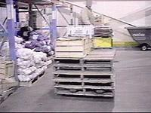

- Raise the bottom level of racking so loads are at heights where torso bending is not necessary


