TOOLBOX TALK - Tight Enough
Working on machines as we do, we have to loosen and tighten nuts, screws, bolts and the like as we’re setting up and adjusting the machines. Some of us tend to “put our all” into it as we tighten up those bolts.
There may be something satisfying about pulling a wrench as hard as you can until it won’t move another hair . . . however you aren’t doing the equipment any favors. In fact, most of the torque (bolt tightness) specifications would really surprise you.
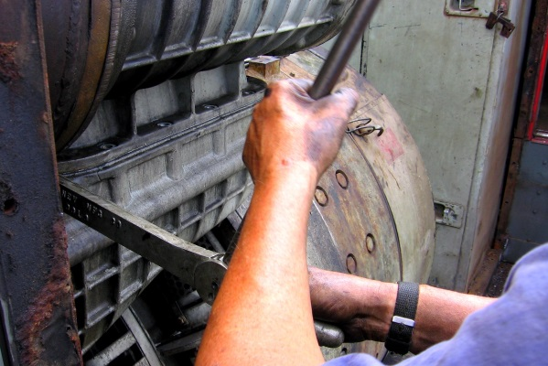
Besides the obvious problem of the bolt being impossible to remove by the next guy, there are some more serious issues that arise when a bolt is overtightened. Overtightened bolts undergo more stress than it was designed to handle. This not only applies to the nut, screw or bolt, but also to the framework you’re bolting into. This extra stress can cause the bolt or the nut to fatigue, weakening them and compromising the safety of the machine.
Not only that, but many injuries occur during the process of overtightening. You can pull a muscle and the opportunity for the wrench to slip off the nut increases dramatically causing a severe hand injury.
Also, remember the guy who has to loosen it during the next setup. He may not be as strong as you are and can get injured trying to loosen it.
Don’t get me wrong, nuts, bolts and screws need to be tight, but there is a difference between snug and back breaking.

