TOOLBOX TALK - Ratchet Strap Safety Inspection
Ratchet straps are one of the most widely utilized tools to secure moving cargo. There are many forms of tie downs offered from heavy chains to synthetic rope, but synthetic ratchet straps are the most widely used.
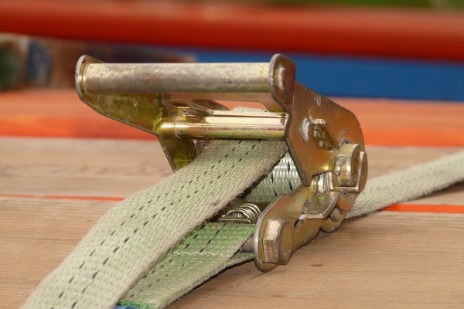
It is important that they are utilized properly. The most important safety consideration is to do a thorough inspection of each strap prior to its use. This takes only a moment and can save many hours and thousands of dollars in the event you experience a preventable failure of this tool.
Today we’ll look at the inspection process for such synthetic ratchet straps.
Even seemingly "minor" damage to a ratchet strap can significantly reduce its capacity to hold objects and increases the chance that the ratchet strap will fail during use. Therefore, it is very important that ratchet straps are regularly and properly inspected. In reality, there simply is no such thing as "minor" damage. If you are not sure whether a ratchet strap is damaged, DO NOT USE IT.
- If ratchet strap identification tag is missing or not readable.
- Holes, tears, cuts, snags or embedded materials.
- Broken or worn stitches in the load bearing splices.
- Knots in any part of the webbing.
- Acid or alkali burns.
- Melting, charring or weld spatters on any part of the webbing.
- Excessive abrasive wear or crushed webbing.
- Signs of ultraviolet (UV) light degradation.
- Distortion, excessive pitting, corrosion or other damage to buckles or end fitting(s).
- Any conditions which cause doubt as to the strength of the ratchet strap.
Synthetic web ratchet straps may be re-webbed using existing hardware if the ratchet strap manufacturer determines the hardware is reusable. All re-webbed ratchet straps utilizing used hardware shall be proof tested to 150% of the WLL and certified. Frankly you are better off just replacing the entire unit.
You should never ignore ratchet strap damage or attempt to perform temporary field repairs of damaged ratchet straps (e.g., tie knots in the webbing, etc.).

