TOOLBOX TALK - Pressure Washer Safety
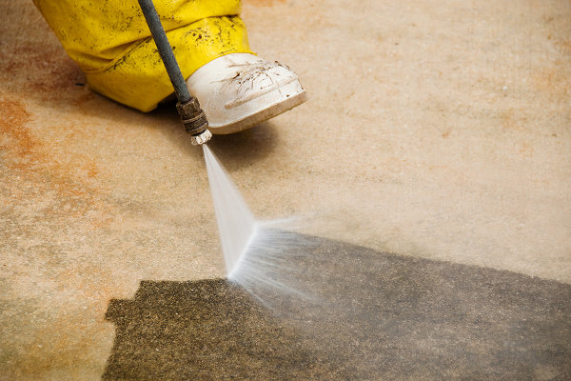
Pressure washers are used to clean equipment, materials and work areas on the job. At home, they may be used for washing automobiles, house exteriors and other uses.
They can also cause injuries. Because the water is under pressure, it moves with enough force to cause damage to the eyes or skin and contribute to other types of injuries. Close contact with a pressure washer's flow to your skin actually abrades away the skin layer by layer rather than cuts and causes injuries that are hard to heal and scar for life. The noise can also damage hearing.
For safer use of a pressure washer, follow these tips:
- Read your operator's manual and follow the manufacturer's instructions for safe use, maintenance and storage.
- Wear eye and hearing protection when you use a pressure washer.
- Avoid contact with the high-pressure stream of water. Keep your hands, feet and body out of the way.
- Always wear good footwear and clothing (preferably long pants and sleeves) when using a pressure washer.
- To keep control of the water stream, hang on to the spray wand with both hands.
- Never point the sprayer at another person, whether the pressure washer is operating or not. It could discharge unexpectedly.
- Maintain good footing. Do not reach so far that you lose your balance.
- Do not let children use a pressure washer.
- Do not use a pressure washer in an area where the water could contact electrical equipment.
Pressure washers get the job done quickly and well. But they have the potential for causing injury, so use them safely at work and at home.

