TOOLBOX TALK - Pneumatic Nailers
pneumatic nailers are a staple of the construction industry. these nail guns, powered by compressed air, cause many injuries to the hands and feet. more serious injuries to the eyes, neck, heart and brain have also occurred.
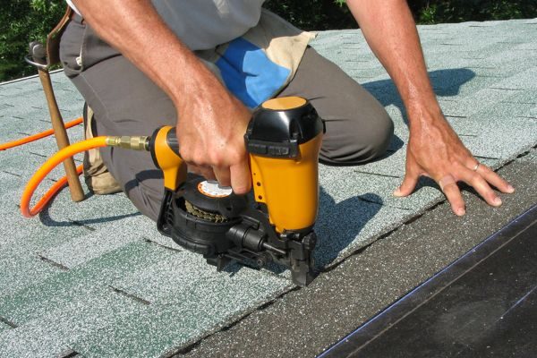
also known as nailers, pneumatic hammers and air-powered hammers, these tools are rightly called guns because they apply a large amount of energy to a small projectile. as such, they should be treated and handled with the same kind of care as a weapon.
here is an example of how things can go wrong when nail guns are used incorrectly:
a worker known to be fast at his job was walking along a timber framework placing a series of nails. he used one hand to hold the job and walked with the trigger depressed, using the pressure on the muzzle guard to activate the tool. he nailed his hand to the wood.
use these safety tips to prevent injuries:
- read the user's manual to learn how to operate and maintain the tool safely.
- get training at work.
- examine the tool before use, making sure it is in good condition. is the nose guard in working order? also check the air pressure before hooking it up.
- do not carry the tool by the hose.
- do not carry the tool with a finger on the trigger.
- do not press the trigger unless you are intending to fire.
- do not point the tool at anyone. even if the tool is disconnected from the air supply or supposedly empty, it could still fire under certain circumstances. it is also possible for a nail gun to go off without you touching the trigger.
- make sure the tool is pointed away from your body and keep your hands out of the way.
- nails hitting the work at the wrong angle and bouncing off can injure hands.
- put the muzzle of the tool firmly against the work piece when firing.
- disconnect the tool from the air supply before clearing blockages, adjusting, handing the tool to another worker or leaving it unattended.
- always wear safety glasses when using an air nailed. hearing protection, head protection and safety-toed footwear might also be required.
pneumatic nailers are among many kinds of equipment powered by compressed air. all these tools require caution to prevent injuries.

