TOOLBOX TALK – Knife Safety
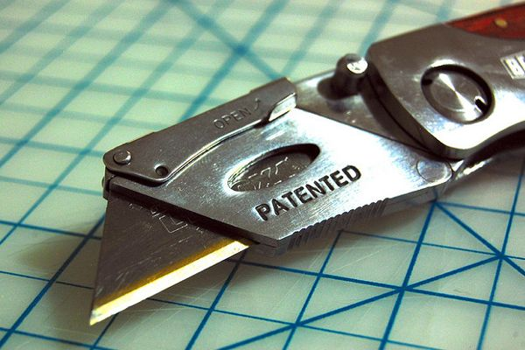
frequently we have a need to use knives and other cutting tools in our jobs, as well as at home. We cut bindings off boxes of paper. We cut seafood, meat or poultry. We open containers of all sorts. We cut ropes, cloth and various materials and adapt them to our use. But we don’t always do this safely.
There are two golden rules in knife safety:
Always cut away from yourself and a sharp knife is safer than a dull knife.
Watch someone use a knife sometime and notice how often they risk being injured by cutting toward their body. You might see individuals hold a loaf of bread near their chest and cut toward themselves when slicing off a chunk. Sometimes when cutting a rope, we bend the rope into a loop and insert the knife into the loop facing upward. When the knife is drawn up through the rope, the force of the cutting action can bring it to the face or other body parts. This is not a good idea!
An unwise but common use of box knives is to reach across the box and draw the knife toward you. This too is dangerous and breaks golden rule one of knife safety.
It takes less force to cut through an object with a sharp knife. This gives you greater control of the blade. When heavy force is applied, the blade often cuts deeper than intended–sometimes into your flesh. When someone tells you their knife is so dull it wouldn’t cut butter, don’t you wonder why they are still using it? Ensure your knife is sharp and keep it sharp.

