TOOLBOX TALK - Circular Saw Safety Tips
Tips for safe use:
• Do not work alone.
• Wear PPE (safety glasses and hearing protection).
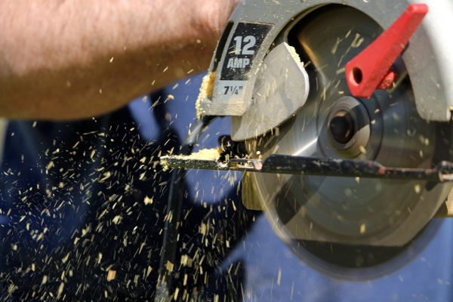
• Keep loose hair, clothing, jewelry, and anything that could get caught in the saw tied back.
• Before the cut, set the depth of the saw to 1/8" thicker than material.
• Prepare a stable surface to cut material on.
• Keep guard on saw as manufactured.
• Blade guard should move freely to both open and closed position.
• Never cut with a dull blade.
• Always unplug the saw before you change the blade.
• Cut short material from long material first.
• Stand to the side when cutting material. This positions you away from potential kickback.
• Hold the saw with two hands while cutting.
• After your cut, do not let go of the saw while the blade is spinning.
Questions to start discussion:
1. How can this tool hurt you?
2. How could you prevent it from happening?

