 | Injury & Illness Prevention Program  Job Safety Analysis Form

Picture of task/equipment: |  | Task: |  | Vehicle Battery Removal/Installation
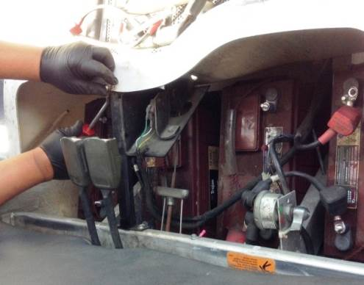 |  | Name of Shop or Dept:
 |  | Job Title(s):
 |  | Analyzed by:
 |  | Date:
Required PPE:



Work Gloves Safety Glasses Closed Toe Shoes
Required/Recommended Trainings:
- Materials Handling
- Safe Lifting/Back Safety

TASK | HAZARDS |  | CONTROLS
1. Restrain Wheels | Cart can roll away |  | - Chock Wheels
2. Remove Obstructions | Strain injuries due to awkward movements when removing batteries |  | - Remove all braces, cables & obstructions blocking battery removal  - DO NOT remove battery without first removing braces, cables and other obstructions
3. Put battery lift into position | Trips/Falls |  | - Move battery lift into position near vehicle  - Slide feet of battery lift under vehicle  - Watch your step  - Move crane into the vehicle
4. Attach battery to  battery lift crane | Dropped battery |  | - Inspect battery handle for wear  - If worn or damaged, attach a battery terminal grabber (see second picture)  - Attach crane hook to lift the battery
5. Remove Batteries with battery lift | Strain injuries due to awkward movements when removing batteries |  | - Use IN/OUT switch on battery lift to operate battery lift. OUT position will cause crane to start lifting the battery.  - Carefully lift battery out of vehicle  - Guide crane with your hands to direct battery out of compartment  - DO NOT lift the battery manually  - Keep face away from lift crane hook  - Move crane arm out of vehicle to desired position  - IN position of switch will gradually lower the battery to the ground  - Unhook battery handle from crane

