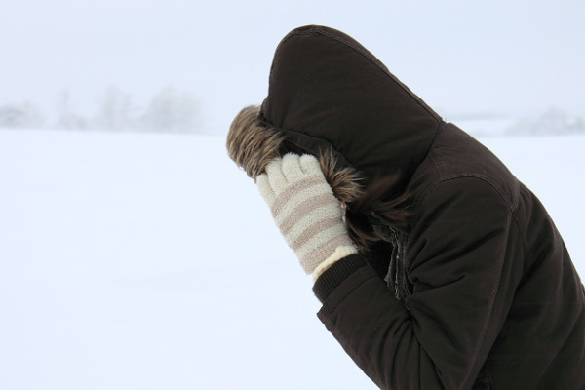
Tool Box Talk - Hypothermia and Frostbite P1

Hypothermia occurs when the core temperature of your body falls below the normal level. If your body becomes too cold, your vital organs cease to function properly. If unrecognized and untreated in the early stages, hypothermia can eventually result in death.
Symptoms of hypothermia include shivering, chattering teeth, confusion, slurred speech, lack of coordination and eventually unconsciousness.
Frostbite is when your flesh freezes. It can occur even without the symptoms of hypothermia. Your extremities, such as your ears, feet, fingers and cheeks, are prone to frostbite in extremely cold weather.
Symptoms of frostbite are quite different from hypothermia. The exposed skin will first appear reddish, and then a greyish-white color. Youve probably seen on TV where mountain climbers have been rescued and their noses or fingers are jet black. This is because the skin has in essence died.
Both hypothermia and frostbite can progress to a medical emergency and therefore require immediate first-aid treatment.
Tomorrow well look at ways to prevent Hypothermia and Frostbite.
This toolbox topic was reviewed by ______________________________________ on ___________________________ with the following employees:

