Toolbox Talks

defensive driving – when to be cautious
Remind crews to drive defensively and to always obey all traffic laws. Driver’s should use particular caution when: | 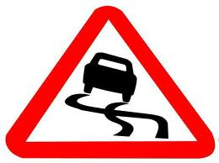
- Driving in high levels of pedestrian or vehicular traffic.
- Driving in a school or park zone. A child could run out into the middle of the street without looking.
- Entering an intersection. Look both ways before entering, even if the light is green.
- Backing up. Remember to always look behind you, check in your rear/side view mirrors, and honk twice to warn any pedestrians or vehicles that may go behind you.
- Changing lanes. Always shoulder check.
- Driving in a lane closure. Workers may enter unexpectedly.
- Exiting from a lane closure. General motorists tend to change lanes at the ends of lane closures.
- Towing a trailer.
- Driving in winter conditions.

ELIMINATE DISTRACTIONS

Be observant of your surroundings, watch for moving machinery and workers while on a construction site. Be wary of drivers who are driving erratically, and most importantly, avoid using a cell phone or eating while driving, so that your full attention can be on the road at all times

- Cell phones may only be used in conjunction with hands free devices. In order to call someone when driving, you must have your cell phone set up for “One touch dialing” (speed dial), otherwise, it is illegal to dial while driving.
- Be sure that any prescription drugs you may be taking are not going to influence your driving abilities.
- Never drink or do drugs on the job-site or prior to working on the job-site.

CREWMEMBER SAFETY TOPIC

