TOOLBOX TALK - Seatbelt Use and Safety

Seatbelt Use Safety Talk
Everyone has heard that seatbelt use is crucial for saving lives on the road, but not everyone wears one. Studies show about 1 in every 7 people do not wear their seatbelt. There are many reasons why people do not wear seatbelts, but the facts are that they save lives.

Excuses Why People Do Not Wear Seatbelts
- It is “not cool”. Teenagers are the least likely age group to wear their seatbelts. Educate the teenagers in your family on seatbelt use. Males are also 10% less likely to wear their seatbelts compared to females.
- They are uncomfortable. If it is to a point that it is uncomfortable for you to wear look into buying an aftermarket pad to put on your seatbelt. Do not put it behind your back instead of across your chest. Wearing it improperly will make it less effective in protecting you during a crash.
- The myth “it is more dangerous to wear seatbelts than not to”. The research shows that this is not the case. Search on YouTube “Man Does Not Wear Seatbelt” to see what it looks like when a person rolls a vehicle and does not have one on.

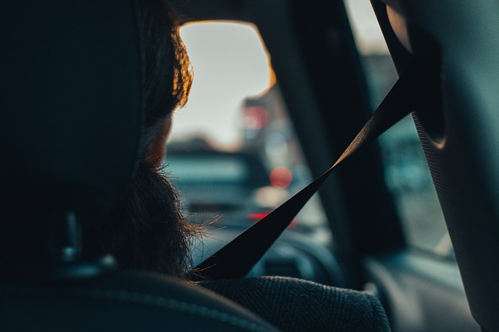
Why You Should Wear Your Seatbelt
According to the NHTSA, seatbelts reduce crash related injuries and deaths by half. In 2016, they saved an estimated 15,000 lives. Individuals who do not wear their seatbelt are more likely to be ejected from the vehicle in a crash. Seatbelts serve as a restraint for passengers in a vehicle. They restrain an individual to the seat instead of being ejected from the vehicle or being thrown around the interior of a vehicle in the instance of a crash.
While airbags serve as great protection during a crash, they do not offer the best protection alone. Air bags combined with proper seatbelt usage offers passengers the best odds of surviving an automobile crash.

Summary
Seatbelts need to be worn every time you are in a vehicle. Reasons such as being uncomfortable or “not cool” are not good enough for not wearing a seat belt. As the driver, you are responsible for everyone in your vehicle. Require anyone riding in your vehicle to wear their seatbelt. Educate others who choose not to wear them.

Discussion points:
- What are some of the other reasons people give for not wearing their seatbelt?
- Do you know someone who has been severely injured or died from result of not wearing their seatbelt?

