TOOLBOX TALK - Mechanical Issue-Related Crashes

Mechanical Issue-Related Crashes Safety Talk
The roads can be an extremely dangerous place. According to the National Highway Traffic Safety Administration, there were an estimated 6.3 million police-reported car accidents in the United States in 2015. While many accidents are caused by distracted driving and driving under the influence, mechanical issues also lead to accidents.

Mechanical Issue-Related Crashes
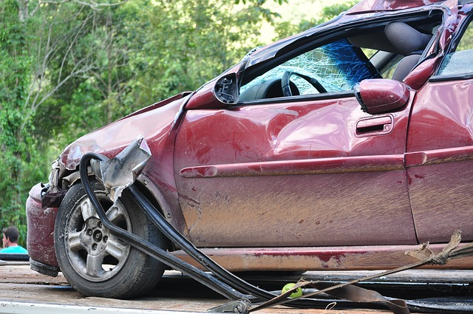
While accidents caused primarily by mechanical issues represent a small percentage of all accidents the statistics are still significant enough to mention. There are many points of failure on vehicles, but there is only a few that represent the majority of mechanical failures that lead to accidents. The National Highway Transportation Safety Administration stated in a 2008 report that tire/ wheel degradation or failure represented 43% of all mechanical issues resulting in crashes. Brake degradation or failure was second at 21% and steering/suspension/ transmission failure represented 10.5% of mechanical issues that lead to accidents. Many of these mechanical issues can be avoided with proper inspections and preventative maintenance.

Vehicle Inspections
Vehicles could be realistically inspected prior to every time you drive them; however, many people choose to go longer without inspecting their vehicle if at all. So many things outside of your immediate control can affect your vehicle that you do not know about. For example, any single trip can result in a nail or other object compromising your tire and causing a dangerous hazard for you the next time you drive your vehicle. Other issues such as wildlife, objects placed near your car, weather, etc. all can affect your vehicle whether or not you are driving it. A simple walk around of your car or truck prior to operation can avoid an accident. A few things to look for during a quick inspection:
- Look for low tire pressure. This could signal that you need air in the tire or a patch depending on the problem.
- Look for any bubbles in your tire. If there is a bubble in your tire this means you have a break in a belt in the tire and it is now compromised. It is recommended that you use your spare or get it replaced immediately before driving the vehicle again because the tire could give way at any time.
- Start the car and listen for any odd noises.
- Make sure there are no objects that you could strike pulling out from where you are parked.
- Pull forward and test the brakes before starting your trip.

Summary
While the majority of the time you will never experience any of the issues mentioned above, the one time you do it could result in a serious accident. Take mechanical issues seriously and when you find one during an inspection get it fixed by a professional to ensure the vehicle is safe to operate.

