TOOLBOX TALK - Defensive Driving
The roads can be an extremely dangerous place. According to the National Highway Traffic Safety Administration, there were an estimated 6.3 million police-reported car accidents in the United States in 2015. Distracted drivers, speeding, and drivers under the influence caused or contributed to the majority of accidents each year. Drivers need to be cautious and aware of the other drivers while on the road. Being a defensive driver is the best way to protect yourself while on the road.
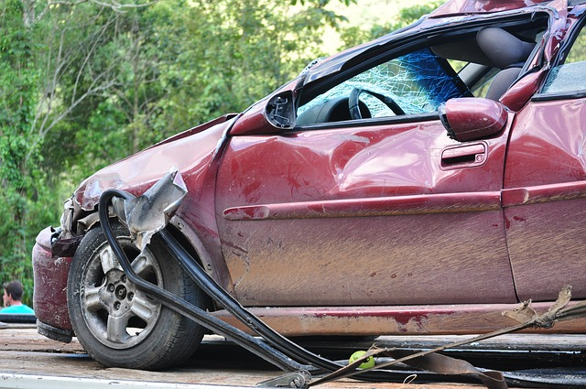
Most collisions that occur today are preventable. With all of the reckless drivers on the road today, it is more important than ever to be a defensive driver. The National Safety Council defines defensive driving as, “Driving to save lives, time, and money in spite of the conditions around you and the actions of others”. Defensive driving techniques involve more than just following the basic traffic laws.

Defensive drivers:
- Leave themselves an “out” when driving. Defensive drivers always think about their next move if a crash were to occur.
- Slow down when the conditions warrant the need to.
- Do not engage in road rage activities.
- Avoid collisions by all means necessary- within the limits of the law.
- Plan their travels before leaving for their destination.
- Recognize the risks of their surroundings while driving.

Defensive Driving Example
John has been seeing a lot of deer activity in the roadway on his normal way home from work. Instead of going the normal way, John decides to take a route where there is less deer activity on to the road. On his way home it begins to rain heavily, and the roadway becomes slick, so he slows down to 5 MPH below the speed limit. After a few minutes of driving at this speed, the driver behind him begins to flash his lights and tailgate his vehicle. Instead of speeding up or stepping on the brakes, John decides to pull over where it is safe to do so to let the other driver pass.

Discussion points:
-What were some of the defensive driving techniques that John used?
-How can we use defensive driving techniques here at work or on our commute to and from work to stay safe?

