TOOLBOX TALK - Winter Weather

Winter Weather Safety Talk
The winter season brings cold temperatures and often times severe weather conditions that create many hazards for individuals working in these conditions. Even if you work indoors, winter weather still poses many hazards for you such as driving into work in bad weather or walking through an icy parking lot to get to your building. It is important to recognize and address the hazards winter brings with it.

Winter Driving Crash Statistics
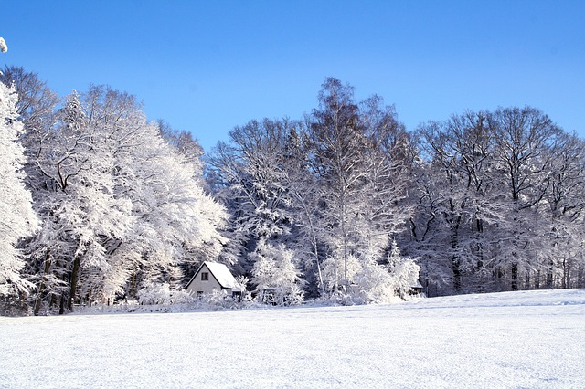
One of the main issues winter poses in many parts of the country is poor driving conditions. According to the Department of Transportation, winter weather conditions are responsible for over 192,000 injuries and 2,200 deaths each year on the road. Outside injury and loss of life, winter weather conditions are responsible for millions of dollars in property damage incidents. The hazards created by winter weather make it hard for even the most experienced drivers to operate a vehicle safely.

Slips, Trips, and Falls
Slips, trips, and falls are one of the leading causes of injuries and fatalities in the workplace. According to OSHA, slip, trip, and fall incidents cause 15% of all accidental deaths, and are second only to motor vehicles as a cause of fatalities on the job. Snow, sleet, and ice greatly increase the chances for slip, trip, and fall incidents to occur.

Winter Safety Tips
When driving:
- Monitor weather for any incoming snowstorms or icy conditions and plan your travel around those conditions. Do not put yourself in a situation where you are stuck on a roadside.
- Do not drive in wintery conditions if possible. Eliminating driving eliminates your chances of being in an accident.
- Be a defensive driver. Stay clear of other drivers and maintain a safe distance in case you need to brake or turn to avoid an accident.
- Slow down. Winter weather conditions necessitate having to reduce your speed. Reducing your speed will give you more time to react as well as help to avoid losing control of your vehicle.
When walking on icy/ snowy surfaces:
- Remove trip hazards before snow or ice conditions are present. This eliminates someone tripping over a buried object after the snow or ice hits.
- Shovel and salt parking lots and walkways prior to work beginning in that area. Have walkways addressed before workers get on site in the morning.
- Take your time when walking across any slippery surfaces. Taking smaller steps lessens your chances to lose your balance.
- Have the proper footwear on for the weather. Wear shoes with solid tread on the soles.

Discussion point:
-What other hazards does winter create?

