TOOLBOX TALK - Winter Weather Driving

Winter Weather Driving Safety Talk
The roads are a dangerous place on even the nicest day, but in the winter the dangers of driving increase dramatically. According to the Department of Transportation, winter weather conditions are responsible for over 192,000 injuries and 2,200 deaths each year. Outside injury and loss of life, winter weather conditions are responsible for millions of dollars in property damage incidents.

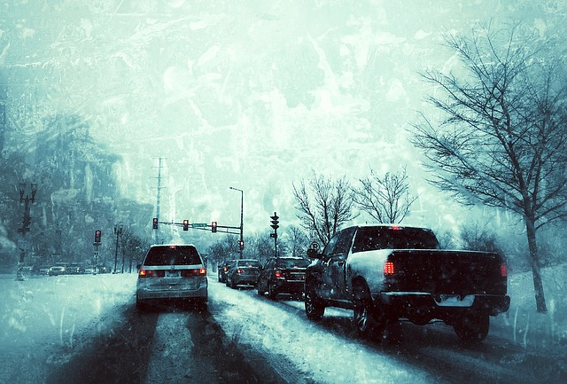
Winter Weather Overview
The majority of the United States and its population are located in an area that receives snow or ice during the winter months. While most of the population has experienced driving in snowy or icy conditions, many individuals do not know how to safely drive in winter weather conditions. The hazards created by winter weather make it hard for even the most experienced drivers to operate a vehicle safely.

Tips for Avoiding a Winter Weather-Related Accident
- Monitor weather for any incoming snowstorms or icy conditions and plan your travel around those conditions. Do not put yourself in a situation where you are stuck on a roadside.
- Do not drive in wintery conditions if possible. Eliminating driving eliminates your chances of being in an accident.
- Be a defensive driver. Stay clear of other drivers and maintain a safe distance in case you need to brake or turn to avoid an accident.
- Slow down. Winter weather conditions necessitate having to reduce your speed. Reducing your speed will give you more time to react as well as help to avoid losing control of your vehicle.

Summary
The best way to avoid an accident during the winter months is to avoid driving in dangerous conditions. If you absolutely have to drive in bad weather conditions travel main roads that have already been plowed and salted. Notify your supervisor if necessary, to alert him or her you will be late for work due to road conditions. Take your time getting to your destination.

Discussion point:
-Has anyone experienced a car accident due to winter weather conditions?

