Safeguarding by distance involves the use of a fixed or movable guard. Several situations are possible (see Figure 5-1).

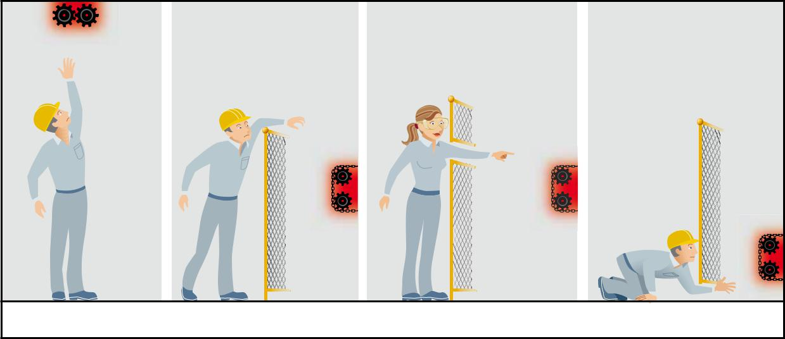

Figure 5-1: Possible location of the danger zone

In all of the following cases, the established safety distance takes into account the fact that no voluntary movement will be made to reach the danger zone and that no accessory (tool, glove, pole, etc.) or object serving as a step (stepladder, chair, etc.) will be used to reach the danger zone.

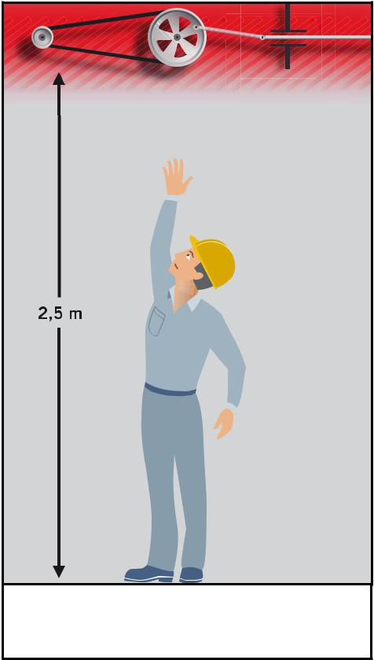
Access by reaching upwards

The safety distance determined between the ground, the catwalk or the permanent working platform and the bottom of the danger zone is a function of the height of the danger zone (see Figure 5-2) and its expected accessibility.

Any danger zone located less than 2.5 m [19] from the ground, catwalk or permanent working platform must be made inaccessible by a guard or by a protective device.

Any danger zone located more than 2.5 m from the
ground, catwalk or permanent working platform must
be made inaccessible by a guard or by a protective
device if its access can be foreseen (for example, a
worker doing regular preventive maintenance by using
an elevating platform in or near the danger zone). As
needed, a complete risk analysis can be done to define
the appropriate means of protection.

Figure 5-2: Access by

Reaching upwards

Access by reaching over a fixed distance guard

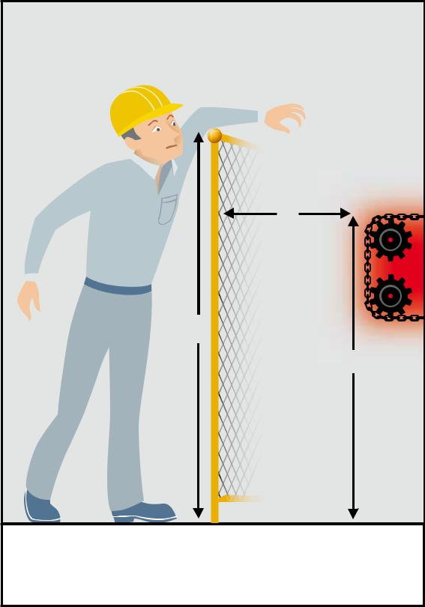
The following symbols are used to designate the critical dimensions relating to access from above the guard .

« a » is the height of the danger zone in relation to the ground or working platform;

« b » is the height of the guard;

« c » is the horizontal distance between the guard and the danger zone.

As a general rule, a distance guard that protects a danger zone must be a minimum of 1800 mm18 high, and the values “a”19 and “c” in bold in Table 5-120 must be used.

However, once a risk analysis has been done, all of the values in Table 5-1 can be used as minimum values when the risk is high, or those in Table 5-2 when the risk is low.
No interpolation must be done from the values indicated in these tables. If data “a”, “b” or “c” are between two values, those that provide the greatest safety must be chosen in all cases.

Access by reaching through an opening in a guard

The safety distance determined between the danger zone and the guard in the case of access through the guard (see Figure 5-4) is a function of the dimension and shape of the opening.

The following symbols are used:

« sd » is the safety distance, namely the distance between the guard and the danger zone;

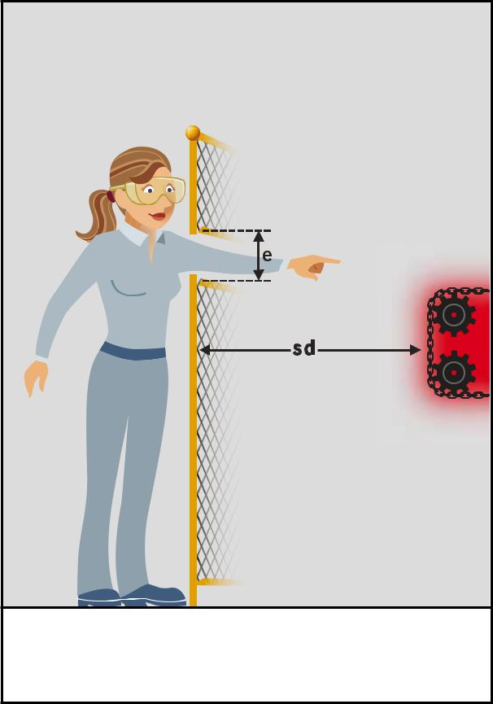
« e » is the smallest dimension of the opening.

Openings in the guard

The guards may include regular-shaped openings (square, round, slot- or groove-shaped) or irregular-shaped openings for feeding the machine or for viewing the danger zone or the process.

Dimension “e” corresponds to the smallest dimension of a rectangular (slot-shaped) opening, to one side of a square-shaped opening, and to the diameter of a circular-shaped opening.

