EHS Talk of the Week

EHS每周讨论

Focus this week on Lockout Tagout Verify

本周重点关注 上锁挂牌检验

Why Lockout Tagout and Verify (LTV)为何要上锁挂牌并检验
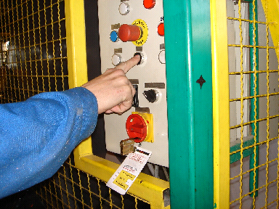
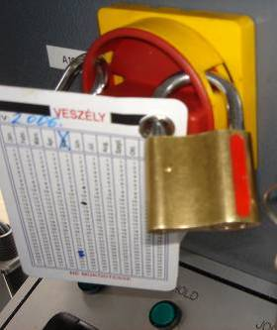

Any powered machinery or electrical equipment that can move in a way that would put people in danger is a hazard that can be prevented by following LTV procedures.
通电机器或电力设备是一种危险设备，其运作方式会使人员陷入危险，但是可以通过以下LTV程序防止危险的发生。

Hazardous energy comes in many forms: 危险能量形成的多种形式：
- Electrical energy (direct or stored) can cause electrocution and burns, provide ignition to flammable atmospheres, and activate mechanical equipment.
- 电能（直接电能或储存电能）会引起触电和起火，在可燃性空气中点燃并激活机械设备
- Pneumatic energy (compressed air) can easily squash our body and cause serious injuries.
- 气压能（压缩气体）能够很容易对我们身体造成挤压并导致严重的受伤事故。
- Steam can cause burns or initiate hazardous reactions.
- 蒸汽能够导致燃烧，或引起危险的反应。
- Nitrogen can cause asphyxiation. 氮气可使人窒息。
- Chemical flow can cause uncontrolled reaction and injury.
- 化学品流动能够导致反应失控，造成人员受伤。

When do we need to Lockout Tagout and Verify?
我们什么时候需要上锁挂牌并检验？

Whenever we work on a piece of equipment, including regular maintenance jobs, troubleshooting, repair, we are exposed to hazardous energy.
当我们操作一台设备，包括常规维修工作、故障排查、修理时，我们暴露于危险能量下。
Therefore all sources of energy must be securely and positively locked out until the equipment is operational again.
因此所有能源必须安全而肯定地进行了上锁，直到设备可以再次操作。
Anyone who operates, cleans, services, adjusts, and repairs machinery or equipment must be aware of the hazards associated with that machinery.
任何操作，清理，维修，调整以及修理机械或设备的人员必须意识到机器有关的危险。
Failure to lock out or tag power sources on equipment can result in electrocutions, amputations, and other serious -sometimes fatal- accidents.设备电源上锁或挂牌发生故障能够导致触电、截肢以及其他严重- 有时致命-的事故。

How do we apply Lockout Tagout and Verify我们如何应用上锁挂牌并检验

- Lock out using an approved method and always apply the correct tag
- 使用准许的方法进行上锁并一直应用正确的挂牌

- Identify all sources of hazardous energy potentially impacting the piece of equipment under intervention and lock out all sources.
- 确定所有在干扰下会影响设备的潜在危险能源并对所有能源上锁。

- Each person working on a piece of equipment must apply his or her personal lock
- 每位操作设备的人员必须使用他或她的个人锁具
- and must keep the personal key till the job is finished.
- 并且必须保留个人钥匙，直到工作完成

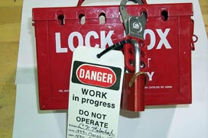

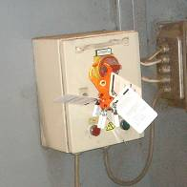

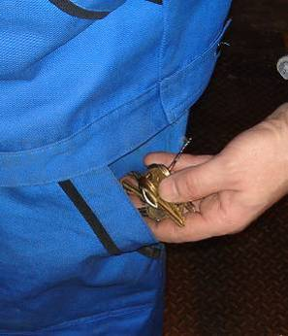

- Tags must be applied to the lockout point in such a way that these cannot be easily or accidentally removed.
- 挂牌必须这样穿过上锁孔，这样这些锁具就无法轻易或意外脱落了。

- Once the locks and tags are in place, verify that you have completely de-energised the equipment by trying the point of isolation (switch, tap, valve, ..) and attempting to restart the equipment.
- 一旦上锁挂牌到位。检验你已经通过隔离按钮（开关、抽头、阀，..）完全切断了设备的电源并尝试重新启动设备。

- Make sure any residual or stored energy has been released.

- 确认残余物或储存能量已经释放

- Locks should not be removed until the equipment is ready to be operated safely.

- 不应当移除锁具，直到设备安全操作准备就绪

- When a maintenance or repair activity extends beyond the current shift, replace the personal locks of the leaving shift with the personal locks of the arriving shift.

- 当维修或修理活动时间跨越了当前轮班的班次，使用即将上班的个人锁具替代即将下班的。

- Remember not to leave your personal lock in place if you need to leave the site.

- 如果你需要离开现场，切记不要将个人锁具遗留在那里

- Never remove another employee’s lock! A qualified supervisor will need to verify and authorise its safe removal.

- 勿将其他员工的锁具移除! 有资质的主管需要检验并赋权方可安全移除。

