TBT-Seven step process-Lockout/Tag out
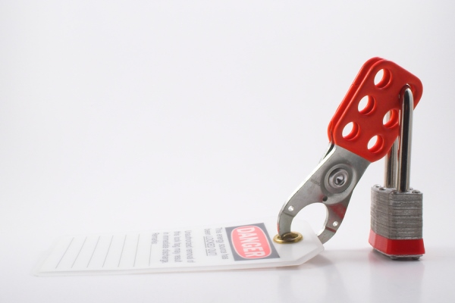

Lockout/Tagout is more than just putting a yellow lock on the main electrical disconnect to a machine or part of a machine. There are 7 very important steps you must do when putting Lockout/Tagout in place:
SEVEN STEPS FOR SHUTDOWN
- NOTIFY – Notify all affected employees that you are going to be conducting a lockout/tagout.
- PREPARE – Before you begin, be sure you know all the types of energy involved, hazards presented by energy, and how to control the energy.
- SHUTDOWN – Turn off machine or equipment.
- ISOLATE - Isolate machine or equipment from its energy source(s). (For example, turn off main circuit breaker.)
- LOCKOUT – apply your lock. Be sure that it holds the isolating device in the “off” or “safe” position.
- RELEASE - Release stored energy. Relieve, disconnect, restrain, block, or otherwise ensure, that all energy sources – electrical, mechanical, hydraulic, compressed, etc. – are de-energized.
- VERIFY – Try the on-off switch or other controls to be sure the machine won’t start. Return the switch to the “off” position.
YOUR LOCKOUT IS COMPLETE

SAFETY TRAINING CERTIFICATION FORM
Toolbox Topic Covered: Lockout/Tag out Standard – Importance of LOTO

Company Name: ____________________________ __________ Date: ____________

Training led by: _______________________________________

PRINT NAME SIGNATURE
_____________________________________ ____________________________________
_____________________________________ ____________________________________
_____________________________________ ____________________________________
_____________________________________ ____________________________________
_____________________________________ ____________________________________
_____________________________________ ____________________________________
_____________________________________ ____________________________________
_____________________________________ ____________________________________
_____________________________________ ____________________________________
_____________________________________ ____________________________________
_____________________________________ ____________________________________
_____________________________________ ____________________________________
_____________________________________ ____________________________________
_____________________________________ ____________________________________

