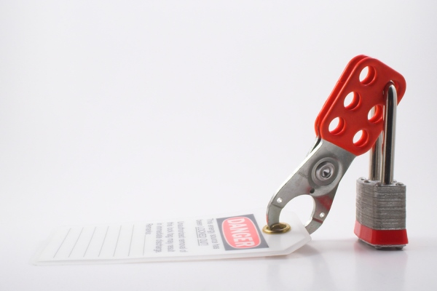
TBT-Importance of Preparing for Lockout/Tag out

As with so many things we do, the preparation and planning can be some of the most important things we do. It is no different with LOTO. Prior to placing a piece of equipment in a LOTO state, we need to step back and look at the "big picture" if you will. We need to plan and prepare for the task.

Gather all information necessary. The more information exchanged by those involved in the job, the less likely an accident will occur. These are just some of the questions you should be able to answer before beginning lockout/tag out procedures:
- What equipment is needed?
- What are all the energy sources?
- What methods will be used to control energy sources?
- Are there hazardous substances that need to be drained?
- What protective equipment needs to be worn?
- Could energy re-accumulate while work is being performed?
- Does adjacent machinery need to be locked out as well?

SAFETY TRAINING CERTIFICATION FORM
Toolbox Topic Covered: Lockout/Tag out Standard – Importance of LOTO

Company Name: ____________________________ __________ Date: ____________

Training led by: _______________________________________

PRINT NAME SIGNATURE
_____________________________________ ____________________________________
_____________________________________ ____________________________________
_____________________________________ ____________________________________
_____________________________________ ____________________________________
_____________________________________ ____________________________________
_____________________________________ ____________________________________
_____________________________________ ____________________________________
_____________________________________ ____________________________________
_____________________________________ ____________________________________
_____________________________________ ____________________________________
_____________________________________ ____________________________________
_____________________________________ ____________________________________
_____________________________________ ____________________________________
_____________________________________ ____________________________________

