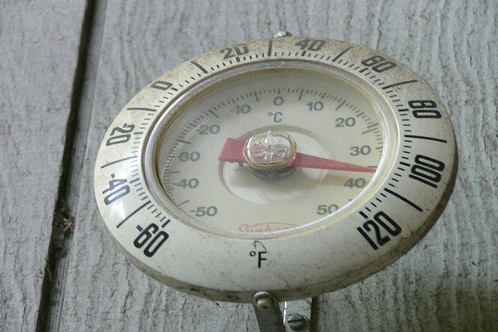
TBT-Heat Disorders - Prevention

This week we’ve been looking at various heat stress disorders that may affect us as the summer heat increases the temperature and humidity of our facility. During the summer, we must all take precautions to ensure our bodies don’t get over heated.
Today we’ll look at ways to prevent these heat stress disorders
- Use general ventilation, cooling fans, and evaporative cooling whenever possible.
- Shield furnaces and other heat producing equipment including steam leaks.
- Wear loose, lightweight, light colored clothes.
- Drink water steadily before and during work in the heat.
- Drink about 16 ounces before starting
- Drink 5 to 7 ounces every 15 or 20 minutes during hot work.
- Eat well-balanced meals. Eat more smaller/lighter meals rather than large meals.
- Avoid drinks with alcohol and caffeine.
- Work at a steady pace, minimizing overexertion.
- Take regular breaks in a cool, well-ventilated area.
- Know your own limits and ability to work safely in heat.
- Take extra precautions with certain medications. Several medications can affect your body's ability to stay hydrated. Check with your doctor.
- Avoid sunburn. Having a sunburn reduces your body's ability to rid itself of heat.

