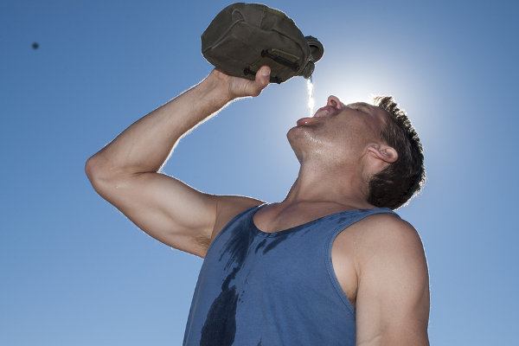
TBT-Heat Disorders - Heat Stroke

This week we’ve been looking at various heat stress disorders that may affect us as the summer heat increases the temperature and humidity of our facility. During the summer, we must all take precautions to ensure our bodies don’t get over heated.
Today we’ll look at Heat Stroke
Heatstroke is a life-threatening condition that occurs when your internal body temperature reaches 104 F (40 C) or higher. Heatstroke is the escalation of two other heat-related health problems: heat cramps and heat exhaustion. You can prevent heatstroke if you receive medical attention or take self-care steps as soon as you notice problems.
Signs of Heat Stroke are:
- High body temperature. A body temperature of 104 F (40 C) or higher is the main sign of heatstroke.
- Cessation of sweating. This is often one of the first signs that your body temperature is too high. In heatstroke brought on by hot weather, your skin is hot and dry to the touch. Your body stops sweating.
- Hyperventilation. Your breathing may become rapid and shallow.
- Rapid heart rate and pulse.
- Seizures or Convulsions.
- Neurological symptoms. You may have seizures, lose consciousness, slip into a coma, hallucinate, or have difficulty speaking or understanding what others are saying.
Whatever the cause, you'll need immediate medical attention to prevent brain damage, organ failure or death.

