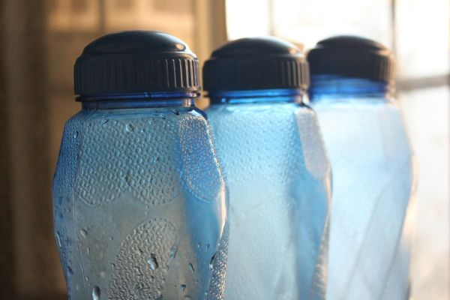
TBT-Heat Disorders - Dehydration

This week we’ve been looking at various heat stress disorders that may affect us as the summer heat increases the temperature and humidity of our facility. During the summer, we must all take precautions to ensure our bodies don’t get over heated.
Today we’ll look at dehydration. Although it is technically not a heat disorder, it is certainly related.
Dehydration occurs when you lose more fluid than you take in and your body doesn't have enough water and other fluids to carry out its normal functions. If lost fluid remains unreplenished, you may suffer serious consequences.
Common causes of dehydration include intense bouts of diarrhea, vomiting, fever or excessive sweating. Inadequate intake of water during hot weather or exercise also may deplete your body's water stores. Anyone may become dehydrated, but young children, older adults and people with chronic illnesses are most at risk.
Mild dehydration can cause symptoms such as
- Dry, sticky mouth
- Sleepiness or tiredness
- Thirst
- Decreased urine output
- Few or no tears when crying
- Muscle weakness
- Headache
- Dizziness or lightheadedness
Dehydration can be treated by replenishing the lost fluids your body has lost. Drink at least 32 ounces of water or sports drinks slowly and steadily. Rest, if you don’t feel better, drink more slowly and steadily.

