TBT- Chemical Label Colors And Numbers
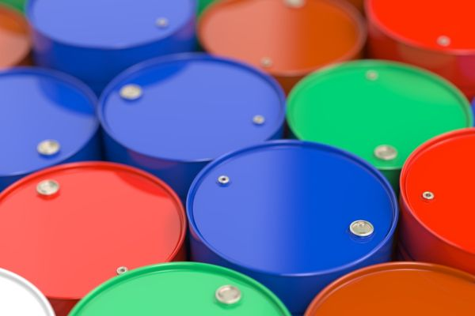

When your using the various chemicals we use, watch for special symbols—pictures with words, such as flammable, poison, etc.
Labels also have special colors, which represent the following:
- Red means fire hazard
- Yellow means reactivity hazard
- Blue means health hazard.
Labels also have special number codes, which represent the following:
- 0 = means minimal hazard
- 1 = means slight hazard
- 2 = means moderate hazard
- 3 = means serious hazard
- 4 = means severe hazard
The white part of the label can show different types of information such as:
- On National Fire Protection Association labels, white shows special information such as acid, corrosive, radioactive, etc.
- On Hazardous Material Identification System (HMIS) labels, the white part tells what kind of PPE to use.

Read the labels first and then consult the MSDS if there are any more questions.

