TBT- Chemical Labels - Part 2
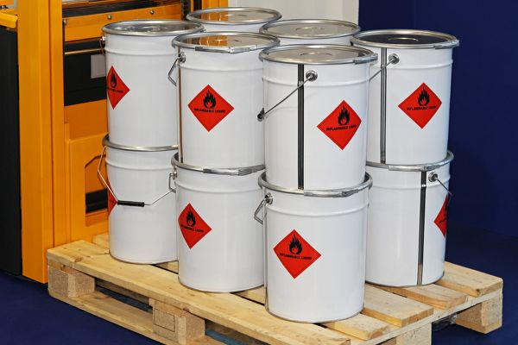

Labels on chemicals are your first line of defense to know what you are using and what, if any, special precautions or PPE should be used.
Remember the following important guidelines:
- Every container should have a label. DON’T USE IT IF IT DOESN’T!
- Report missing or illegible labels.
- Even portable containers should have labels.
- Read labels before using.
- Always follow the instructions on labels.
- Ask your supervisor if you don’t understand the information.
In conclusion always remember to:
- Read the label first before starting to work with any chemical.
- Always refer to the MSDS for more detailed information.
- Ask a supervisor if you have any questions.
- Most important: use the information on labels and MSDSs to protect your health and safety.

