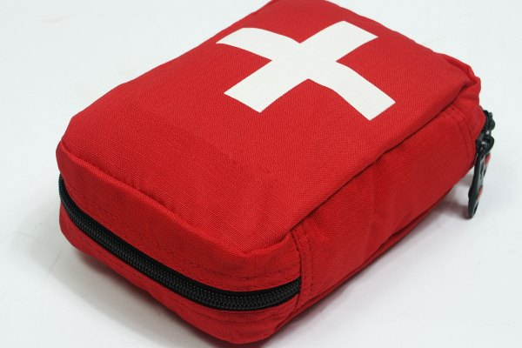
First Aid Awareness
When an accident happens, a first aid program that meets the requirements of the law and is tailored to the type and size of the workplace can literally make the difference between life and death, or between recovery and permanent disablement.
Supervisors should have information readily available that list emergency contacts in case of a serious injury. The emergency notice should state the phone numbers of the closest ambulance service, fire/rescue unit, police station, and hospital. The amount of time it takes to look up one of these important numbers can make a big difference to a seriously injured person. The location of first aid equipment and rescue equipment should also be posted prominently.
First aid equipment and supplies should be stored where they can be reached quickly and easily in case of an accident. These supplies should be inspected frequently, making sure they are kept in sanitary and usable condition and re-stocked after use. Larger workplaces may need more than one, fully equipped first aid kit.
In isolated work sites, emergency supplies and an action plan are especially important. If first aid is not given properly, it can sometimes hurt rather than help an injured or ill person, or even be harmful to the person giving the first aid. All workers should know where the emergency first aid equipment is located, and what medical professional or medical facility should be contacted if a medical emergency should occur.
These are simple objectives to administer when providing First Aid to an injured person until professional help arrives.
- Make sure you and the victim are not in any danger.
- Maintain individual breathing
- Maintain blood circulation
- Prevent continued loss of blood
- Prevent or treat for shock
- Contact the nearest Medical Services as soon as possible.
One of the handy tips for caring for a victim: If the face is red, raise the head. If the face is pale, raise the tail.
This toolbox topic was reviewed by ______________________________________ on ___________________________ with the following employees:

