Toolbox Talks
Weekly Tailgate Topic

Shoveling Safety

Commit to ensuring a safe work environment for all employees. Shoveling, although considered a “straight forward” task, has led to worker injuries due to improper technique. In order to avoid injury, here are a few techniques that all of us can apply on the job-site, and in our yard at home.
First, keep your shovel clean. This will reduce your risk of injury while lightening your workload.
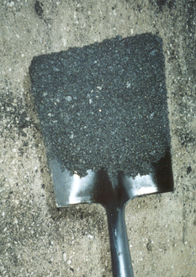
Unclean Shovel | Clean Shovel

Second, maintain good posture and technique.
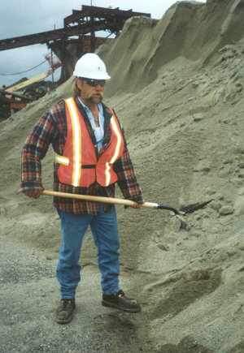 | 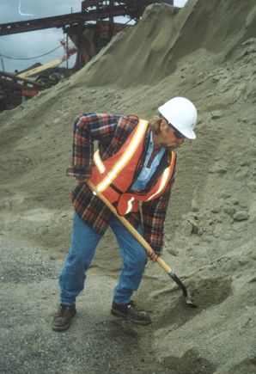 | 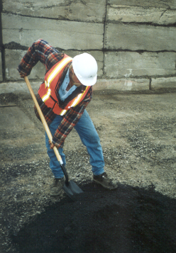  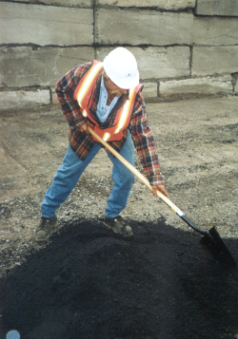  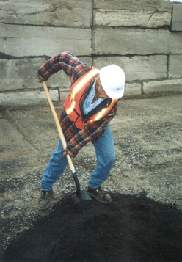
- Stand upright.  Stand with feet apart,  Bend your knees. | - Face the direction your shoveling. | C) Move the body as a unit  Use your momentum,  Shovel in a smooth, fluid motion. Avoid jerking motions.
Third, avoid awkward posture and technique.

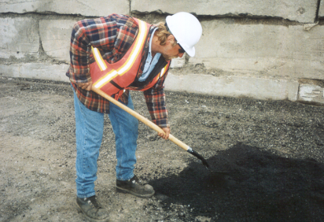 | 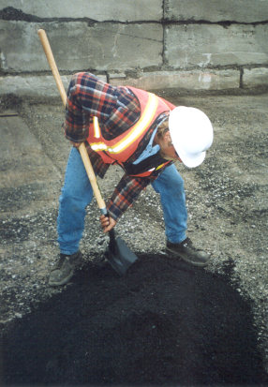 | 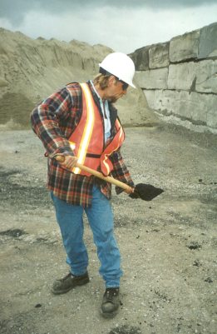.
Avoid leaning forward. | Avoid holding the shovel too far down. | Avoid twisting while shoveling. | Avoid keeping weight away from your body.

Similar to lifting, it is important that you:
Use your legs instead of your back while shoveling.
Always try to keep your upper body in an upright position.
Avoid leaning or bending way over as this puts you in a position that is susceptible to injury.

There is no “ONE WAY” to shovel, but by following these simple do’s and don’ts all of us can reduce our risk of injury.

