Tool Box TIPS
MANUAL TOOLS

Facilitator / Leader Tasks Before the Tool Box Talk (TBT):
    - Read through this TBT guide.
    - Walk the job site to find ergonomics examples based on the TBT. If possible, take photos of “safe” and “unsafe” examples at the site to be used during the TBT.
    - Write down discussion questions to ask the group. Fill them in on page 2 “Other Questions.”

Learning Goals: After discussing this training topic, workers will have gained a general understanding of:
      - Hand injuries related to manual hand tool use.
      - Principles of choosing comfortable hand tools.

TRAINING CARD: TRAINER’S TALKING POINTS:
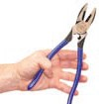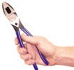Why should we talk about manual hand tools? To save your hands and elbows from fatigue and wear and tear over time.

=
⃝ CHOOSING MANUAL HAND TOOLS: 6 Tips
Ask these 6 questions when choosing your hand tools: Does the tool…
- Fit the task? Long handle vs. short,
wrench vs. ratchet, straight snips vs. offset…
- Allow a good power grip, not too wide/ narrow?
Poor, wide grip >3.5” Good, closed grip span
between 2” to 3.5”
When using hand tools that don’t fit your hand, require high force to use, and need to be used repeatedly, you are at risk for a hand or arm musculoskeletal disorder or MSD like carpal tunnel syndrome or tennis elbow. Reduce your risk of a hand or elbow MSD, by asking these
6 questions when choosing your hand tools:
Does the tool…
- 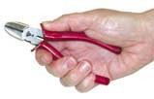Fit the task? Try to use tools that are made for the task instead of substitutes. For instance, use a chisel with a hand guard instead of a straight screw driver as a chisel. Other examples include: Long handle vs. short and straight snips vs. offset snips.
- Keep your wrist in a straight posture? Poor, bent wrist Good, straight wrist

- Feel comfortable? Doesn’t cut into hand or press into palm, & tool is not too heavy.
- Take less effort than other tools for the task?
- Work effectively? When blades are sharp, joints are oiled, or bolts are tight, it does a good job.
- Allow a good power grip, not too wide/ narrow?
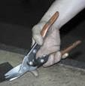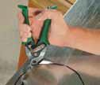A wide grip occurs with a handle span more than 3.5” wide. A good grip span is between 2 and 3.5 inches.
- Keep your wrist in a straight posture? Gripping with the wrist bent reduces your available grip strength.
- Feel comfortable? A tool that cuts into the hand or presses into the palm can damage your hand. Heavy tools may make you work harder to handle them compared to a lighter tool.
- Take less effort than other tools for the task? Some tools are designed to improve mechanical advantage. Examples include: wrench vs. ratchet wrench, short handle vs. long handle.

- Work effectively? When blades are sharp, joints are oiled, or bolts are tight, the tool does a good job.

TRAINER’S TALKING POINTS
Tool Comparison Discussion: Print a copy of this sheet for your workers to use a discussion guide. Bring a few hand tools (currently used at the job site) to use as hands-on examples for the discussion. Discuss the pros and cons of the recommended design features as they relate to current work tasks.

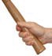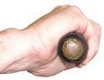
Discussion Questions: Tool Design Quality
For single-handle tools used for power tasks: Does the tool feel comfortable and have a handle diameter between 1- 1/4 inches and 2 inches?
Examples
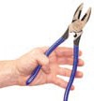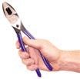For double-handle tools used for power tasks:
Is the grip span at least 2 inches when closed and no more than 3 1/2 inches when open?

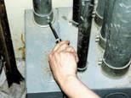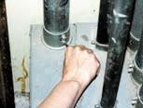Is the tool handle the best length for the task to maximize leverage and keep the wrist straight?

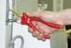Can the tool be used while keeping your wrist straight?
Long-handle tool Short-handle tool

