TOOLBOX TALK - Portable Saw Safety
Whether here or at home it is important to remember these safety tips when using a portable power saw:
- Always wear eye protection. Chips from material can fly into your face, or the blade can break.
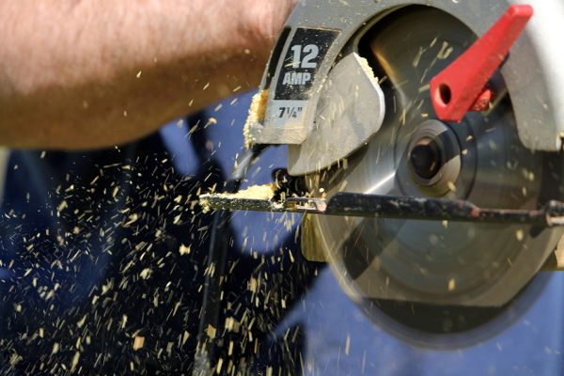
- Avoid loose clothing, jewelry and anything that could get caught in the saw. Tie back long hair.
- Use both hands on the saw and make sure you are in full control of it. Avoid cutting above shoulder height.
- Always make sure you are using the proper blade for the material you are cutting.
- Make sure the workpiece is secure before cutting. Never hold a workpiece in your hand or across your lap.
- Don’t overreach. Keep a stable footing.
- Double-insulated saws do not require a three-wire grounding cord and the user is protected in the event of an electrical short.
- Always unplug the tool before changing blades.
- Beware of kickback when using a circular saw, which is when the blade becomes pinched and the saw lifts up out of the workpiece and toward the user. To prevent kickback, make sure the blade is sharp and clean; do not let it overheat; support large panels so they will not pinch the blade; beware of knots or sap in the wood and never remove the blade from the material while it is cutting. Release the switch immediately if the saw stalls or binds.
- Always make sure the cord is out of the way and not in the line of the cut.
- Do not leave plugged-in tools unattended, especially if there are children nearby.

