TOOLBOX TALK - Exploding Flashlight
There have been several recent news reports about flashlights that have exploded while in use by various people either at work or at home.
In researching this toolbox, I discovered that flashlights like many batteries powered devices can indeed explode during use. There have been recent cases of e-cigarettes and hover boards also in the news although they typically utilize a different type of battery.
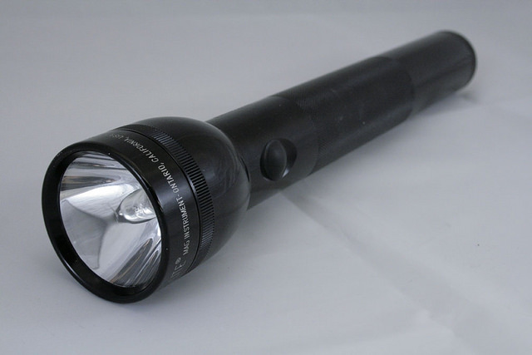
In the types of batteries most commonly used in flashlights—zinc/carbon batteries and alkaline batteries—hydrogen gas (H2) is produced naturally as a product of the corrosion of the zinc electrode in the aqueous electrolyte. Differences in batteries, including cell design and charge rate, affect the rate and volume of H2 generation.
Excess hydrogen gas is more likely to be released if batteries are used incorrectly; that is, if different types or brands of batteries are mixed, damaged batteries are used, old batteries are mixed with new batteries, or batteries are inserted incorrectly so that polarity is reversed. Excess hydrogen gas may also be produced by rechargeable batteries during recharging.
If H2 accumulates within batteries or battery compartments without sufficient release, the buildup of pressure can cause the battery or compartment casing to rupture. Also H2 and oxygen (O2) mixtures are highly explosive, and if ignited by a spark or excessive heat can produce powerful explosions.
In order to protect themselves, workers should follow these precautions:
- Read and follow manufacturers recommendations for product use
- DO NOT MIX batteries of different brands
- DO NOT MIX old and new batteries
- DO NOT MIX alkaline with no alkaline batteries
- DO NOT USE damaged batteries
- Ensure that proper polarity is observed when installing batteries
- PRIOR TO THEIR USE IN FLAMMABLE ATMOSPHERES, inspect approved battery-powered flashlights to ensure that the batteries are in good condition, and that the proper batteries are installed correctly. Opening the battery compartment should allow any accumulated H2 to dissipate.
- DO NOT inspect the flashlight in a hazardous area or near an open flame.

