TOOLBOX TALK - Dangers of saw kickback
We don't know all the details nor what specific type of equipment the man was utilizing but even the common table saw that many of us use can be a source of kickback. Most people know kickback is dangerous, but often people don't understand why. Kickback happens when the wood hits the back of the blade or the wood binds. Common causes of kickback are:
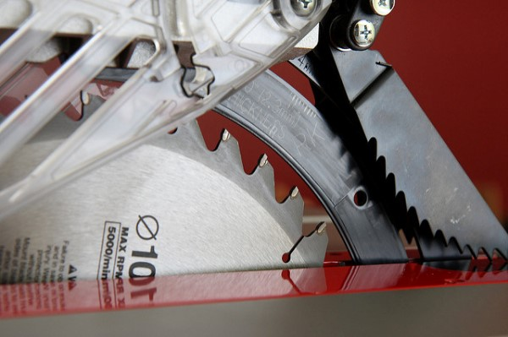
- the kerf closes behind the cut pinching the blade
- a board is warped, cupped, twisted, etc. and binds against the blade
- the side of the wood against the table saw fence isn't straight
- the blade isn't parallel to the fence
- across cut is made without properly supporting the board and it twists into the blade
- a cut-off gets trapped between blade and fence.
In each case, the velocity of the spinning blade can lift the board and send it flying. I've seen a piece of wood fly so hard it stuck in a plywood wall. You don't want to be hit by that!
Kickback is over before you are even aware it happened, so don't think you can react in time to pull your hand out of the way. You can't.
Here are some tips to prevent getting injured by saw kickback on a table saw:
- The best way of preventing kickback is to use a riving knife or splitter and an anti-kickback device on your table saw. The riving knife and splitter will hold the kerf open behind the blade so the wood can't close on the cut.
- Don't pull the workpiece from the back side of the table saw, a kickback can yank your hand right into the blade. People do serious injury to their hands when the blade grabs the board pulling it and their hand into the blade.
- Don't use the fence when cross cutting narrow stock. There isn't enough wood against the fence to control the cut. Instead use the miter gauge to push the wood and leave your table saw fence to the side.
- Kickback often occurs when you're cutting large sheets of material. If you let the sheet sag down, the kerf can close and pinch the blade as you near the end of the cut.
- Keep your hands and body to one side of the line of cut.
- When using portable saws always maintain a firm grip on the saw and don't stretch so far over the workpiece that you're left in an awkward, unbalanced position.
- Make sure your wood is flat and the side against the fence is straight.
- Keep your blade parallel to the fence.
- Never try to free hand a cut.

