Facilities Management - Pool Maintenance
Job Safety Analysis Form

Picture of task/equipment: | Task: |  | Adding Hypochlorite Tablets
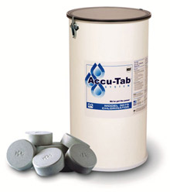 | Name of  Shop or Dept: |  | FM Pool Maintenance
 | Job Title(s): |  | Pool Maintenance
 | Analyzed by: |  | G.Jasso / Neil Mansky
 | Date: |  | 4/30/13
Required PPE:
Goggles | Face Shield | Neoprene Gloves

Required/Recommended Trainings:
Hazard Communication

TASK | HAZARDS | CONTROLS
Adding Sodium Hypochlorite Tablets  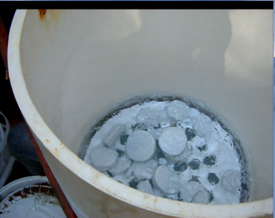 | Inhalation of airborne dust from chlorine tablets  Irritation / tissue damage from inhalation or handling hypochlorite tablet powder  Hazardous chemical reaction with  other chemicals | - Wear safety goggles and splash shield  - Wear neoprene gloves  - Store hypochlorite tablets in a cool place, in  a sealed container, away from acid,  ammonia, amines, and combustible chemicals  - Use caution when adding tablets to avoid  creating airborne tablet dust, by emptying  container slowly and carefully

